Download all Associated Files for this lesson from our Website




- Introduction Page 1

- Terminology Page 2

3. Experiment Page 3
What Color is that Sharpie?

4. Alternative Experiments Page 9
Water Soluble vs. Permanent

Alcohol vs. Alcohol

Paper vs. Paper

Food Colors

Flower Pigments
Kool-Aid Food Dyes

Mystery Sample

5. Hints, Tips, and Extras Page 15

Sabrina Schmidtke
Protein Chemistry Laboratory
Texas A&M University

Paper Chromatography: Introduction

Chromatography is a technique for separating mixtures into the components that they are made from in order to analyze, identify, quantify, or purify the mixture or components.

A scientist will use chromatography to:
- examine a mixture, its components, and their relations to one another (analyze)
- determine the identity of a mixture or components based on known components (identify)
- separate components in order to isolate one of interest for further study (purify)

- determine the amount of the mixture and/or the components present in the sample (quantify)

Real life examples of uses for chromatography include:
- pharmaceutical companies determining the amounts of each chemical found in a new product
- hospitals detecting drug or alcohol levels in a patient’s blood stream
- law enforcement agencies comparing a sample found at a crime scene to samples from suspects
- environmental agencies determining the level of pollutants in the water supply
- manufacturing plants purifying a chemical needed to make a product

Different types of chromatography are used: liquid chromatography, gas chromatography, paper chromatography, and thin-layer chromatography. While each type of chromatography uses different methods to separate compounds, they all share the same principles. Chromatography utilizes the differential affinities of the components for a gas or liquid mobile medium (mobile phase) and for a stationary adsorbing medium (stationary phase) through which they pass. The stationary phase holds the mixture until the mobile phase passes through, solubilizes the components, and moves them along at their individual rates. Once components are separated from one another, they can be analyzed.

In paper chromatography the stationary phase is the filter paper and the mobile phase is the solvent. The filter paper holds the components until the solvent dissolves them and carries them up the filter paper. The solvent travels up the filter paper by capillary action. The solvent’s attraction to itself pulling it up is greater than the force of gravity pulling it down. The separation of components depends on their solubility with the solvent and their affinity to the solvent and filter paper. The solvent can only move the components if they are soluble in it and the more soluble a component is the more there is available to move up the filter paper. Solutes will dissolve into solvents that have similar properties. Polar solvents dissolve polar solutes and non-polar solvents dissolve non-polar solutes. (Like dissolves like.) A component will travel up the filter paper at a rate that is determined by its affinity to the filter paper and solvent. Since each component has its own solubility with the solvent and its own affinity to the solvent and filter paper, they can be separated in multiple ways by using mixtures of different solvents and different filter papers.

Page 1

Paper Chromatography: Terminology

Affinity – natural attraction or force between things.

Capillary Action – the movement of liquid within the spaces of a porous material due to the forces of adhesion, cohesion, and surface tension.

Chromatogram – the graphic record produced by chromatography.

Chromatography – a laboratory technique that separates components within a compound by utilizing the differential affinities of the components for a gas or liquid mobile medium and for a stationary adsorbing medium through which they pass.

Component – a constituent element or part.

Differential – showing a difference, distinctive.

Mixture – a material composed of two or more elements or parts.

Mobile Medium – gas or liquid that carries the components (mobile phase).

Solubility – the quality, condition, or degree of being soluble or solvable.

Solute – a substance that is dissolved in another substance to form a solution.

Solution – a mixture of a solvent and a solute.

Solvent – a substance that dissolves other substances to form a solution.

Stationary Medium – the part of the apparatus that does not move with the sample (stationary phase).

Page 2

Paper Chromatography: Experiment

What Color is that Sharpie?

Purpose

To introduce students to the terminology and principles of chromatography and demonstrate separation of the dyes in Sharpie Pens with paper chromatography.

Time Required

- Preparatory time – 10 minutes
- Experiment time – 45 minutes

Costs

- Less than $10
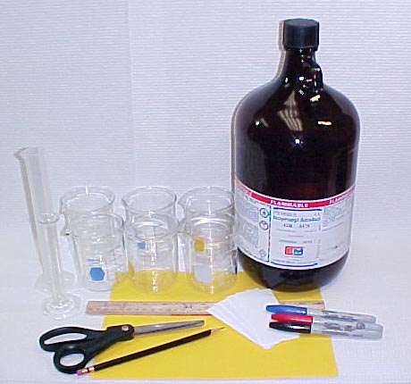
Materials List

- 6 beakers or clear jars/cups
- 6 covers or lids (tinfoil is sufficient)
- Distilled H₂O
- 100% isopropanol or 70% isopropanol (rubbing alcohol)
- 10 ml graduated cylinder
- 6 strips of filter paper
- Different colored Sharpie pens
- Pencil
- Ruler
- Scissors
- Tape

Prepare the Isopropanol Solutions

- Label the beakers with the following: 0%, 5%, 10%, 20%, 50%, and 100%.

- Using the 100% isopropanol and distilled H₂O, make the following isopropanol solutions: 0%, 5%, 10%, 20%, 50%, and 100%.

Isopropanol Solutions for Paper Chromatography
 | 0% | 5% | 10% | 20% | 50% | 100%
Isopropanol 100% | 0 ml | 7.5 ml of 10%* | 2.5 ml | 3 ml | 7.5 ml | 15 ml
Distilled H₂O | 15 ml | 7.5 ml | 22.5 ml | 12 ml | 7.5 ml | 0 ml
Total Volume | 15 ml | 15 ml | 25 ml | 15 ml | 15 ml | 15 ml
* Use 7.5 ml of the 10% isopropanol solution and 7.5 ml of H₂O to make the 5%.

Page 3

Paper Chromatography: Experiment cont.

** When using 70% ispropanol instead of 100%, an adjustment is made in making the 50% **

Isopropanol Solutions for Paper Chromatography
 | 0% | 5% | 10% | 20% | 50% | 70%
Isopropanol 70% | 0 ml | 7.5 ml of 10% | 11.25 ml of 20% | 10.5 ml | 20 ml | 15 ml
Distilled H₂O | 15 ml | 7.5 ml | 11.25 ml | 15.75 ml | 8 ml | 0 ml
Total Volume | 15 ml | 15 ml | 15 ml | 15 ml | 28 ml | 15 ml

- Pour each of these solutions into their labeled beakers just enough to cover the bottom. Cover them immediately because the isopropanol will evaporate.

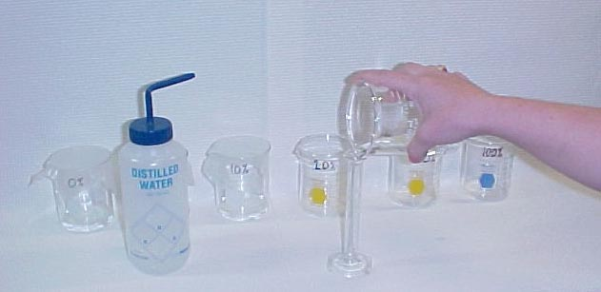

Prepare the Chromatography Strips

- Cut the filter paper into 6 strips that are about 5 cm x 8 cm. If the beakers are tall enough you can make the strips longer to allow for more separation. The longer the strips are the longer it will take to develop them.

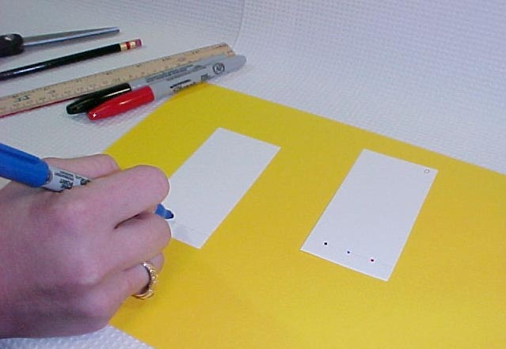
- Draw a line lightly with the pencil across the strips 1 cm above the bottom edge.

- Label the strip with the corresponding solution that it will be placed in.

- Spot each Sharpie pen on the starting line. For better results spot a pen, let it dry and spot it again on top of the first spot. Keep the spots small and space them out as much as possible so that the colors will not run together as they separate.

Page 4

Paper Chromatography: Experiment cont.

Developing the Chromatograms

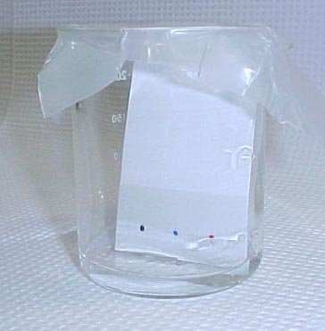
- Place the strips in the beakers. Make sure the solution does not come above the starting line. If you need to, remove some of the solution. If you use a thin filter paper you may need to support the strips to keep them from sliding down into the solution as they get wet. Depending on the type of cover used for your beakers, you can either tape the top of the strip to a pencil sitting on top of the beaker or tape the strip to the sides of the beaker.

- Cover the beakers and let the strips develop until the ascending solution front is about 2 cm from the top of the strip.

- Remove the strips and let them dry on a paper towel.

- Dispose of the isopropanol solutions down the drain with large amounts of water.

Observing the Chromatograms

- Look at the chromatograms and observe:
  - How the spots of dye separated in low concentrations of isopropanol compared to higher concentrations?
  - What colors are each of the dyes made of?
  - In what concentration did the dye of each color start to move and in what concentration had all of the dye from each color moved from the starting line?

- Results:
  - Black
    - dye separated into purple and black
    - dye is not soluble in water
    - dye is partially soluble in concentrations of isopropanol >20%, but does not fully solubilized in 100% isopropanol
  - Green
    - dye separated into blue and yellow
    - yellow dye is soluble in isopropanol concentrations >0%
    - blue dye is less soluble than the yellow, but is completely soluble in 100% isopropanol
  - Blue
    - dye separated into blue
    - dye is not very soluble in water
    - dye is completely soluble in 100% isopropanol

Page 5

Paper Chromatography: Experiment cont.

  - Red
    - dye separated into red and yellow
    - yellow dye is water soluble and shows up at the top of the 10% and 20% chromatograms, it travels less in the 50% and even less in the 100% because of the increasing isopropanol concentrations
    - red dye is not very soluble in water and is completely soluble in isopropanol concentrations >20%

- Even though all of the dyes are soluble in isopropanol, the different colored pens started to separate at different concentrations of isopropanol. Each color has a slightly different solubility with isopropanol.




0% Isopropanol 5% Isopropanol 10% Isopropanol
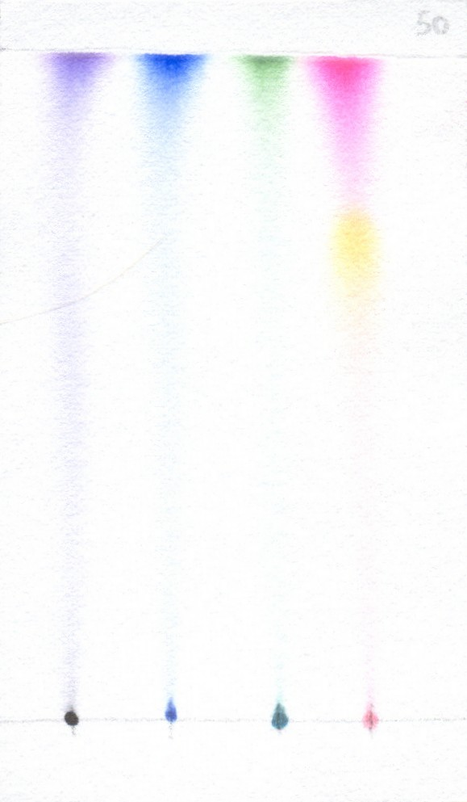
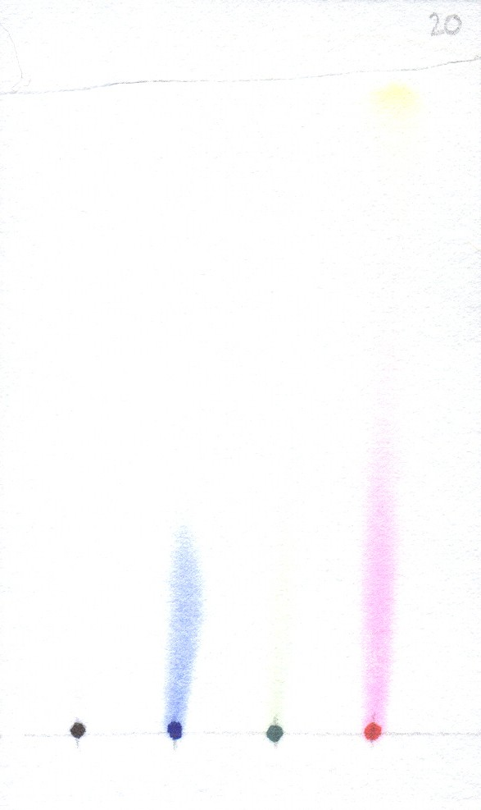
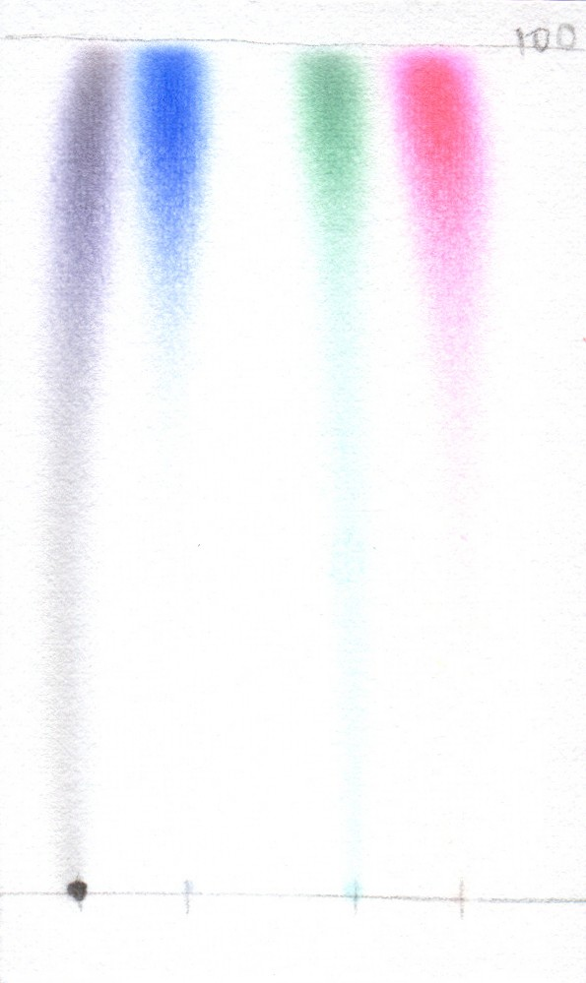

20% Isopropanol 50% Isopropanol 100% Isopropanol

Page 6

Paper Chromatography: Experiment cont.

Questions

Before Experiment

- What is isopropanol commonly used for?
- Are there any safety precautions that should be taken with isopropanol?
- What colors do you think each pen dye will have?
- Which solution do you think will separate the dyes the best?

After Experiment

- What color does each pen dye contain?
- When did each pen start to solubilize in the isopropanol?
- Why does some of the black dye not move?
- Why does the yellow dye move farther than the red dye in the 10% and 20% isopropanol solutions and the red dye move farther than the yellow dye in the 50% and 100% isopropanol solutions?
- Are the blue dyes in the blue pen and the green pen the same? How about the yellow dyes in the red pen and the green pen? How do you know?
- Which pen color would be the easiest to wash off your skin with isopropanol? Which would be the hardest to wash off? Why?

Answers

Before Experiment

- Isopropanol is a common disinfectant and skin antiseptic.
- You should not inhale, ingest, or come into contact with the isopropanol because it can be harmful in some cases. Isopropanol is flammable, do not ignite it.
- Students’ Predictions.
- Students’ Predictions.

After Experiment

- Black – purple and black, Blue – blue, Green – yellow and blue, Red – yellow and red.
- Black – 50% isopropanol, Blue – 20% isopropanol, Green – 20% isopropanol, Red – 0% isopropanol.
- Some of the black dye is not soluble in isopropanol or in water, so it cannot travel up the filter paper with the solvent.
- The yellow dye is more soluble in water than the red dye. That is why it moves in low concentrations of isopropanol. The red dye is more soluble in isopropanol than the yellow dye. That is why it moves in high concentrations of isopropanol.
- If the dyes were the same, we would expect the color to be the same and for the dyes to travel the same way in the different solutions. The blue dyes in the blue and green pens

Page 7

Paper Chromatography: Experiment cont.

are not the same. We know this because the color of blue on the chromatograms are different and because the blue dye from the blue pen starts to move up the filter paper in a
different solution than the blue dye in the green pen. The yellow dyes in the red and green pens are not the same. We know this because the yellow dye in the green pen is more soluble in isopropanol than water. The yellow dye in the red pen is less soluble in isopropanol than water. The yellow dyes are found in different positions on the chromatograms.
- The red pen would be the easiest to wash off because it is more soluble in isopropanol than the other pens. Look at the 50% isopropanol chromaotogram. There is only a little of the red left at the starting line, while there is still a lot of the other colors. The black pen would be the hardest to wash off because some of the black dye is not soluble in isopropanol. That part of the black dye would stay on your skin and not wash off with just isopropanol.

Page 8

Paper Chromatography: Alternative Experiments

Water Soluble vs. Permanent

- Purpose – to compare the solubility of different types of markers in water and isopropanol.

- Additional Materials – several water soluble markers (washable markers, felt tip pens, ink pens, and highlighters) and several permanent markers. Markers can be different colors or all the same color as long as they are different brands.

- Make the isopropanol solutions as described in the Sharpie experiment.

- Prepare the strips and spot them with the water soluble markers and permanent markers as described in the Sharpie experiment.

Develop the strips until the solvent is about 2 cm from the top of the strip.

After developing the strips, you should be able to determine which markers are water soluble and which are permanent.

Alcohol vs. Alcohol

- Purpose – to determine what alcohol separates permanent markers the best.

- Additional Materials – different types of alcohols including methanol, ethanol, propanol, isopropanol, and/or butanol. WARNING: Be very careful when working with these solvents. Some can be dangerous if not handled properly.

- Instead of using different concentrations of each alcohol, use the same concentration of each to separate the spots of permanent markers.

- Prepare the strips and spot them as described in the Sharpie experiment.

- Develop the strips until the solvent is about 2 cm from the top of the strip.

- After developing the strips, you should be able to determine if the type of alcohol used as the solvent makes a difference in separating the permanent markers.

Page 9

Paper Chromatography: Alternative Experiments cont.

Paper vs. Paper

- Purpose – to test different type of paper to compare their separation capabilities.

- Additional Materials – different types of papers including coffee filters, construction paper, notebook paper, copy paper, paper towels, typing paper, and any other type of paper you have available.

- Prepare a solution in a concentration that will separate your sample well.

- Prepare a strip from each type of paper and spot them. You can use just one marker on each strip or a variety as long as they will all separate in the solvent.

- Place the different papers in the solutions and let them develop. Depending on the size of your beakers may be able to put multiple strips in one, but make sure they are standing up and not touching one another.

- Compare the separation between the different papers to determine which separated the dyes the best.

Food Colors
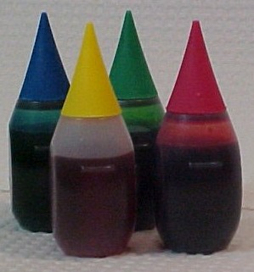
- Purpose – to determine what color of food dyes make up food colors.

- Additional Materials – food colors and capillary tubes*.

- Make the isopropanol solutions as described in the Sharpie.
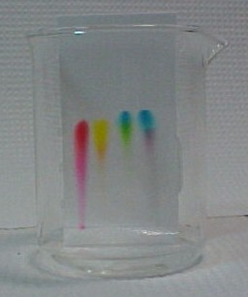

- Prepare the strips as described in the Sharpie experiment.

- Use the capillary tubes to spot the food colors onto the strips. Try and keep the spots small and spaced apart. Spot 2 or 3 times for each spot.

- Place the strips in the beakers and cover. Keep an eye on the strips, the 0% isopropanol will be done quickly (<10 minutes for an 8 cm strip).

* Further information is located on page 18 if you do not have capillary tubes. Page 10

Paper Chromatography: Alternative Experiments cont.

Flower Pigments

- Purpose – to determine the solubility of flower pigments in isopropanol.

- Additional Materials – about ¼ cup each of several different colored flower petals and/or leaves* (use bright colors, no white or pastels), mortar and pestle, Buchner funnel, filter flask with stopper, tubing, filter paper, and capillary tubes**.

- Pull the petals and/or leaves off of the plant and place in the mortar.

- Pour about 5 ml of isopropanol in the mortar.

- Grind the petals and/or leaves until the pigments have left the plant and are in the liquid.
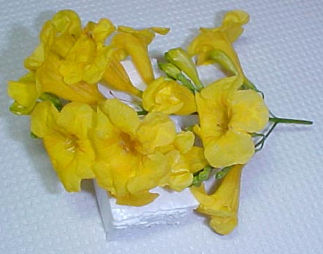
- Assemble the filter apparatus. Place the contents of the mortar into the funnel and filter the liquid out.

- Collect the colored liquid into a test tube. Discard the remaining petals and/or leaves.

- Make the isopropanol solutions and prepare the strips as described in the Sharpie experiment.

- Use the capillary tubes to spot the colored pigments onto each of the strips. Depending on the concentration of pigment in the liquid you may have to apply the sample multiple times. Allow the spot to dry each time in between spotting.

- Develop the strips as described in the Sharpie experiment.

- After developing the strips, you should be able to determine which of the pigments are water soluble and which are alcohol soluble.

Example: In our experiment we used the samples and isopropanol solutions. The pigments had to be spotted several times on the paper in order to get a dark spot.
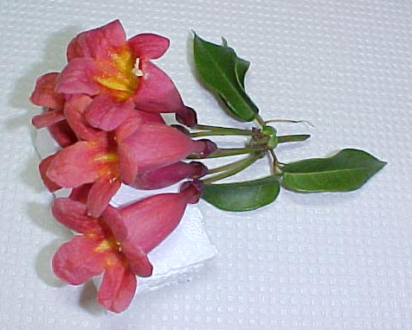
Samples:
Red Flower
Yellow Flower
Orange Flower
Green Leaves
Pink Flower

Isopropanol Solutions:
0%, 20%, 40%, 60%, 80%, 100%

* You will need to plan ahead to have time to collect the petals and/or leaves. Page 11
** Further information is located on page 18 if you do not have some of these materials.
Paper Chromatography: Alternative Experiments cont.

The pink and red flower pigments are water soluble and separated in the low-medium concentrations of isopropanol. The orange flower and green leaf pigments were not water soluble and separated in the medium concentrations of isopropanol. The yellow flower pigment was not water soluble and separated in high concentrations of isopropanol.

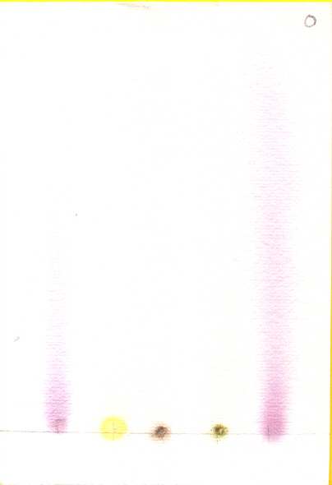
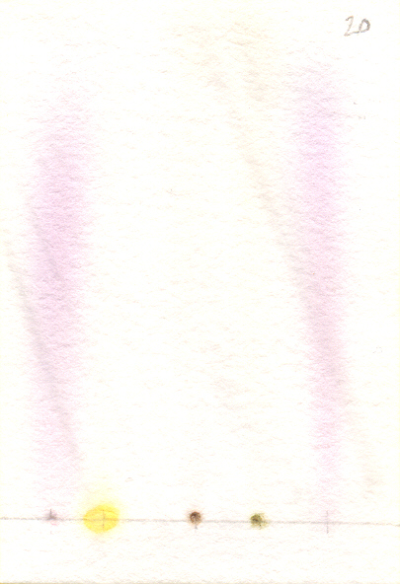
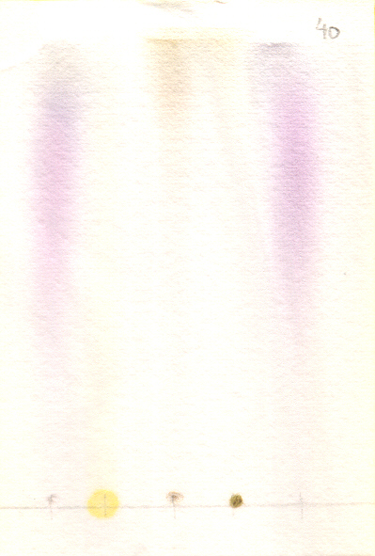

0% Isopropanol 20% Isopropanol 40% Isopropanol
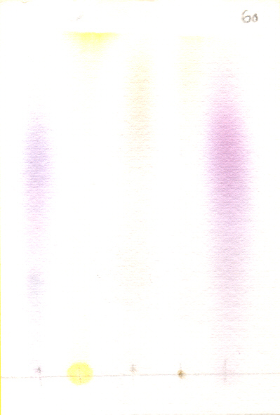
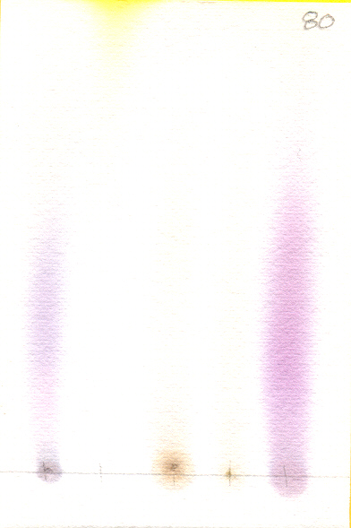
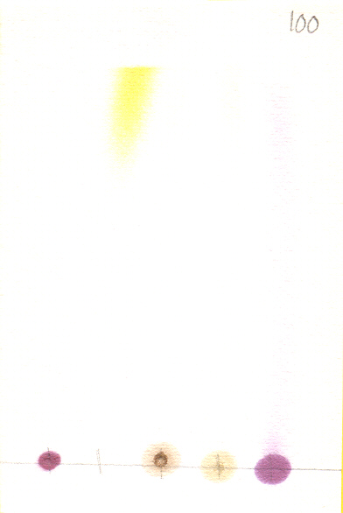

60% Isopropanol 80% Isopropanol 100% Isopropanol

Page 12

Paper Chromatography: Alternative Experiments cont.

Kool-Aid Food Dyes

- Purpose – to determine the food dyes used in different flavors of Kool-Aid drink and their solubility in water and alcohol.

- Additional Materials – several packets of different colored Kool-Aid drink, test tubes, balance, weigh paper, spatula, transfer pipettes, small vials, and capillary tubes*.

- Use the balance and weigh paper to weigh out 0.5 g of each of the Kool-Aid drink powders. Place each powder into its own test tube.

- Add 6 drops of water to each test tube. Shake the test tubes gently to help dissolve the powder. Add additional drops of water until the powder is just dissolved.

- Transfer the colored liquids to their own vial.

- Make the isopropanol solutions as described in the Sharpie experiment.

- Prepare the strips as described in the Sharpie experiment.

- Use the capillary tubes to spot the colored liquids onto the strips. Place the bulb on the capillary tubes. Allow the liquid to fill the capillary tube. Place your finger over the hole on top of the bulb and carefully dot a spot on each strip. Try to keep the spots small. Let each spot dry and repeat the spotting several times for each color.

Develop the strips until the solvent is about 2 cm from the top of the strip.

After developing the strips, you should be able to determine what food dyes are used in each Kool-Aid drink. You will also find out if food dyes are water soluble or alcohol soluble.

Example: In our experiment we used the following samples and isopropanol solutions.
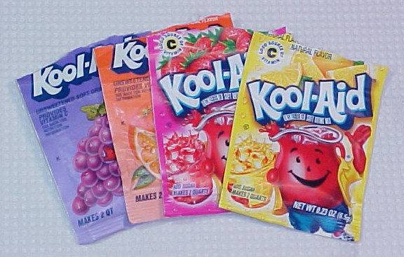
Samples:
Grape
Orange
Strawberry
Lemonade

Isopropanol Solutions:
0%, 20%, 40%, 60%, 80%, 100%

** Further information is located on page 18 if you do not have some of these materials. Page 13

Paper Chromatography: Alternative Experiments cont.

All of the food dyes in the Kool-Aid drinks were water soluble. In the lower concentrations of isopropanol, the grape drink separated into blue and red food dyes. The orange drink separated into yellow and red food dyes. The strawberry drink had only red food dye. The lemonade drink had only yellow food dye.



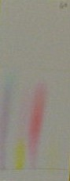
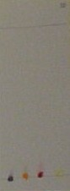
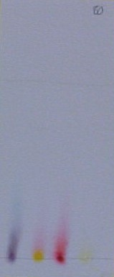

0% Isopropanol 20% Isopropanol 40% Isopropanol 60% Isopropanol 80% Isopropanol 100% Isopropanol

Mystery Sample

- Purpose – to have the students identify an unknown sample by comparing it to their known samples.

- This can be done with any of the experiments.

- Before giving the filter strips to the students, spot one of the samples on the starting line and do not tell them which one it is. Have them spot their known samples next to this mystery spot.

- Develop the strips.

- Ask the students to compare the mystery spot to their known spots and determine which sample it was.

- For an added challenge you can make the mystery spot a combination of two known samples.

Page 14

Paper Chromatography: Hints, Tips, and Extras

Safety Warnings

- Isopropanol
  - While isopropanol is a common household item, it is flammable and can be harmful. Do not inhale, ingest, or allow the isopropanol to come into contact with your body or clothes. If any of these occur, follow these treatment procedures:
    - Inhalation – move the person to fresh air and observe for coughing, shortness of breath and irritation of throat and eyes. Contact your local Poison Control Center if symptoms persist.
    - Ingestion – Do Not Induce Vomiting! Contact your local Poison Control Center immediately and observe the poisoned person for symptoms of initial confusion and inebriation, followed by severe abdominal pain, vomiting, visual changes, headache, and weakness.
    - Body/Clothing Exposure – remove clothes or contact lenses and rinse with water for a minimum of 30 minutes. If visual changes, pain, and/or swelling appear and persist after the rinsing, contact the appropriate local health care facility.
  - National Poison Control Hotline – 1-800-222-1222

- Permanent Markers
- Appropriate use of permanent markers, such as in this experiment, is not harmful. Abuse of permanent markers, such as sniffing them, is very harmful.
- The adverse effects caused by sniffing (permanent brain damage, respiratory problems, organ damage, increased heart rate, loss of muscle control, disorientation, acting inebriated) can happen very quickly and are very dangerous.
- Sniffing inhalants (such as permanent markers, correction fluid, finger nail polish remover, paint, cleaning solvents, etc.) can kill people the first time they do it.
- National Drug Information and Treatment Hotline – 1-800-662-4357

Page 15

Paper Chromatography: Hints, Tips, and Extras cont.

Presenting Ideas

- If you are doing this experiment just as a demonstration:
    - Label all of the beakers
    - Prepare and pour solutions into their beakers
    - Cut filter paper strips
    - Spot the samples
    - Let the students observe the strips develop and discuss the results

      - If you want to have the students do this experiment, but need to keep it simple:
          - Label all of the beakers
    - Cut filter paper strips
          - Let the students make the solutions with the tables provided
          - Let the students spot the samples
    - Let the students observe the strips develop and discuss the results
    - Have the students answer some questions about the experiment

            - To expand on the experiment:
                - Have the students design their own experiment from the Alternative Experiments ideas or their own ideas
                - Have the students label all of the beakers
                - Have the students make the solutions that will be appropriate for their experiment
                - Have the students cut their strips
                - Have the students spot their samples
                - Have the students develop the strips
                - Have the students discuss the results
                - Have the students prepare a laboratory report including the steps of the Scientific Method

Page 16

Paper Chromatography: Hints, Tips, and Extras cont.

Chromatography Roll

If you have numerous samples that need to be put into one solution and you are using a large beaker, then you can put the samples on one piece of filter paper instead of several strips.

- Cut a large rectangle, draw the start line and spot the samples
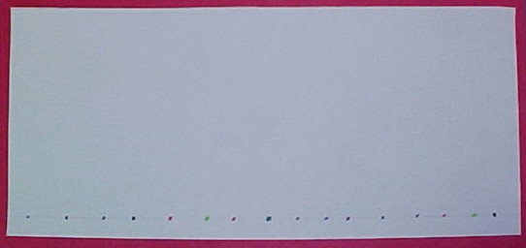

- Roll the strip and staple the edges (make sure the edges do not touch)

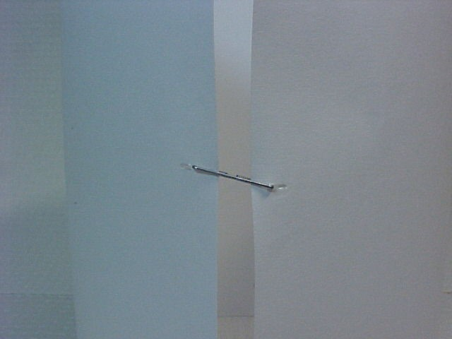
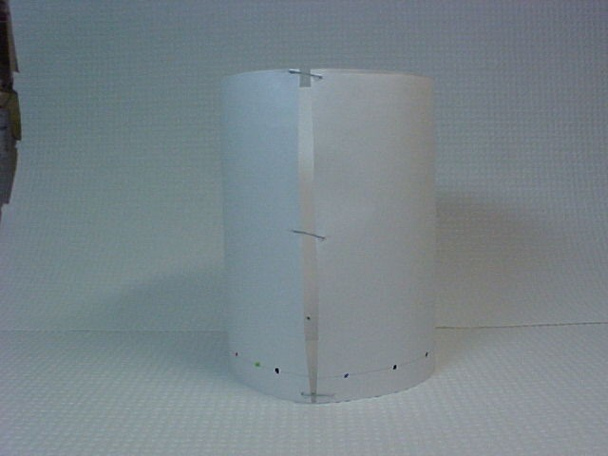

- Place the roll in the solution and develop the strip as described in the Sharpie experiment.
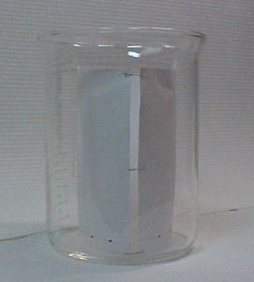

- If the strip is not strong enough to hold itself up as the solution travels up it, you may need to support it by taping it to a pencil laying across the top of the beaker or taping it to the sides of the beaker

- If the strip is not strong enough to dry in a standing position, carefully remove the staples and lay it flat on a paper towel

Page 17

Paper Chromatography: Hints, Tips, and Extras cont.

Materials

If you do not have some of the materials listed in the experiments, you can purchase them from the following vendors or use the substitutes listed instead.
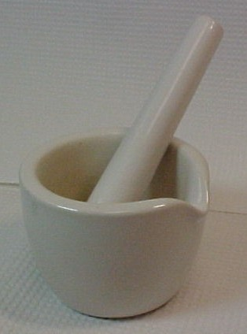
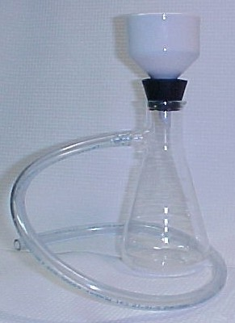
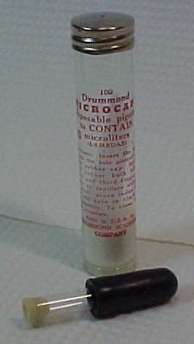
Mortar and Pestle
Buchner Funnel with Filter Flask, Stopper, and Tubing
Capillary Tubes with Bulb

Capillary Tubes
- Purchase:
  - Fisher Scientific (https://www1.fishersci.com/index.jsp)
    - Click on Catalogs at the top of the page > Fisher Catalog > ‘P’ > Pipets > Disposable Pipets > Disposable Microcapillary Pipets > Drummond Short-Length Microcaps Micropipets > 10μl size.
  - Substitute:
    - You can substitute toothpicks for capillary tubes. Dip the toothpick into the sample and then spot it onto the filter paper strips. Be careful not to spot a drop of sample onto the strips, that will cause a spot too large. You will need to repeat spotting for each sample multiple times.

Buchner Funnel
- Purchase:
- Mountain Home Biologicals (http://www.pelletlab.com)
  - Click on Lab Supplies > Plastic Labware.
- A.A. Pesce Glass Company (https://pesceglass.com)
  - Click on Filters.
- All World Scientific (http://www.awscientific.com)
  - Click on Store > Filtration thru Goggles > Funnels.
- EBay (http://www.ebay.com)
  - Type Buchner Funnel into the search box and click Search.
- Carolina Biologicals (http://carolina.com)
  - Place cursor over Product Catalog > Browse > Lab Equipment Supplies, and Furniture > Funnels > Buchner.
- Substitute:
- You can use any filter system available. You just need to get the liquid separated from the petals/leaves. A piece of filter paper formed into a cone and placed over a beaker or flask would be sufficient.

Page 18

Paper Chromatography: Hints, Tips, and Extras cont.

Filter Flask
- Purchase:
- Labwarehouse.com (http://www.labwarehouse.com)
  - Click on Lab Glass and Vessels.
- All World Scientific (http://www.awscientific.com)
  - Click on Store > Filtration thru Goggles > Flasks.
- EBay (http://www.ebay.com)
  - Type Filter Flask into the search box and click Search.
- Carolina Biologicals (http://carolina.com)
  - Place cursor over Product Catalog > Browse > Lab Equipment, Supplies, and Furniture > Flasks > Glass.
- Substitute:
- You can use any flask or beaker that you can place your funnel in. It does not have to be a vacuum system, gravity will pull the liquid through.

Mortar and Pestle
- Purchase:
- Labwarehouse.com (http://www.labwarehouse.com)
  - Click on Lab Glass and Vessels.
- Carolina Biologicals (http://carolina.com)
  - Place cursor over Product Catalog > Browse > Lab Equipment, Supplies, and Furniture > Mortar and Pestles.
- EBay (http://www.ebay.com)
  - Type Mortar and Pestle into the search box and click Search.
- Substitute:
- You can use anything that will allow you to grind the petals/leaves in your solvent without putting contaminants into your samples. A glass stirring rod and an old coffee mug or test tube would work.

Page 19

