Activity 1-Information Coding

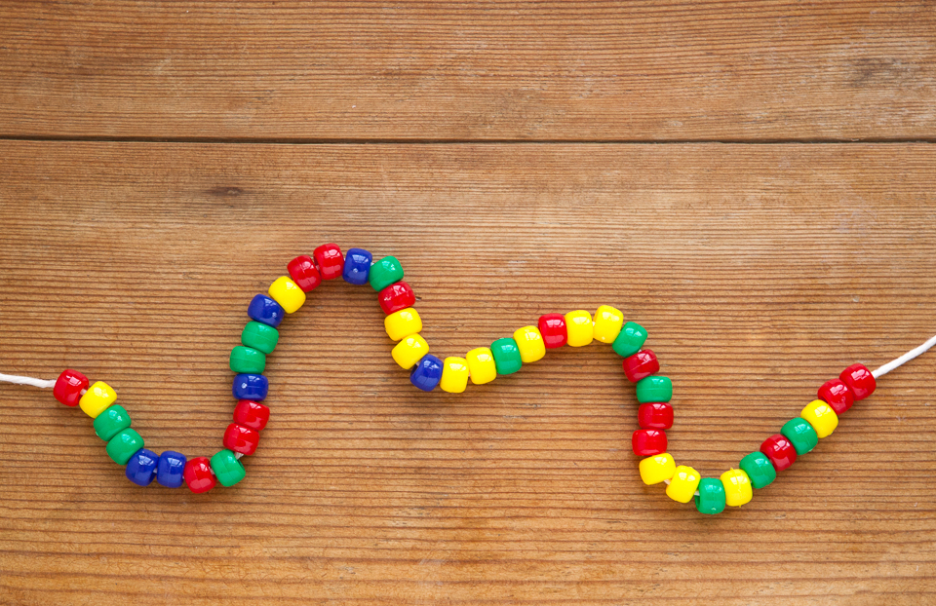
Teacher Instructions

This activity is designed to help students understand how the genetic code allows many different types of proteins to be created.

This activity is from: https://www.exploratorium.edu/snacks/secret-codon

Objective
After this activity, students should be able to:
- Model the process of DNA coding for amino acid structure

Materials:
- Pony beads in four different colors
- Cotton string
- Amino acid codon table

Procedure:

Assign each pony bead color to one of the four DNA bases – adenine (A), thymine (T), cytosine (C), and guanine (G). The string pictured above uses this color key:
A: red
T: yellow
C: blue
G: green

Instruct the students to think of a word or short phrase that they want to encode into their DNA strand. Tell them to make sure it can be spelled or sounded out without using the letters B, J, O, U, X, or Z. These letters are not abbreviations for any of the amino acids. They should determine what amino acids the letters in their phrase correspond to by looking up the one-letter amino acid abbreviations in the amino acid codon table. Then, they should use the table to write down the DNA sequence that encodes for those amino acids. All proteins start with a methionine amino acid residue that is encoded by the DNA sequence ATG. They end when the DNA encodes one of the three stop codons. So to be realistic, they should add ATG to the beginning of their sequence, and pick one of the three stop codons for the end of their sequence. Instruct them to make their DNA strand by stringing the beads so that the colors match the order of the DNA sequence that they wrote down. Don’t forget that they should include the proper start and stop codons in their sequence. Have them trade strands with another student or group and see if they can decode each other’s secret message!

Original work is licensed under a Creative Commons Attribution-NonCommercial-ShareAlike 4.0 International License.
Attribution: Exploratorium Teacher Institute

Name: ____________________________________________Date: _______________
Activity 1 – Secret Codon
Write a Message in DNA!

Activity found at: https://www.exploratorium.edu/snacks/secret-codon

DNA is referred to as the genetic code for life, because it contains information about which amino acids join together to create different proteins. You can use the one-letter abbreviations for amino acids to make a secret message that will give new meaning to the description of DNA as beads on a string.

Materials:
- Pony beads in four different colors
- Cotton string
- Amino acid codon table (available below or at this link)

Procedure:

Assign each pony bead color to one of the four DNA bases – adenine (A), thymine (T), cytosine (C), and guanine (G). The string pictured above uses this color key:
A: red
T: yellow
C: blue
G: green

Think of a word or short phrase that you want to encode into your DNA strand. Make sure it can be spelled or sounded out without using the letters B, J, O, U, X, or Z. These letters are not abbreviations for any of the amino acids. There are only 20 amino acids that are coded for, so six alphabet letters are not used. Determine what amino acids the letters in your phrase correspond to by looking up the one-letter amino acid abbreviations in the amino acid codon table. Then, use the table to write down the DNA sequence that encodes for those amino acids. All proteins start with a methionine amino acid residue that is encoded by the DNA sequence ATG. They end when the DNA encodes one of the three stop codons. Add ATG to the beginning of your sequence, and pick one of the three stop codons for the end of your sequence. Make your DNA strand by stringing the beads so that the colors match the order of the DNA sequence that you wrote down. Don’t forget to include the proper start and stop codons in your sequence. Trade strands with a friend and see if you can decode each other’s secret message!

Amino Acid Codon Table from: https://www.exploratorium.edu/sites/default/files/snacks/SecretCodonTable.gif

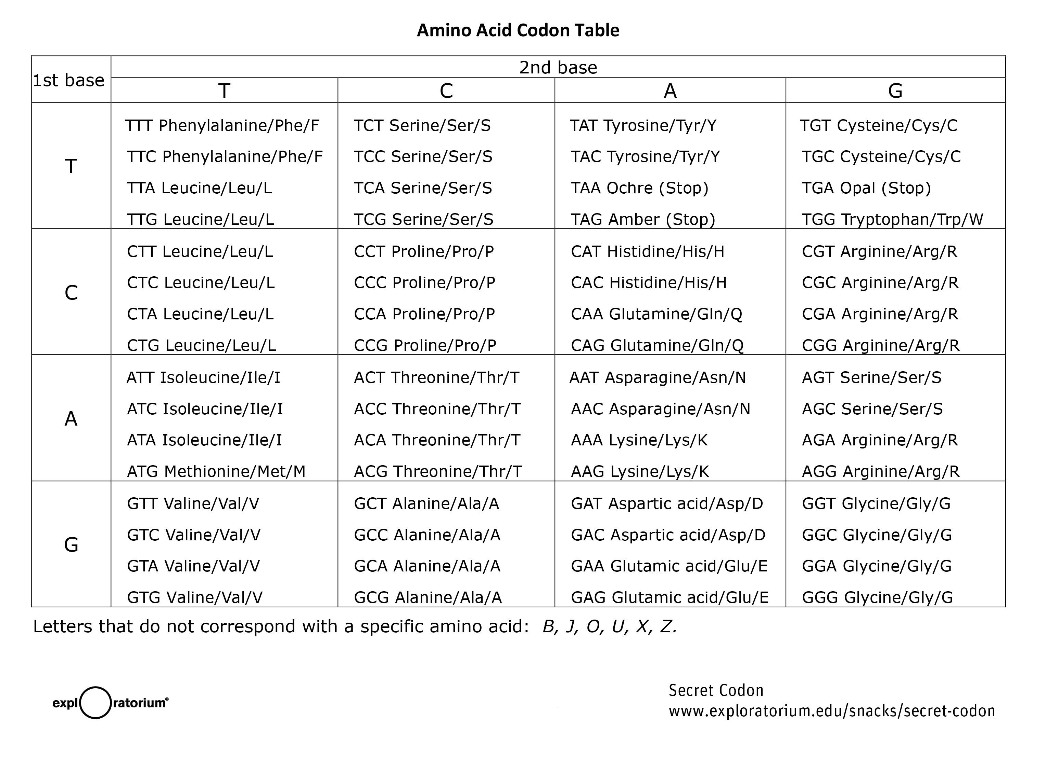

What’s Going On?

Proteins are long chains of individual amino acid subunits. The order of the amino acids in the chain is determined by the DNA sequence of the gene that encodes for it. This is commonly referred to as the genetic code.

DNA is a chain of four different nucleotides (adenine, thymine, cytosine, and guanine), often abbreviated A, T, C, and G. These four nucleotides (sometimes referred to as bases) give the instructions for the 20 different amino acids that compose proteins. Each amino acid is encoded by a sequence of three DNA bases, called a codon. Since it takes three DNA bases to designate an amino acid, there are enough combinations of the four different bases to represent all of the amino acids, as well as three stop codons that indicate when the protein ends. Each base can be in any position, which yields 43, or 64, possible combinations, so there is some redundancy between the 20 amino acids. This just means that a given amino acid can be encoded by more than one DNA codon sequence.

For simplicity, individual amino acids are often abbreviated using one or three letter abbreviations. For example, the amino acid arginine can be abbreviated Arg or R. The single-letter amino acid abbreviations provide a fun way to write secret messages using the genetic code. Since there are only 20 different amino acids, there are 6 letters of the alphabet that don’t stand for a specific amino acid. With the 20 letters that do, however, you can use the genetic code to determine the DNA sequence that corresponds to your amino acid message.

This work is licensed under a Creative Commons Attribution-NonCommercial-ShareAlike 4.0 International License.
Attribution: Exploratorium Teacher Institute

Activity 2-Cereal Translation

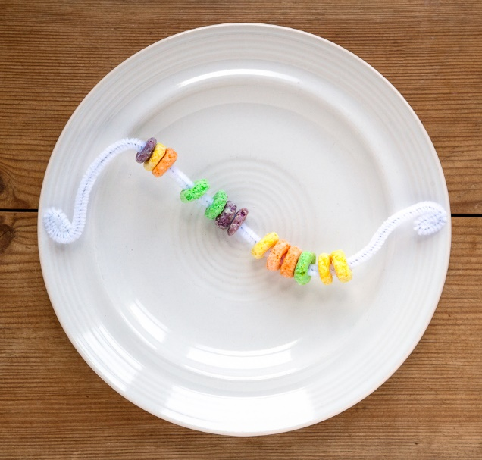
Teacher Instructions
This activity is designed to help students understand the process of translation and how mistakes in translation can occur.
This activity is from: https://www.exploratorium.edu/snacks/breakfast-proteins

Objective
After this activity, students should be able to:
- Understand and model the process of translation

Materials:
- Colored, donut-shaped cereal such as Froot Loops or Fruity Cheerios
- Cups
- Chenille stems
- String
- Pencils
- Paper

Teacher Preparation:
1. Make up a template for the cereal chain using single letters to correspond to different colors of cereal—for example, yellow, orange, purple, purple, red, red, green, yellow, yellow, orange, purple would be YOPPRRGYYOP. Write the template on a piece of paper.
2. Tape your template down on a table in the corner of the room so no one can remove the template. Place some string on the floor near the table to section off the area.
3. Arrange paper and pencils next to the template.
4. Place a cup of cereal and some chenille stems in the main part of the room.

To Instruct the Class:

1. Tell students that the instructions to make their cereal chain are in the corner of the room. Since the template is taped down, they can use the paper and pencils to help them remember the order.

2. Direct students to construct their cereal chains in the main part of the room using the cereal and chenille stems.

3. Compare the finished cereal chains. Is everyone’s the same?

Explanation:
The process of making the cereal chains models the process of how proteins are made in a cell. The initial template represents a single copy of DNA that sits in the nucleus of a cell and gives instructions for how proteins are made. In order to get this information to an area where proteins can be made, it must be copied into RNA. RNA is very similar to DNA, but has a different form: this is represented by the handwritten notes.
The copying process is called transcription. Just like in a cell, a single DNA template gave rise to many RNA transcripts. In a cell, these transcripts move from the nucleus of the cell into the cytoplasm. The string you used to section off your instruction table represents the nuclear membrane that holds the DNA in the nucleus of a cell.
In the cytoplasm, a process called translation occurs: ribosomes use the RNA transcripts to assemble proteins from amino acid subunits. In cells, the genetic code dictates which amino acid residues correspond to a given DNA sequence. In the cereal chain, the letters in the instructions correspond to the color of the cereal.

Going Further
How did the different cereal chains compare? It’s likely that most were identical, since they were all generated from the same initial instructions. However, sometimes a difference can arise due to an error in copying or an error in making the chain. This part of the model extends to what happens in cells where there are also sometimes errors in transcription or translation.
The cereal chain represents a model of a string of amino acids. In a cell, this amino acid chain would then be folded into a three-dimensional protein. This folding can be modeled with simple rules like “yellow always links to yellow” or “orange avoids green” to give an idea of how chemical rules such as disulfide bridges and hydrophobic interactions dictate the final form of a protein.

This work is licensed under a Creative Commons Attribution-NonCommercial-ShareAlike 4.0 International License.
Attribution: Exploratorium Teacher Institute

Activity 3 – Cartoon Coding and Translation

Teacher Instructions:
From:
Activity Sheet:
https://www.amoebasisters.com/uploads/2/1/9/0/21902384/dna_vs_rna_and_protein_synthesis_updated_recap_by_amoeba_sisters.pdf
Protein Synthesis Video: https://www.youtube.com/watch?v=oefAI2x2CQM&index=29&list=PLwL0Myd7Dk1F0iQPGrjehze3eDpco1eVz
DNA vs RNA Video:
https://www.youtube.com/watch?v=JQByjprj_mA&list=PLwL0Myd7Dk1F0iQPGrjehze3eDpco1eVz&index=43

In this activity, students will watch two animated videos on DNA vs. RNA and Protein Synthesis. They will them complete an activity sheet summarizing the videos.

Objective:
-Explain the difference between DNA and RNA
- Understand the process of protein synthesis

Materials:
Computer or device access for video viewing
Activity Sheet

Procedure:
Instruct students to watch the above linked videos by Amoeba Sisters. This could be done individually, in groups, or as a class.
Have students complete the activity sheet as they watch the videos.

Activity 4 – Elephant DNA CSI

Teacher Instructions:
From:
Howard Hughes Medical Institute Biointeractive
https://www.biointeractive.org/classroom-resources/csi-wildlife

This activity is a more advanced activity that would be appropriate for Pre AP science and Biology. It requires a significant amount of reading, analyzing, and reasoning. It uses a real-life scenario of elephant poaching to engage the students in learning about DNA and amino acid sequencing. Real data is used. It is a completely interactive, engaging activity. There are detailed teacher instructions, including a video for teachers. There are many interactive activities on this site that are appropriate for middle school and high school science.

From the website:
This interactive module allows students to use DNA profiling and related biological concepts to solve two cases of elephant poaching.
This Click & Learn combines elephants, species conservation, and forensics to teach key biological concepts and science practices. Students explore actual cases, adapted for use in the classroom, in which scientists use DNA profiling to investigate the elephant poaching that supplies the ivory trade. In the process, students learn about genetic markers, PCR, gel electrophoresis, allele frequencies, and population genetics.
The Click & Learn has three associated worksheets:
- “Student Worksheet One (Analyzing Genetic Evidence)” walks students through all sections of the Click & Learn, except for the "Frequency Primer" section. This worksheet can serve as a record of completion, as well as a reference for key concepts.
- “Student Worksheet Two (Using Genetics to Hunt Elephant Poachers)” provides additional data sets that students will use to solve several new cases. This worksheet is more of an extension activity in which students apply what they learned from the Click & Learn. It requires students to think scientifically, use math appropriately, and apply claim-evidence-reasoning to support their thinking.
- The “Student Supplement (Frequency Primer)” scaffolds the "Frequency Primer" section at the end of Case One and provides additional practice with probability calculations. It may be helpful for students who are new to frequency and probability calculations.
The “Resource Google Folder” link directs to a Google Drive folder of resource documents in the Google Docs format. Not all downloadable documents for the resource may be available in this format. The Google Drive folder is set as “View Only”; to save a copy of a document in this folder to your Google Drive, open that document, then select File → “Make a copy.” These documents can be copied, modified, and distributed online following the Terms of Use listed in the “Details” section of the webpage, including crediting BioInteractive.

Objective:
- Analyze and interpret gel electrophoresis results to determine relationships between individuals and populations.
- Use allele frequencies to calculate the probability of two individuals sharing the same genetic profile.
- Explain how the geographic and genetic distances between two populations are related.
- Explain how genetic data helps law enforcement officers and conservationists decide where to target their efforts.

Materials:
Downloadable from website: https://www.biointeractive.org/classroom-resources/csi-wildlife
Educator Materials PDF
Student Worksheet One PDF
Student Worksheet Two PDF
Student Supplement
Computer with App downloaded from above website

Activity 5-Squishy Strawberry Science

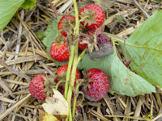
Teacher Instructions

Taken directly from: https://www.scientificamerican.com/article/squishy-science-extract-dna-from-smashed-strawberries/
Produced by Science Buddies at Scientific American

Objective
After this activity, students should be able to:
- Identify and Extract DNA from strawberries using common household materials

Materials:
- Rubbing alcohol
- Measuring cup
- Measuring spoons
- Salt
- Water
- Dishwashing liquid (for hand-washing dishes)
- Glass or small bowl
- Cheesecloth
- Funnel
- Tall drinking glass
- Three strawberries
- Resealable plastic sandwich bag
- Small glass jar (such as a spice or baby food jar)
- Bamboo skewer, available at most grocery stores. (If you use a baby food or short spice jar, you could substitute a toothpick for the skewer.)

Teacher Preparation
- Chill the rubbing alcohol in the freezer. It must be ice cold for this procedure to work.
- Mix one half teaspoon of salt, one third cup of water and one tablespoon of dishwashing liquid in a glass or small bowl. Set the mixture aside. This is your extraction liquid. Why do you think there is detergent in the extraction liquid?
- Completely line the funnel with cheesecloth. Insert the funnel tube into the tall drinking glass (not the glass with the extraction liquid in it).
- Remove and discard the green tops from the strawberries.

Student procedure found in following student worksheet.

Name: ____________________________________________Date: _______________
Activity 5 – Squishy Strawberry Science

Taken directly from: https://www.scientificamerican.com/article/squishy-science-extract-dna-from-smashed-strawberries/
Produced by Science Buddies

Key concepts
DNA
Genome
Genes
Extraction
Laboratory techniques

Introduction
Have you ever wondered how scientists extract DNA from an organism? All living organisms have DNA, which is short for deoxyribonucleic acid; it is basically the blueprint for everything that happens inside an organism’s cells. Overall, DNA tells an organism how to develop and function, and is so important that this complex compound is found in virtually every one of its cells. In this activity you’ll make your own DNA extraction kit from household chemicals and use it to separate DNA from strawberries.
Background
Whether you’re a human, rat, tomato or bacterium, each of your cells will have DNA inside of it (with some rare exceptions, such as mature red blood cells in humans). Each cell has an entire copy of the same set of instructions, and this set is called the genome. Scientists study DNA for many reasons: They can figure out how the instructions stored in DNA help your body to function properly. They can use DNA to make new medicines or genetically modify crops to be resistant to insects. They can solve who is a suspect of a crime, and can even use ancient DNA to reconstruct evolutionary histories!
To get the DNA from a cell, scientists typically rely on one of many DNA extraction kits available from biotechnology companies. During a DNA extraction, a detergent will cause the cell to pop open, or lyse, so that the DNA is released into solution. Then alcohol added to the solution causes the DNA to precipitate out. In this activity, strawberries will be used because each strawberry cell has eight copies of the genome, giving them a lot of DNA per cell. (Most organisms only have one genome copy per cell.)

Materials:

- Rubbing alcohol
- Measuring cup
- Measuring spoons
- Salt
- Water
- Dishwashing liquid (for hand-washing dishes)
- Glass or small bowl
- Cheesecloth
- Funnel
- Tall drinking glass
- Three strawberries
- Resealable plastic sandwich bag
- Small glass jar (such as a spice or baby food jar)
- Bamboo skewer, available at most grocery stores. (If you use a baby food or short spice jar, you could substitute a toothpick for the skewer.)

Procedure:
- Put the strawberries into a resealable plastic sandwich bag and push out all of the extra air. Seal the bag tightly.
- With your fingers, squeeze and smash the strawberries for two minutes. How do the smashed strawberries look?

- Add three tablespoons of the extraction liquid you prepared to the strawberries in the bag. Push out all of the extra air and reseal the bag. How do you think the detergent and salt will affect the strawberry cells?

- Squeeze the strawberry mixture with your fingers for one minute. How do the smashed strawberries look now?

- Pour the strawberry mixture from the bag into the funnel. Let it drip through the cheesecloth and into the tall glass until there is very little liquid left in the funnel (only wet pulp remains). How does the filtered strawberry liquid look?

- Pour the filtered strawberry liquid from the tall glass into the small glass jar so that the jar is one quarter full.
- Measure out one half cup of cold rubbing alcohol.
- Tilt the jar and very slowly pour the alcohol down its side. Pour until the alcohol has formed approximately a one-inch-deep layer on top of the strawberry liquid. You may not need all of the one half cup of alcohol to form the one-inch layer. Do not let the strawberry liquid and alcohol mix.
- Study the mixture inside of the jar. The strawberry DNA will appear as gooey clear/white stringy stuff. Do you see anything in the jar that might be strawberry DNA? If so, where in the jar is it?

- Dip the bamboo skewer into the jar where the strawberry liquid and alcohol layers meet and then pull up the skewer. Did you see anything stick to the skewer that might be DNA? Can you spool any DNA onto the skewer?

- Extra: You can try using this DNA extraction activity on lots of other things. Grab some oatmeal or kiwis from the kitchen and try it again! Which foods give you the most DNA?
- Extra: If you have access to a milligram scale (called a balance), you can measure how much DNA you get (called a yield). Just weigh your clean bamboo skewer and then weigh the skewer again after you have used it to fish out as much DNA as you could from your strawberry DNA extraction. Subtract the initial weight of the skewer from its weight with the DNA to get your final yield of DNA. What was the weight of your DNA yield?

- Extra: Try to tweak different variables in this activity to see how you could change your strawberry DNA yield. For example, you could try starting with different amounts of strawberries, using different detergents or different DNA sources (such as oatmeal or kiwis). Which conditions give you the best DNA yield?

Observations and results
Were you able to see DNA in the small jar when you added the cold rubbing alcohol? Was the DNA mostly in the layer with the alcohol and between the layers of alcohol and strawberry liquid?

When you added the salt and detergent mixture to the smashed strawberries, the detergent helped lyse (pop open) the strawberry cells, releasing the DNA into solution, whereas the salt helped create an environment where the different DNA strands could gather and clump, making it easier for you to see them. (When you added the salt and detergent mixture, you probably mostly just saw more bubbles form in the bag because of the detergent.) After you added the cold rubbing alcohol to the filtered strawberry liquid, the alcohol should have precipitated the DNA out of the liquid while the rest of the liquid remained in solution. You should have seen the white/clear gooey DNA strands in the alcohol layer as well as between the two layers. A single strand of DNA is extremely tiny, too tiny to see with the naked eye, but because the DNA clumped in this activity you were able to see just how much of it three strawberries have when all of their octoploid cells are combined! (“Octoploid” means they have eight genomes.)

