Physical hazards are environmental hazards which are not chemicals or elements or organisms, but those that you could feel or hear, i.e. those that can be detected by our senses such as temperature.
Environmental temperature can cause serious health effects by increasing or decreasing the body temperature. The body temperature increases when we are in a hot environment such as hot tub and decreases when we are in a cold environment such as a mountain slope.
Following are the factors that increases or decreases body heat.:
Heat Balance Equation
S = M + W + R + C + K + E
S is the change of temperature in the body (loss or gain).
M is the heat gained due to the metabolic process in the body (as a byproduct of metabolism).
W is the heat gained from external work such as physical activity, which leads to contraction of muscles, producing heat.
R is the radiant heat exchange rate (if outdoors – taking in warmth from sun, if indoors then no heat taken in).
C is the loss of heat due to wind velocity.
K is the conductive heat exchange rate (If in a hot tub – conduct heat from warm water, if fall into the sea – lose heat from the body due to cold environment)
E is the rate of evaporative heat loss (amount of heat lost during jogging)
The Exposure Table
Environment | Source | Health Effects
Hot Environment | Hot tub, Summer, | Heat stroke, Heat exhaustion, Dehydration (loss of fluid in the body), Heat syncope (sudden loss of consciousness related to dehydration), Heat cramps, Heat rash (prickly heat)
Cold Environment | Hill station, diving in sea, winter | Reduced blood flow to skin, Shivering, Frostbite, Raynaud’s Phenomenon (occurs in individuals sensitive to cold environment - skin turns white and often painful. It is a reversible phenomenon, Hypothermia (body temperature becomes low - this can occur at less than 50⁰ F)
Would you rather be in an extremely cold or hot environment?

Noise & Vibration
We are constantly exposed to noise of varying degree in our day to day life. Exposure to noise could lead to serious health effects such as hearing loss.
Vibration is the back-and-forth, side-to-side, and up-and-down motion of the body that starts from and returns to the same reference position. Exposure to vibration motion could occur at an occupational setting or during a pleasure trip in ship or car.
The Exposure Table
Hazard | Source | Type | Properties | Health Effects
Noise | Loud noise- diesel engine room, chain saw, jet flyover, live rock and roll band, farm tractor.  Moderately loud - passenger car, auto traffic near freeway, air conditioning unit, dishwasher, living room music, television, vacuum cleaner.  Quiet noise - Rustling leaves, normal conversation | Acute - a loud noise  Chronic - long term exposure to hazardous noise level. | Frequency - How often.  Intensity - how loud.  Duration - how long each time. | Annoyance, distraction, interference with oral, communication, cardiovascular disease, hearing loss.
Vibration | WBV - traveling in car, truck, ship, or aero plane, vibration of the building during construction, farming.  HAV - Using chain saw, brush cutter | WBV (whole body vibration) - The vibration is transferred to the entire body.  HAV (hands-arm vibration) - affects only a part of the body. | Frequency -  Low - traveling in a ship.  High - | Performance degradation, tiring, reduced comfort, low back pain, HAVs – causes blanching of fingers, numbness, and tingling sensation on fingers

Radio nuclides are materials, which produce radiation, such as X-rays, gamma rays, alpha particles and beta particles.
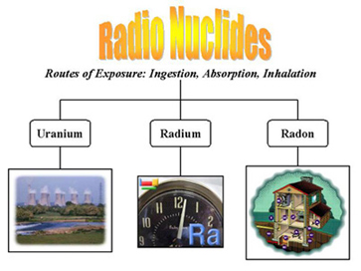
Depending on the level of exposure, radiation can produce adverse health effects. It can adversely affect individuals who are directly exposed as well as the children. Listed below are three radio nuclides, their source, the route of their entry into our body, and the health effects that they produce after they enter our body. To learn more about radio nuclides click on the link below.
Radio Nuclide | Source | Route of Exposure | Health Effects
Uranium | Underground uranium mining, sea water. X-ray targets, nuclear explosion. | Inhalation, ingestion | Acute Effects - burns, loss of hair, nausea, loss of fertility.  Chronic Effects - shortness of breath, cancer of the mouth region, pharynx, and larynx or leukemia, physical deformities, and mental retardation in children of exposed parents.
Radon | Basements of buildings and houses, sump holes, cracks in foundations and concrete floors, ground water( deep well). | Inhalation, ingestion | Lung cancer
Radium | Radium forms when isotopes of uranium or thorium decay in the environment. It is in virtually all rocks, soil, and water at low levels. | Ingestion, inhalation | Lymphoma, bone cancer, leukemia and aplastic anemia

Source: http://www.epa.gov/radiation/radionuclides/

Metals are the oldest toxin known to man. They are present in the rocks and ores. Rain water dissolves them and distributes them in the environment. We get exposed to them because we use them for various purposes.
Health effects due to exposure to metals could range from skin lesions to cancer. Metals can be classified into four different groups.
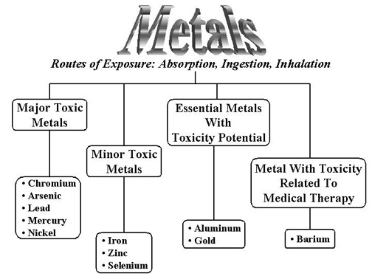

Major Toxic Metals
These are the most toxic metals, which produce multiple health effects in us. Listed below are the more important major toxic metals.
Metals | Source of Exposure | Health Effects
Chromium | Combustion of coal and crude oil, cement manufacturing, tanning industry, toner of copying machine. | Acute Effects - Dypsnea, coughing, and wheezing, skin burns, Nausea, vomiting, diarrhea.  Chronic Effects - Bronchitis, pneumonia, asthma, nasal itching and soreness, human carcinogen
Arsenic | Volcanoes, contaminated drinking water ( leaching from soil), defoliant, was used as an insecticide, and herbicides. | Acute Effects - nausea, diarrhea, abdominal pain, headache.  Chronic Effects - irritation of the skin, dermatitis, skin lesion - hyper pigmentation, and Blackfoot disease (necrosis and gangrene). Inhalation causes lung cancer, ingestion causes skin, bladder and liver cancer.
Lead | Leaded gasoline, food and soil, toys, battery manufacturing plants | Acute Effects - headache, dizziness, gastrointestinal symptoms, Death at high level of exposure.  Chronic Effects - anemia in children, behavioral and learning disabilities, spontaneous abortion in pregnant women, low birth weight, hyperactive, cancer-causing agent.
Mercury | Freshwater fish caught from contaminated waters, dental filling, fluorescent lights, and thermometers, | tremors, inability to walk, convulsions, and even death at high doses, emotional changes, delayed onset of walking and talking in children.
Nickel | Food, nickel containing jewelry, cooking utensils, stainless steel kitchens, and clothing fasteners, spark plugs, batteries. | Acute Effects - Headache, vertigo, nausea, vomiting, insomnia, and irritability  Chronic Effects - lung and nasal cancers

Essential Metals With Toxicity Potential
These are the metals which we need for our growth and development, but become toxic when taken more than what is required.
Metals | Source of Exposure | Health Effects
Iron | Mine, iron and steel workplace, during medical use. | Acute Effects - Vomiting, and ulceration of GIT, liver damage and renal failure.  Chronic - diabetes mellitus, affects liver functions and cardiovascular effects.
Zinc | Foodstuff, water, and air, galvanized cans and utensils, and plastic pipes, higher amount in seafood, meat, whole grains, dairy products, and nuts. | Gastrointestinal distress and diarrhea, Inhalation could cause fever,
Selenium | Food, drinking water, metal industries, selenium-recovery processes, plastics, paints, enamels, inks, and rubber, antidandruff shampoos. | Acute Effects - irritation of the mucous membranes of lungs, pulmonary edema, severe bronchitis, and bronchial pneumonia. irritation of the mucous membranes of nose and throat, producing coughing, and nosebleeds, indigestion and nausea, headaches, dizziness, and irritation of the eyes, nausea, vomiting, diarrhea, aches, irritability, chills, and tremors.  Chronic Effects - discoloration of the skin, deformation and loss of nails, loss of hair, excessive tooth decay and discoloration, and lack of mental alertness.

Metals with Toxicity Related to Medical Therapy
These are the metals which are used to treat a number of human ills, but they produce toxic effects when they accumulate in the body.
Metals | Source of Exposure | Health Effects
Aluminum | Cooking utensils, used in dialysis fluid, containers. | Irritated eyes, skin, irritates the lung tissues and causes pulmonary fibrosis producing restrictive and obstructive lung diseases, affects GIT.
Gold | Seawater, during medical use, industrial use. | Dermatitis, stomatitis

Minor Toxic Metals
Metals | Source of Exposure | Health Effects
Barium | Paints, soap, paper, and rubber, water, X-rays | Gastroenteritis, muscular paralysis, lungs and causes pneumoconiosis.

