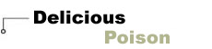

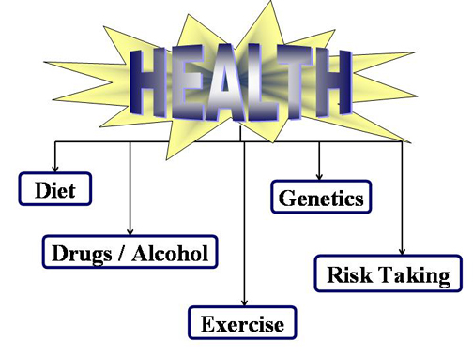
(click on the chart above or on "Lesson" in the side bar to begin)
A person's lifestyle plays a crucial role in developing and maintaining a healthy body. Research has shown that poor diet, a lack of physical activity, partaking of harmful substances (such as tobacco, alcohol and drugs) and illicit sexual activity will dramatically increase the risk of chronic disease and premature death.
This unit of study will discuss how lifestyle choices can affect health.
For example, research has shown: obesity is a risk factor for chronic diseases such as heart disease, diabetes, high blood pressure, stroke and some forms of cancer;¹¹ and smoking cigarettes for as little as five years can cause irreversible damage to the lungs, heart, eyes, throat, urinary tract, digestive organs, bones and joints, and skin.¹² While hereditary factors have been shown to contribute somewhat to obesity in some individuals, lifestyle choices such as diet and exercise have been shown to have a far more substantial effect.

By the end of this lesson you should be able to:
- Identify the difference between the types of drugs and how it affects us.
- Summarize the effects of a variety of major lifestyle choices on health.
- Demonstrate making lifestyle choices which will have a positive impact on health.

References
1. National Institutes of Health's National Center for Biotechnology Information - Genes & Disease - http://www.ncbi.nlm.nih.gov/disease/Obesity.html
2. The American Council on Science and Health - The Irreversible Health Effects of Cigarette Smoking - http://www.acsh.org/publications/booklets/iesmoke.pdf
3. BMI calculator - http://nhlbisupport.com/bmi/
4. Cigarette Smoking as a Cause of Cancer, Cancer Rates and Risks, Surveillance, Epidemiology, and End Results (SEER) Statistical Publications, National Cancer Institute - http://seer.cancer.gov/publications/raterik/risks67.html
5. Smoking: Facts and Tips for Quitting, Tobacco Control Research, National Cancer Institute - http://dccps.nci.nih.gov/TCRB/Smoking_Facts/facts.html
6. Wayne State University, Department of Biological Sciences, Toxicity - http://sun2.science.wayne.edu/~bio103/toxicity.html
7. The University of Queensland, Mayne Medical School, Department of Molecular and Cellular Pathology, Alcohol Related Pathology - http://www.som.uq.edu.au/Pathology/teaching/yearThree.html
8. National Organization on Fetal Alcohol Syndrome, What is Fetal Alcohol Syndrome? - (www.nofas.org)
9. National Institute on Drug Abuse, NIDA InfoFacts, Marijuana - http://www.nida.nih.gov/Infofax/marijuana.html
10. Kaplan, Pathology, USMLE Step 1 Preparation Book, 2002
11. Genes and Disease, National Institute of Health - http://www.ncbi.nlm.nih.gov/books/bv.fcgi?call=bv.View..ShowSection&rid=gnd.section.232
12. American Council on Science and Health - http://www.acsh.org/publications/booklets/iesmoke.pdf
Photo credits
1. Working Out Apple: San Francisco State University Student Health Service (http://www.sfsu.edu/~shs/dpm/wellness.htm)
2. Drug-free Zone: The Public School Parent's Network (http://www.psparents.net/SubstanceAbuse.htm)
3. Lungs: PresMark Publishing Co. (http://www.presmark.com/htmlfile/pictures.htm)
4. Liver: University of Utah, Health Sciences Library (http://www-medlib.med.utah.edu/WebPath/LIVEHTML/LIVERIDX.html#1)

