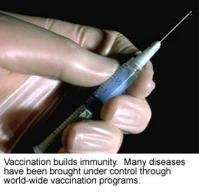
Infectious microorganisms are organisms such as viruses, bacteria, fungi, and protozoa, that survive in certain environments, have ways to infect, and can multiply.
They can enter your body through breathing, food, water, air, sexual contact, skin to skin contact, or blood transfusion.
These agents produce reactions or disease in the body. Some agents produce severe illness in the body, while others produce a mild one. Some agents produce toxins when they grow in food and these toxins cause illness.
In this lesson you will learn about different types of microorganisms and their properties.

By the end of this lesson you should be able to:
- Identify which microorganism causes what disease.
- Identify modes of transmission of these microorganisms.
- Describe the main properties of these microorganisms.

