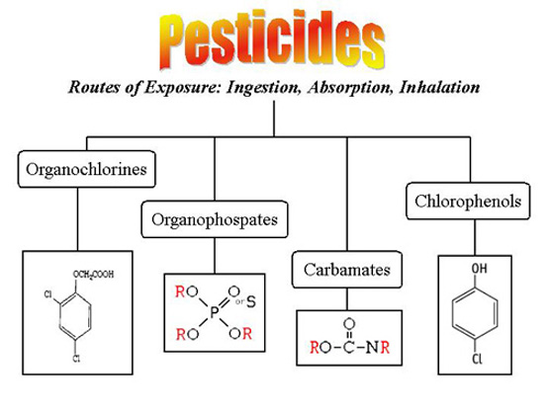
(To begin click on the diagram above or "Lesson" on the side bar)
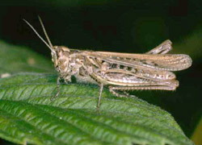
Pesticides are any substance or mixture of substances intended for controlling pests. Pests can be insects, mice and other animals, or weeds.
While pesticides are used mainly in agriculture, home use is rapidly increasing. Home-use products include cockroach sprays, insect repellents, rat poisons, tick sprays, and powders, kitchen, laundry, and bath disinfectants and sanitizers, lawn and garden products, such as weed killers, and some swimming pool chemicals. Pesticides are found everywhere in the world, contaminating soil, air, groundwater, surface water, rain, snow, fog, and even the Arctic ice.
Pesticides are useful to society because of their ability to control insects, weeds, and other pests, but they may cause serious health problems for humans.
In this lesson you will learn about different types of pesticides, source of exposure, and what it does to your body.

By the end of this lesson you should be able to:
- Describe how some pesticides (organophosphate and carbamates) inhibit the normal functions of the nervous system.
- Recognize the symptoms of pesticide poisoning.
- Understand the importance of immediate treatment for pesticide poisoning
- Understand how to decrease your risk of being exposed to pesticides.

This lesson was written by Charles C. Farnsworth, Sowmya Ramesh, Nathan Shepard, and W. R. Klemm

