What happens when pesticides enter the body?
Most people are aware of the potential dangers of pesticide use. However, understanding that pesticides can be harmful to human health is one thing; knowing how they work is another!

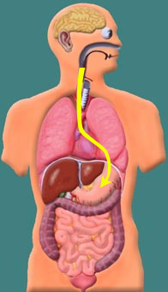 | 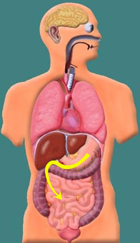
1. Most pesticides can enter the body through the skin, lungs or mouth. If pesticides are eaten the muscular action of the esophagus carries them to the stomach. | 2. From the stomach, the pesticide enters the small intestine. It then enters the blood through the villi of the small intestine. Regardless of how a pesticide enters the body, it always winds up in the blood.
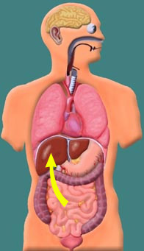 | 3. Blood from the small intestine is carried to the liver. Liver cells change the chemical nature of foreign chemicals, and this often has the effect of reducing the toxicity. These chemical reactions are called metabolism. During metabolism the chemical structure of the pesticide is changed and the modified pesticide is then called a metabolite.  In the case of some pesticides, the process of metabolism actually causes a nontoxic pesticide to become a toxic metabolite.

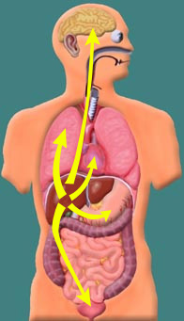 | 4. Pesticide metabolites enter the bloodstream after leaving the liver and are then transported to the rest of the body.  The effect of these metabolites varies with the type of pesticide. Some pesticides produce their toxic effects by interrupting the normal function of acetylcholinesterase in the nervous system.  Let's look at how the nervous system is affected.
Acetylcholine | Acetylcholinesterase

Acetylcholine is a special chemical manufactured by the body called a neurotransmitter. It transmits nerve impulses from one nerve to the next. It acts much like a green light telling certain functions of the body to begin.
Acetylcholinesterase is another type of chemical produced by the body. It tells the nervous system to stop the functions started by acetylcholine. The body functions started by acetylcholine do not stop until they are stopped by acetylcholinesterase.

So what happens to the body when the normal function of acetylcholinesterase is inhibited? Acetylcholine continues to send "go" messages to various part of the body. The symptoms produced by leaving the green light on depends on how much pesticide was taken into the body (the dose).

The following charts describe the symptoms that will occur based on the dose of the pesticide. Note that the first chart's symptoms are for pesticides that inhibit the function of acetylcholinesterase, such as organophosphates and carbamates. Other types of pesticides will produce different symptoms as shown in charts two and three.
(Victims of high dose exposure suffer from low dose symptoms as well)

Effects of Exposure to Organophosphate and Carbamate Pesticides
(listed in order from low dose to moderate to high dose)

Brain - Headache & dizziness, coma  Eyes - Excess tears, constricted pupils (won't dilate)  Mouth - Increased salivation, slurred speech  Trachea - Constriction, increased mucus  Muscles - Tremors, clumsiness, convulsions  Heart - Decreased heart rate  Respiration - Difficulty breathing, bluish skin tint  Bladder - No bladder control  Digestive organs - Nausea, vomiting & diarrhea, no control over bowel movements  * Death occurs because of respiratory failure when the dose is too high. | NOTE: "nerve gas" is a weapon of mass destruction that is chemically like organophosphate pesticides, only much more potent. More on these poisons can be found in the Hazards section of Organ Systems.

Effects of Exposure to Organochlorine Pesticides
(listed in order from low dose to moderate to high dose)

Brain - Headache and dizziness, confusion, hyperexcitable state, violent seizures, coma
Muscles - Convulsions, paresthesia of face and extremities, tremors, violent seizures
Heart - Increased blood pressure, cardiac arrhythmia
Respiratory - Respiratory depression / failure
Digestive organs - Nausea, vomiting

Effects of Exposure to Chlorophenols
(listed in order from low dose to moderate to high dose)

Brain - Headache, dizziness, tremors, restlessness, seizures, coma, death
Eyes - burning, irritation
Skin - burning, irritation
Muscles - Fatigue, muscle weakness
Nose, Throat, and Lungs - Burning, coughing, wheezing, laryngitis, shortness of breath
Digestive organs - damage liver and kidneys
Treatment for pesticide poisoning
If you are exposed to pesticides it is important to receive medical treatment as soon as possible. If you have received a high dose of a pesticide death can occur within 24 hours. In most cases, a physician can administer drugs that can counteract the effects of the pesticide.
Another important thing to remember about pesticide poisoning is that it takes a while for acetylcholinesterase to return to its normal levels in the blood. If you are exposed to a second dose of pesticide (even if it is a low dose) shortly after being exposed to a previous low dose, the second dose will affect your body in the same way as a high dose of pesticide.
Decreasing your risk of exposure to pesticides
It is important to remember that you can be exposed to pesticides by eating fresh fruits and vegetables that have been sprayed with pesticides. Always wash or peel fresh fruits and vegetables before you eat them.
Also, be aware that many pesticides can enter the body just as easily through the lungs and skin as they can through the digestive system. If you must use pesticides (as an adult -- young people and pets should never be exposed to pesticides) remember to cover your skin and wear an approved breathing device. Remove all your clothes carefully and shower immediately after applying any pesticide.

