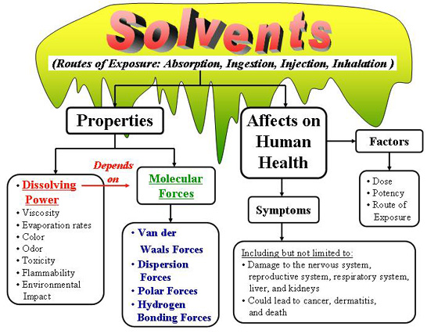
(Click the chart above or on "Lesson" in the side bar to begin)
Solvents include a variety of commonly used chemicals found in many consumer products, such as degreasers, glues, paints, household cleansers and fuels. The most common solvent is water, which is an inorganic solvent. Water can be toxic, but only in huge quantities. This lesson will discuss organic solvents because they can cause very harmful effects, even in small amounts.
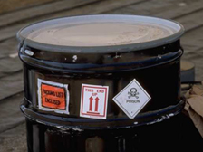
Nearly everyone gets exposed to solvents. Solvents are used widely in the manufacture of many of the products we use daily such as typewriter correction fluid, dry cleaning fluid, flues, and gasoline.
While exposure to solvents is commonplace, adverse effects to exposure may not occur if the dose is low. Remember, toxicity is dependent upon the potency of the toxicant and the amount of exposure to the toxic substance.
Health hazards associated with organic solvent exposure include toxicity to the nervous system (headache), reproductive damage (menstrual irregularities, infertility), liver (cirrhosis) and kidney damage, respiratory impairment, cancer, and dermatitis.
In this lesson you will learn about different properties of solvents and how we can use an understanding of these properties to reduce the hazards to ourselves and our environment.

By the end of this lesson you should be able to:
- Identify the properties of solvents.
- Describe the different types of molecular interactions.
- Use a Hansen graph to determine solubility.

This lesson was written by Charles C. Farnsworth, Sowmya Ramesh, Nathan Shepard, and W. R. Klemm.

