To the Teacher:
In teaching this lesson, it will be useful to refer to the Teachers' Materials before you begin, to give you vital information associated with the unit.
Do you know what an environmental pollutant or hazard is? Environmental pollutants/hazards are substances like motor oil and even chemicals like ammonia, that when present in air, water and soil have a harmful impact on human, animal, and ecological health.
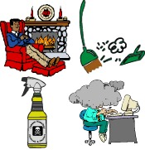
Environmental pollutants/hazards can be classified into three major types:
An indoor pollutant is a hazard present inside buildings that has a harmful health effect on the occupants of the building. Indoor pollutants include dust, smoke, mold and even common household chemicals.

An outdoor pollutant is a hazard present in the outdoor environment that has a harmful impact on human, animal and ecological health. An outdoor pollutant can be found in the air, water, or soil.
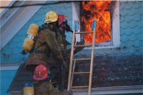
A special environment pollutant is a hazard that people are only exposed to in certain settings, such as work places or while practicing a hobby. Can you think of a type of career that might expose a person to a special environment pollutant? One example is firefighters. Firefighters are exposed to extremely high temperatures and smoke while performing their job each day
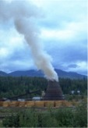
By the end of this lesson you should be able to:
- Identify common indoor airborne illnesses and contaminants
- Identify common outdoor airborne illnesses and contaminants
- Identify common airborne illnesses and contaminants of special environments

Begin by taking the "Pre-Test", then proceed with the rest of this unit by going through the "Lessons". When you get to the lesson guides, read each one. When you are finished, complete the post-test.

