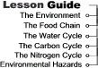

Directions:
Work through all of the topics in the lesson guide, then continue to the activity and posttest.
The Environment
The environment is the sum of all external conditions affecting the life, development and survival of an organism.
An ecosystem is the interacting system of a biological community and its non-living environmental surroundings. Ecosystems have two essential functions.
- Ecosystems enable the energy from the sun to travel through all the levels of the food chain.
- Ecosystems allow for matter to be recycled.
The next few pages in this lesson will introduce you to the energy and food functions of the environment, the chemical cycles in the environment, and how various hazards effect the environment.

The Food Chain
Energy and Food
The sun is the major source of energy for Earth. Producers such as plants harness this energy. Plants absorb less than one percent of the light that reaches the Earth. Yet plants and other photosynthetic organisms make over 170 billion metric tons of food a year. The energy captured by producers is used to make all of the organic matter in the environment which is called biomass
Food Chains
Food chains form the basic structure of how producers, consumers, and decomposers interact in an environment. A food chain is a series of organisms that transfer food between different levels of an ecosystem.

The Food Chain
The Role of Living Things
In the ecosystem, organisms get their food in one of three ways:
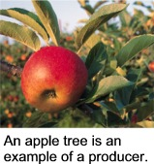
1. A producer is an organism that makes its own food from an inorganic energy source. The energy source that is used in most cases is the sun. The energy from the sun is used to convert CO₂ into sugar.
2. A consumer is an organism that can not produce its own food and must eat another organism. Consumers include organisms the eat plants, called herbivores, organisms that eat meat, called carnivores, and omnivorous animals that eat both plants and animals.
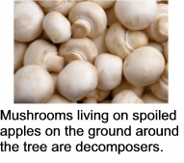
3. Decomposers consume the bodies of dead organisms as well as organic waste. Decomposers are important in that they complete the cycle of matter by turning organic waste into the inorganic components producers use to make food.

The Chemical Cycles
Unlike energy, matter can be recycled. The Water, Carbon, and Nitrogen Cycles are the three main ways matter is recycled in the environment.
The Water Cycle
More than ninety percent of the Earth's water is locked beneath its surface either in crystal rocks or deep in the interior and does not take part in the water cycle. A large portion of the water that does participate in the water cycle comes from the Earth's oceans.
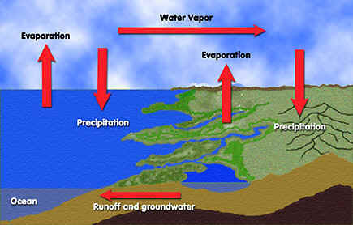
Step 1: A large quantity of water evaporates from the surface of the ocean. Evaporation is the conversion of liquid water to a gaseous form of water called water vapor.
Step 2: The water vapor then condenses to form clouds. Most of this condensed water will then precipitate back into the ocean, but some will travel on and eventually float over land. Precipitate means to condense from a vapor and fall as rain or snow.
Step 3: The condensed water (clouds) that floats over land picks up more water vapor from evaporation and transpiration. Transpiration is the evaporation of water from the leaves of plants.
Step 4: The accumulated water vapor will then fall to the ground as rain.
Step 5: The rain water makes its way back to the ocean through streams and rivers and starts the water cycle over again.

The Chemical Cycles
The Carbon Cycle
The Carbon Cycle describes the flow of carbon between living organisms and the non-living environment. Carbon cycles through the environment in the form of a gas, carbon dioxide (CO₂). The atmosphere of Earth contains .04 percent CO₂.
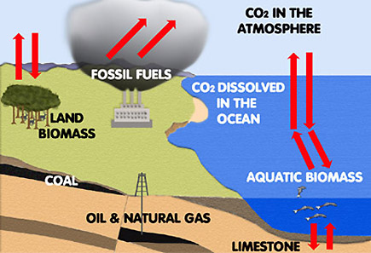
Living organisms provide two important steps in the carbon cycle:
- Plants absorb CO₂ from the atmosphere to use during photosynthesis.
- Other organisms release CO2 into the air during respiration.
In addition, there are several important non-organic storage areas of carbon in the environment:
- A large portion of the Carbon on the Earth is stored in rocks.
- The Earth's oceans hold a large amount of CO₂ because it easily dissolves in water.
- Coal, oil, and limestone store carbon that once formed ancient organisms. Burning fossil fuels, like coal and oil, will release CO₂ into the atmosphere.
The Chemical Cycles
The Nitrogen Cycle
Organisms require nitrogen to produce amino acids. Nitrogen makes up seventy-eight percent of the atmosphere, but most organisms can not use this form of nitrogen, and must have the fixed form. The nitrogen cycle produces the fixed form of nitrogen these organisms need.
Step 1: A special type of bacteria called nitrogen fixing bacteria take in atmospheric nitrogen and produce ammonia (NH₃).
Step 2: Other bacteria use this ammonia to produce nitrates and nitrites, which are nitrogen and oxygen containing compounds.
Step 3: The nitrates and nitrites are used by plants to make amino acids which are then used to make plant proteins.
Step 4: Plants are consumed by other organisms which use the plant amino acids to make their own.
Step 5: Decomposers convert the nitrogen found in other organisms into ammonia and return it to the soil. A few of these type of bacteria return nitrogen to the atmosphere by a process called denitrification, however this amount is small.

Environmental Health Hazards
Environmental hazards are things found in air, water, and soil that negatively impact living beings. These health hazards are assessed in terms of dose-response, exposure and risk.
Dose-Response Assessment
Paracelsus, the Swiss physician and alchemist, the "father" of modern toxicology (1493 – 1541) said, "The dose makes the poison." In other words, for most toxic substances, the amount of a substance a person is exposed to is as important as how toxic the substance might be. For example, small doses of aspirin can be beneficial to people, but at very high doses, this common medicine can be lethal. Individual responses to dose often vary. Even in very low doses, aspirin is deadly for some people.
Exposure Assessment
People can be exposed to environmental hazards in three ways:
- Absorption through the skin
- Inhalation (entry through the respiratory system)
- Entry through the mouth and digestive system
Most hazardous substances are more likely to be absorbed into the body by one means of exposure than by another. Knowing how a hazardous substance is likely to enter the body aids in assessing our potential for exposure.
Risk Characterization
Environmental hazards are often characterized by the risk they pose to human health as well as by their effects on our environment. Risk is assessed by the combined effect of the toxicity of the substance and the amount of exposure. At least some exposure and some toxicity are required to result in a risk. For example, if your exposure to a non-toxic substance is high, there is no risk. By the same token, if the substance is very toxic but no one is exposed to it, there is no risk. Thus -
RISK = TOXICITY x EXPOSURE
It is very important to be aware of how to minimize the risks of environmental health hazards. In the following lessons, we will talk about hazards and how to avoid them.

