Name: ____________________________________________Date: _______________
Activity 1 – Secret Codon
Write a Message in DNA!

Activity found at: https://www.exploratorium.edu/snacks/secret-codon

DNA is referred to as the genetic code for life, because it contains information about which amino acids join together to create different proteins. You can use the one-letter abbreviations for amino acids to make a secret message that will give new meaning to the description of DNA as beads on a string.

Materials:
- Pony beads in four different colors
- Cotton string
- Amino acid codon table (available below or at this link)

Procedure:

Assign each pony bead color to one of the four DNA bases – adenine (A), thymine (T), cytosine (C), and guanine (G). The string pictured above uses this color key:
A: red
T: yellow
C: blue
G: green

Think of a word or short phrase that you want to encode into your DNA strand. Make sure it can be spelled or sounded out without using the letters B, J, O, U, X, or Z. These letters are not abbreviations for any of the amino acids. There are only 20 amino acids that are coded for, so six alphabet letters are not used. Determine what amino acids the letters in your phrase correspond to by looking up the one-letter amino acid abbreviations in the amino acid codon table. Then, use the table to write down the DNA sequence that encodes for those amino acids. All proteins start with a methionine amino acid residue that is encoded by the DNA sequence ATG. They end when the DNA encodes one of the three stop codons. Add ATG to the beginning of your sequence, and pick one of the three stop codons for the end of your sequence. Make your DNA strand by stringing the beads so that the colors match the order of the DNA sequence that you wrote down. Don’t forget to include the proper start and stop codons in your sequence. Trade strands with a friend and see if you can decode each other’s secret message!

Amino Acid Codon Table from: https://www.exploratorium.edu/sites/default/files/snacks/SecretCodonTable.gif

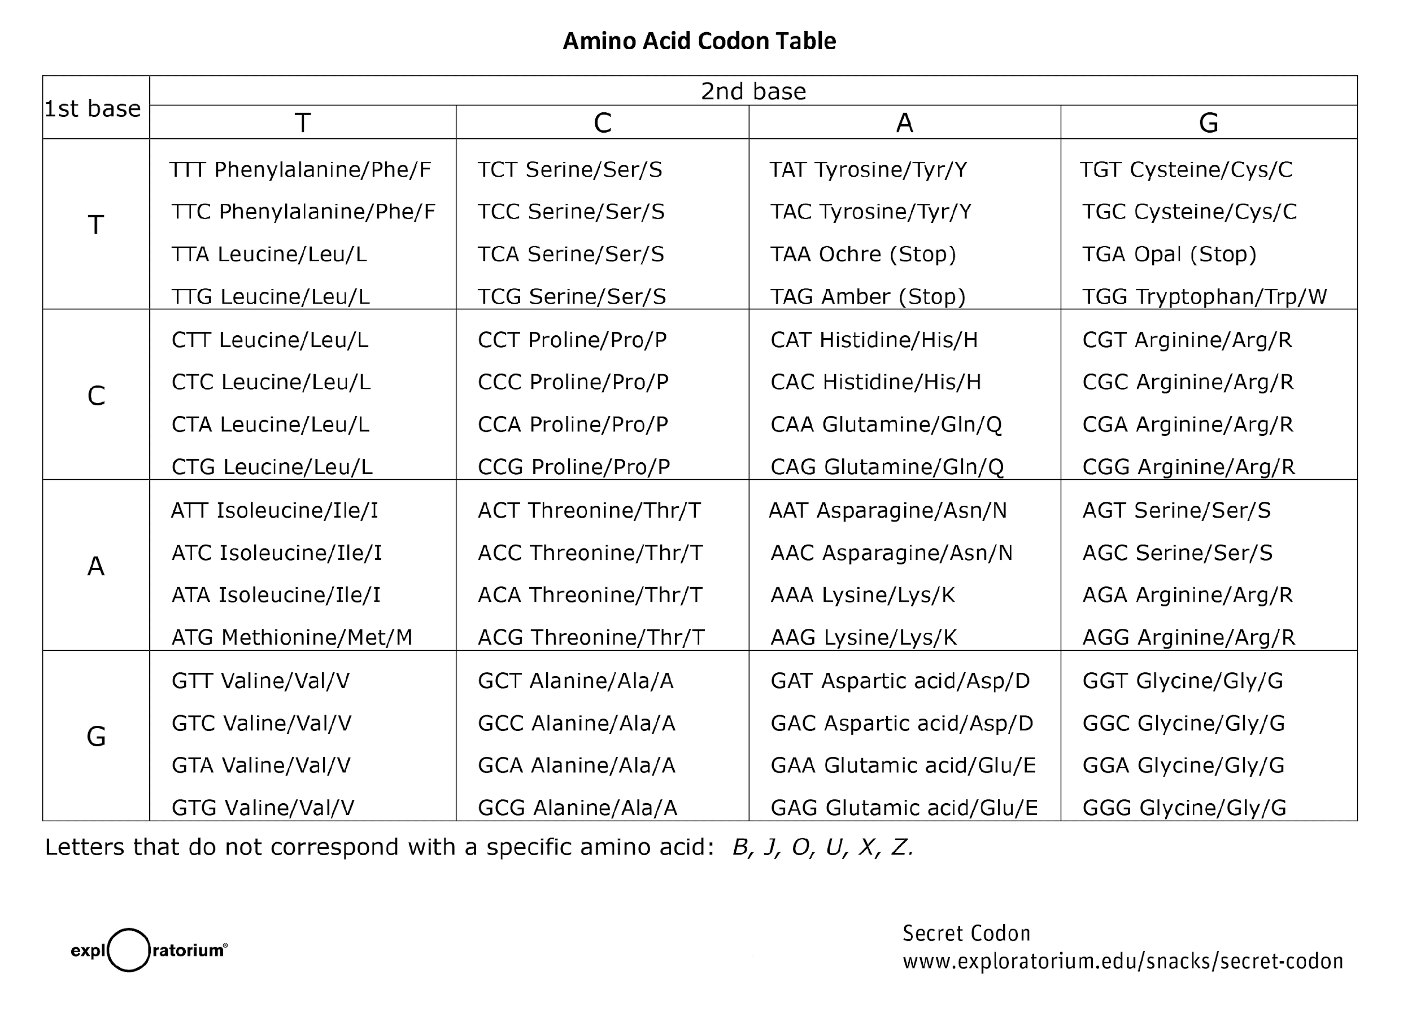

What’s Going On?

Proteins are long chains of individual amino acid subunits. The order of the amino acids in the chain is determined by the DNA sequence of the gene that encodes for it. This is commonly referred to as the genetic code.

DNA is a chain of four different nucleotides (adenine, thymine, cytosine, and guanine), often abbreviated A, T, C, and G. These four nucleotides (sometimes referred to as bases) give the instructions for the 20 different amino acids that compose proteins. Each amino acid is encoded by a sequence of three DNA bases, called a codon. Since it takes three DNA bases to designate an amino acid, there are enough combinations of the four different bases to represent all of the amino acids, as well as three stop codons that indicate when the protein ends. Each base can be in any position, which yields 43, or 64, possible combinations, so there is some redundancy between the 20 amino acids. This just means that a given amino acid can be encoded by more than one DNA codon sequence.

For simplicity, individual amino acids are often abbreviated using one or three letter abbreviations. For example, the amino acid arginine can be abbreviated Arg or R. The single-letter amino acid abbreviations provide a fun way to write secret messages using the genetic code. Since there are only 20 different amino acids, there are 6 letters of the alphabet that don’t stand for a specific amino acid. With the 20 letters that do, however, you can use the genetic code to determine the DNA sequence that corresponds to your amino acid message.

This work is licensed under a Creative Commons Attribution-NonCommercial-ShareAlike 4.0 International License.
Attribution: Exploratorium Teacher Institute

