Activity 1 – Organizing Structures and Functions

Teacher Instructions
This activity helps students to use everyday experiences to understand the more abstract ideas of cell organization.

Objective
After this activity, students should be able to:
- Recognize and describe levels of organization of living things. Compare levels of organization of living things to how common non-living groups are organized.

Materials
Each student needs:
- Copy of student worksheet

Name: Date:

Activity 1-

Organizing Structures and Functions

ORGANIZING STRUCTURES

Even non-living things can have two or more levels of organization. Think about the levels of organization in your school from outside to inside. First, there is an external wall around the entire building. Next, there might be floors or hallways in your building. Each hall or floor is organized into rooms and maybe the room is organized into different centers or tables. Each part of the building has a specific purpose and is structured to accomplish those purposes. These different structures or parts of a school can be organized into levels of organization

1. Relate the example of the organization of a school building to the way the structures of a cell could be organized.

2. Why might a school building be a bad example of organizing structures? What would be different about the organization of cell structures?

3. Describe your own example to model the levels of organization for structures.

ORGANIZING FUNCTIONS
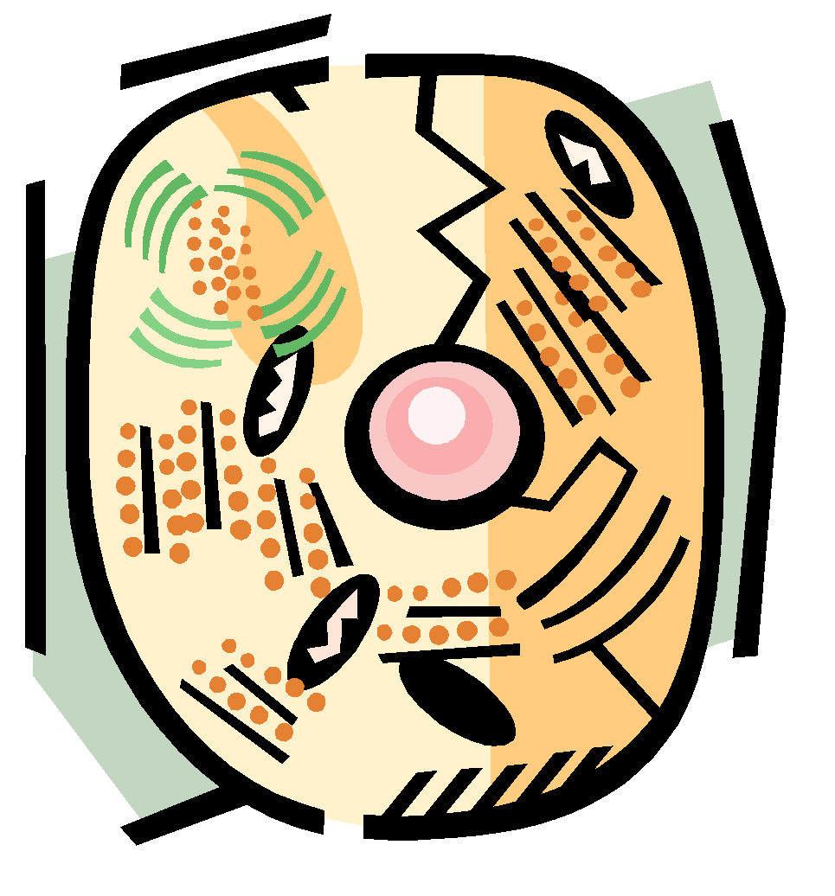
In terms of function, think about a sports league. An organized person acts as the league leader. He or she helps assign the coaches, whose function it is to teach the players. The player's job is to play the game as well as he can. Other people create the schedules, arrange for the times and places of the games, help the team raise money, and act as referees. Once these functions are identified, they can be organized in various ways, interacting to make the sports league function. Each of these functions is a different level in the organization of a sports league. Functions of a cell can be organized in a similar way.

4. Can you identify the various functions associated with a sports league or club you have been involved with? How would you order these functions into various levels of organization?

5. What are some of the functions that take place in a cell? How do you think they could be organized into different levels?

Activity 2 –

Cells on Mars?

Teacher Instructions
This activity is designed to stimulate student imagination and creativity. In the process, students will discuss those types of structures and functions that are needed to survive. Students will draw and describe new types of cells, fitting the descriptions provided.

Objective
After this activity, students should be able to:
- Understand the structure and function of cells and their organelles and use that knowledge to create a new type of cell that suits a specific environment.

Materials
- Student worksheet

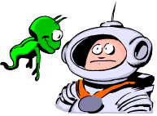
Name: Date:

Activity 2-

Cells on Mars?

ORGANIZING STRUCTURES

Pretend you are a scientist on Mars. One day, you discover a Martian settlement with creatures you've never seen before. When you examine them closely, you see that they are made up of cells, but not human cells. These creatures have cells with structures very different from human cells even though they complete some of the same functions as human cells.

1. Imagine the kinds of structures the Martian cells might need to live and survive. Draw what you think the Martian cell structures would look like below. Be sure to label the Martian organelles (differently from human cells) and describe how each part of the Martian cell helps it to survive. See if you can think of other ways these cells might work to accomplish the same results as your human cells.

2. Give your organism a scientific name. Share your organism with the class.

3. Imagine how the structures of the Martian cell work. Can you think of ways these cells might work to accomplish the same results as your cells do when they form together to make tissues, organs, and organ systems?

Activity 3 – Life in a Drop of Pond Water

Teacher Instructions
These are two labs that guide students in observing and analyzing living organisms in pond water from the American Association for the Advancement of Science. There are excellent virtual resources available in this exercise including a virtual pond water jar with organisms to view if real pond water is not available. The website explains the entire lesson and gives very detailed instructions for the teacher.

Link: http://sciencenetlinks.com/lessons/pond-1-pond-life/
In Pond 1: Pond Life, students explore how various organisms satisfy their needs within their environments and the kinds of relationships that exist between organisms within an environment. This lesson is geared more toward ecology than cell biology but is a good introduction.

Link: http://sciencenetlinks.com/lessons/pond-2-life-in-a-drop-of-pond-water/
In Pond 2: Life in a Drop of Pond Water, students observe microscopic organisms found in pond water using a hand lens, 30x magnification, and 100x magnification. Observing these organisms should stimulate discussions about how single-celled living things might satisfy their needs for food, water, and air. They can do this by comparing the needs of macroscopic organisms to those of microscopic ones. It is important to remember that while watching microorganisms is informative, it is not always likely that students will be able to observe these tiny cells performing such functions as dividing or taking in food. Thus, direct observation should be supplemented with films of living cells or by using prepared materials.

Objective
To investigate the living creatures in a drop of pond water under magnification.

Materials

Pond 1:
- Jars for water samples from a local pond, lake, river, or stream
- Poster board
- Microscopes
- Slides

Pond 2 At the pond:
- Fresh pond water
- Clear glass jar(s)

Pond 2 In the lab:
- Slides
- Droppers
- Hand lenses
- 30x microscopes
- 100x microscope

Activity 4 – How Big is a Cell?

Teacher Instructions
Link: https://www.lsu.edu/science/soar/files/how_big_is_a_cell.pdf

This activity is designed to show students the size of cells relative to other common objects. It contains very detailed instructions on how to do the procedures and also includes a teacher key. It includes a glossary and a math extension activity.

Objective
This activity is designed to introduce students to the range of cell sizes.

Materials:
Light microscope with 200x objective
Activity calls for a “Scope on a Rope,” however this can be done with a regular standing microscope

Activity 5 – Build You Own Cell Activities
Teacher Instructions

Activity Link: https://bbsrc.ukri.org/documents/build-your-own-cell-pdf/
This site has an extended lesson plan for many activities on this topic. It includes puzzles, a cell model, and a student worksheet. Teacher keys are provided.

Objectives

Students will be able to:
• Describe that all living things are made up of cells
• Name the parts of plant and animal cells
• Explain the function of the parts of plant and animal cells
• Make models of plant and animal cells
• Compare animal and plant cells
• Describe a feature of a specialized cell
• Relate features of specialized cells to the function of the cell
Materials:

- Materials vary depending on activity chosen.

