PEER Life Science Cells Are Us Levels of Organization Notes Outline Key
Introduction
- A cell is the smallest unit of life.
- The human body is composed of trillions of cells. Their size and shape depends on their function.
- Name three functions of cells:
  - Provide structure for the body
  - Take in nutrients and convert them into energy
  - Carry out specialized functions like reproduction
- Each cell contains the body’s hereditary material that is passed on to our offspring.
Why It Matters
- Each cell in our body has a role that helps our body stay well and survive.
  - When our cells are healthy, our body is healthy/sick.
  - When our cells are sick, our body is healthy/sick.
- Name four situations that can cause cells to lose or change their function.
  - Disease/sickness
  - Exposure to radiation
  - Substance abuse
  - Aging
  - Natural causes
  - New cells not replacing dying cells
  - Cells replace themselves too much
What We Know
- The basic structural, functional, and biological unit of all living organisms is a cell.
  - This is similar to a brick that makes up buildings in a city.
- A group of cells with similar functions joining together makes up tissues.
  - This is similar to walls of buildings in a city.
- Groups of different tissues working together make up organs.
  - This is similar to buildings in a city.
- Groups of organs working together for a shared function makes up organ systems.
  - This is similar to a city district, like a medical district.
- Different organ systems work together to make up an entire organism.
  - This level is like the entire city.
- Specialized structures that perform various jobs in cells are called organelles. They function within the cell similarly to how organs function in the body.
- Mitochondria are organelles that obtain usable energy for the cell. This is kind of like part of the digestive system in the body.
- The nucleus is a cellular organelle that stores DNA and is the command and control center of the cell. It’s similar to the brain in the body.
- The cell membrane is a barrier around the cell that controls what enters and leaves the cells and interacts with the world outside of the cell. It’s similar to the skin in the body.
- The cytoplasm is a gel-like fluid in which the cell’s organelles are suspended and that transports materials within the cell. It’s analogous to the circulatory system in the body.
- The endoplasmic reticulum transports materials from one part of the cell to another, like the circulatory system in the body.
- Ribosomes manufacture proteins and send them to parts of the cell where they are needed. They have similarities to the digestive system.
- The golgi body packages and sends out proteins similar to how the digestive system breaks down and repackages food for the body.
- Lysosomes break down cell parts and remove cellular waste. Vacuoles store waste, water, and necessary materials. They function similarly to the excretory system.

- Label the organelles in the diagram below.
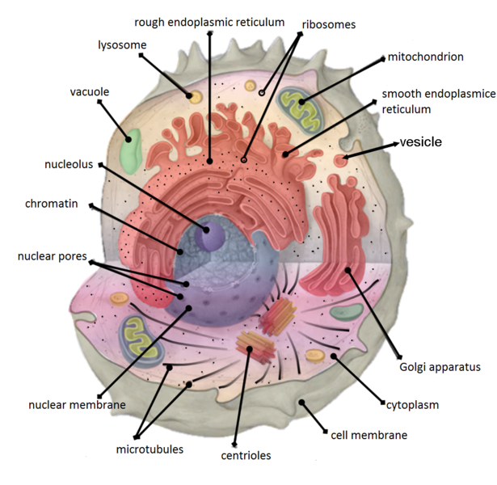
- Cells can have many/few different structures. Cell shape and structure is determined by their function.
- Most cells are naturally transparent, but we can use stains to see the different parts.
How We Know
- Most cells are microscopic.
- To study cells and how they work, scientists often grow them as a culture. A cell culture is a growth of a large group of cells in the laboratory.
- Name two things that cell cultures can be used for.
  - Diagnose infections
  - Test new drugs
  - Cell research
- In order for cells to stay alive in a culture they need:
  - A sample of the type of cells needed that are healthy and can divide.
  - A culture media that supplies the cells with energy, amino acids, and vitamins.
  - Oxygen
  - Warm temperature
  - Removal of waste gas
- The warm temperature is provided by a machine called an incubator.
- When looking at a tissue cut from an organ under a microscope, that organ may have several types of cells. Each cell has even smaller structures called organelles.
- Organelles can be visualized with powerful microscopes like electron microscopes.
Common Hazards

