PEER Life Science Cells Are Us Levels of Organization Notes Outline
Introduction
- A ______ is the smallest unit of life.
- The human body is composed of ____________ of cells. Their size and shape depends on their ___________.
- Name three functions of cells:
  - ____________________________________________
  - ____________________________________________
  - ____________________________________________
- Each cell contains the body’s ______________ material that is passed on to our offspring.
Why It Matters
- Each cell in our body has a ________ that helps our body stay well and survive.
  - When our cells are healthy, our body is healthy/sick.
  - When our cells are sick, our body is healthy/sick.
- Name four situations that can cause cells to lose or change their function.
  - ___________________________________
  - ___________________________________
  - ___________________________________
  - ___________________________________

What We Know
- The basic structural, functional, and biological unit of all living organisms is a ________.
  - This is similar to a __________ that makes up buildings in a city.
- A group of cells with similar functions joining together makes up ____________.
  - This is similar to __________ of buildings in a city.
- Groups of different tissues working together make up _________.
  - This is similar to ______________ in a city.
- Groups of organs working together for a shared function makes up _____________________.
  - This is similar to a city district, like a medical district.
- Different organ systems work together to make up an entire ______________.
  - This level is like the entire ___________.
- Specialized structures that perform various jobs in cells are called ________________. They function within the cell similarly to how ____________ function in the body.
- ____________________ are organelles that obtain usable energy for the cell. This is kind of like part of the _______________ system in the body.
- The _____________ is a cellular organelle that stores DNA and is the command and control center of the cell. It’s similar to the ____________ in the body.
- The ______________________ is a barrier around the cell that controls what enters and leaves the cells and interacts with the world outside of the cell. It’s similar to the _______ in the body.
- The ______________ is a gel-like fluid in which the cell’s organelles are suspended and that transports materials within the cell. It’s analogous to the ________________ system in the body.
- The __________________________ transports materials from one part of the cell to another, like the _______________ system in the body.
- __________________ manufacture proteins and send them to parts of the cell where they are needed. They have similarities to the _________________ system.
- The ____________________ packages and sends out proteins similar to how the ________________ system breaks down and repackages food for the body.
- ___________________ break down cell parts and remove cellular waste. ______________ store waste, water, and necessary materials. They function similarly to the excretory system.
- Label the organelles in the diagram below.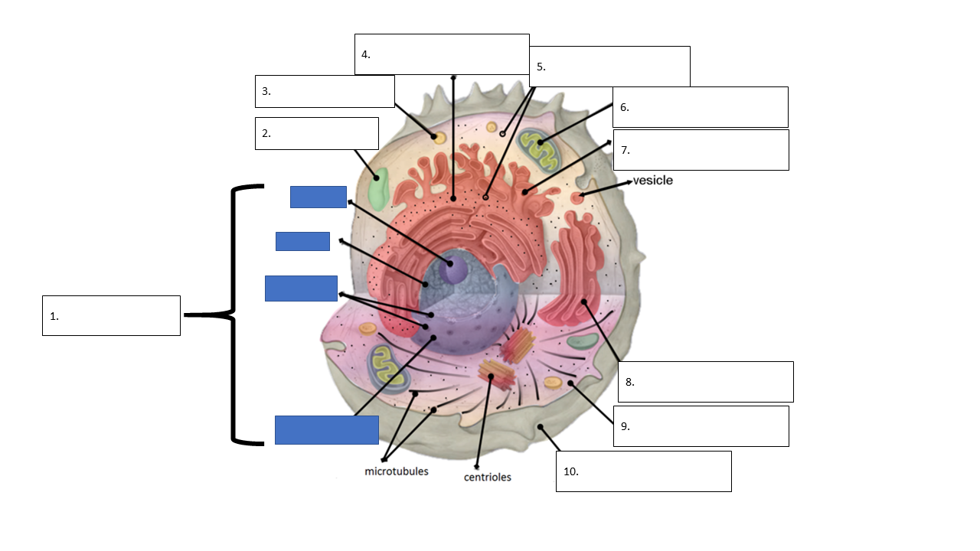
- Cells can have many/few different structures. Cell shape and structure is determined by their _____________.
- Most cells are naturally transparent, but we can use __________ to see the different parts.
How We Know
- Most cells are ______________.
- To study cells and how they work, scientists often grow them as a ______________. A cell culture is a growth of a large group of cells in the laboratory.
- Name two things that cell cultures can be used for.
  - _________________________
  - _________________________

- In order for cells to stay alive in a culture they need:
  - A sample of the type of cells needed that are __________ and can ___________.
  - A culture media that supplies the cells with __________, _________________, and ____________.
  - _____________
  - Warm _______________
  - Removal of __________ gas
- The warm temperature is provided by a machine called an _____________.
- When looking at a tissue cut from an organ under a microscope, that organ may have several types of ________. Each cell has even smaller structures called _______________.
- Organelles can be visualized with powerful microscopes like _______________ microscopes.
Common Hazards

