Name: Date:

Activity 1-

Organizing Structures and Functions

ORGANIZING STRUCTURES

Even non-living things can have two or more levels of organization. Think about the levels of organization in your school from outside to inside. First, there is an external wall around the entire building. Next, there might be floors or hallways in your building. Each hall or floor is organized into rooms and maybe the room is organized into different centers or tables. Each part of the building has a specific purpose and is structured to accomplish those purposes. These different structures or parts of a school can be organized into levels of organization

1. Relate the example of the organization of a school building to the way the structures of a cell could be organized.

2. Why might a school building be a bad example of organizing structures? What would be different about the organization of cell structures?

3. Describe your own example to model the levels of organization for structures.

ORGANIZING FUNCTIONS
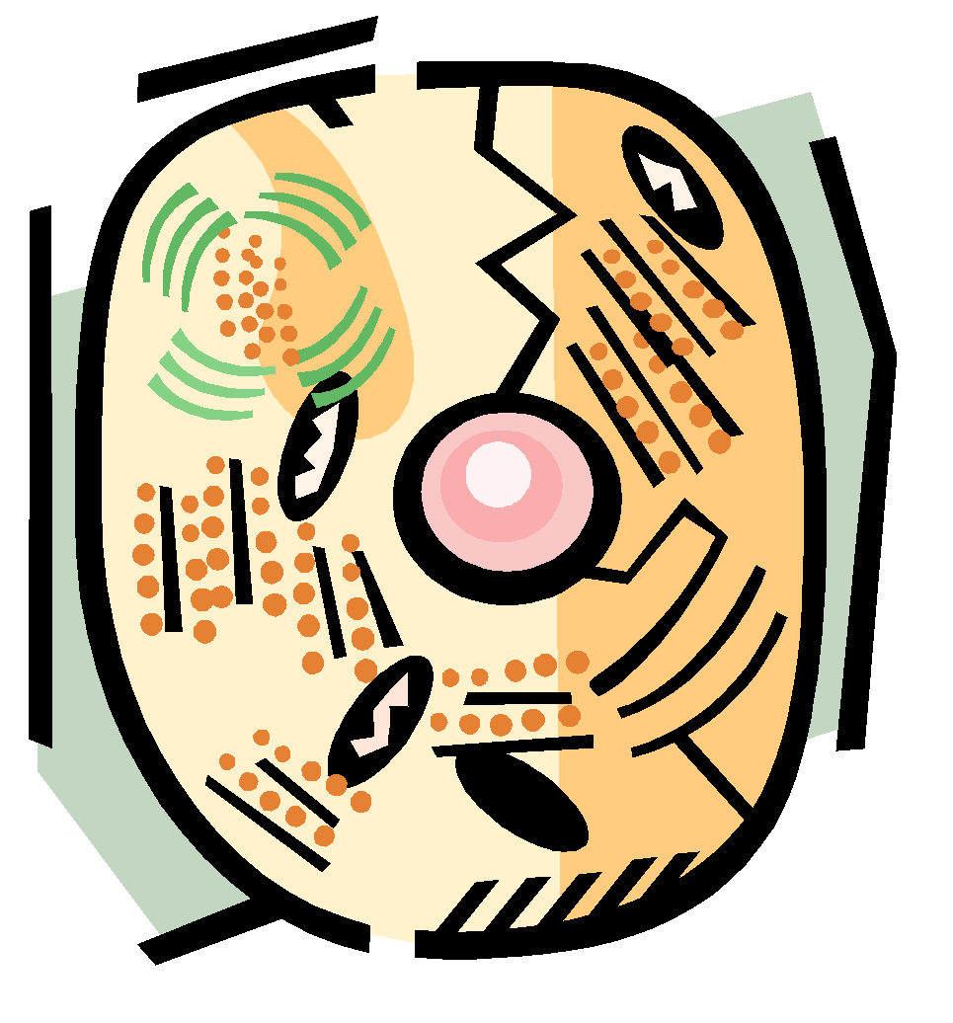
In terms of function, think about a sports league. An organized person acts as the league leader. He or she helps assign the coaches, whose function it is to teach the players. The player's job is to play the game as well as he can. Other people create the schedules, arrange for the times and places of the games, help the team raise money, and act as referees. Once these functions are identified, they can be organized in various ways, interacting to make the sports league function. Each of these functions is a different level in the organization of a sports league. Functions of a cell can be organized in a similar way.

4. Can you identify the various functions associated with a sports league or club you have been involved with? How would you order these functions into various levels of organization?

5. What are some of the functions that take place in a cell? How do you think they could be organized into different levels?

