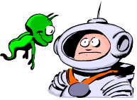
Name: Date:

Activity 2-

Cells on Mars?

ORGANIZING STRUCTURES

Pretend you are a scientist on Mars. One day, you discover a Martian settlement with creatures you've never seen before. When you examine them closely, you see that they are made up of cells, but not human cells. These creatures have cells with structures very different from human cells even though they complete some of the same functions as human cells.

1. Imagine the kinds of structures the Martian cells might need to live and survive. Draw what you think the Martian cell structures would look like below. Be sure to label the Martian organelles (differently from human cells) and describe how each part of the Martian cell helps it to survive. See if you can think of other ways these cells might work to accomplish the same results as your human cells.

2. Give your organism a scientific name. Share your organism with the class.

3. Imagine how the structures of the Martian cell work. Can you think of ways these cells might work to accomplish the same results as your cells do when they form together to make tissues, organs, and organ systems?

