Name: ____________________________________________________ Date: _______________
Activity 1 – How Many Calories in a Nut?
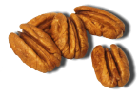

Objective:
To calculate the amount of energy contained in common nuts by doing a Calorimetry investigation.

Supplies (per group):
- Three nut halves like dried almond, pecan, walnut or cashew (almonds work very well)
  - WARNING: Please inform your teacher if you are allergic to any of the nuts used in this experiment. DO NOT DO THIS EXPERIMENT if you are allergic to these types of nuts or if you think you might be allergic to these nuts.
- Empty soda can
- Small ball of clay
- Aluminum foil
- Wire Coat Hanger
- Straight pin
- Thermometer that will fit in the opening of the soda can
- Balance to take the mass of nuts
- Lighter for burning nut
- Safety Goggles

Safety:
Review all laboratory safety guidelines and, during this lab, follow the guidelines for using heat and flame. Safety goggles are required for this experiment.

Background Information:
Our bodies need energy for all of our activities, and we get this energy from the food that we consume. Our bodies transform the chemical energy in foods into mechanical energy to do our activities and heat (or thermal energy). Calories are a measure of the amount of energy in foods.

One calorie is formally defined as the amount of energy required to raise one milliliter of water by one degree Celsius. For the purpose of measuring the amount of energy in food, nutritionists most commonly use Kilocalories (equal to 1000 calories) and label the measurement either as "Kcal" or as "Calories" with a capital "C".

In this experiment we will be burning nuts. When the nuts burn, the chemical energy stored in the nuts is converted into heat energy, which causes the temperature of the water to rise. By measuring the rise in temperature of the water, we will be able to calculate the amount of calories (energy) contained in the nut.

- Construct a frame for suspending the can of water by bending a coat hanger. Lay the hanger flat on the table. Fold one wing of the hanger at its half-way point inward about 90 degrees. Then fold the other wing the same way.
- Place a square of foil on the table. The hanger can now stand up and it will support itself. Place the hanger on the foil square on a sturdy table. Follow safety rules and make sure no flammable objects or materials are near the experiment area.
- Rotate the hook 90 degrees in the same direction as the wings. The hook can now be bent and the can’s tab slid over it to suspend the can. The vertical position of the hook can be adjusted up or down as needed so that the bottom of the can will rest just above the flame of the burning nut.
- Measure 100 milliliters of room-temperature water and pour it into the can.
- Measure the temperature of the water with a thermometer. Record the measurement on the attached data table.
- Measure the mass of the nut half before burning and record it in a data table.
- Place the nut half on the point of a straight pin and place the head of the pin in a piece of clay.
- Make sure you are wearing safety goggles. Follow all safety guidelines for using heat and flame. Light the nut with the lighter while holding the pin parallel to the ground (your teacher is required to be present during this step). As soon as it starts to burn on its own, place it under the can with the nut about 2 cm from the bottom of the can, and allow it to burn. If the nut sputters and goes out before it looks completely burned, there is no need to start over as long as there is a measurable temperature change.
- When the nut stops burning, measure the temperature of the water. When measuring the temperature, be sure to stir the water in the can to help distribute the heated water. Do not let the thermometer rest on the bottom of the can because this might cause an inaccurate reading. Record the temperature in the data table.
- Measure the mass of the burned nut and record in the data table.
- Using the data collected and formulas provided, calculate the amount of Kilocalories per gram of the nut.
Data Table:

 |  | Trial 1 (Nut 1) | Trial 2 (Nut 2) | Trial 3 (Nut 3)
Before Burning | Amount of water, in grams (water is 1g/mL)
 | Mass of nut (grams)
 | Temperature of water (degrees Celsius)
After Burning | Mass of nut (grams)
 | Temperature of water (degrees Celsius)
Final Calculations | Change in mass of nut (grams)
 | Change in temperature of water (degrees Celsius)
 | Energy of nut, in Kilocalories
 | Energy per gram of nut (Kilocalories/gram)
 | Average Energy per gram of nut (Kcal/g)
 | Class Average (Kcal/g)

Calculations:

Formulas:

Conversion to get the mass of water used
1 mL of water =1 gram

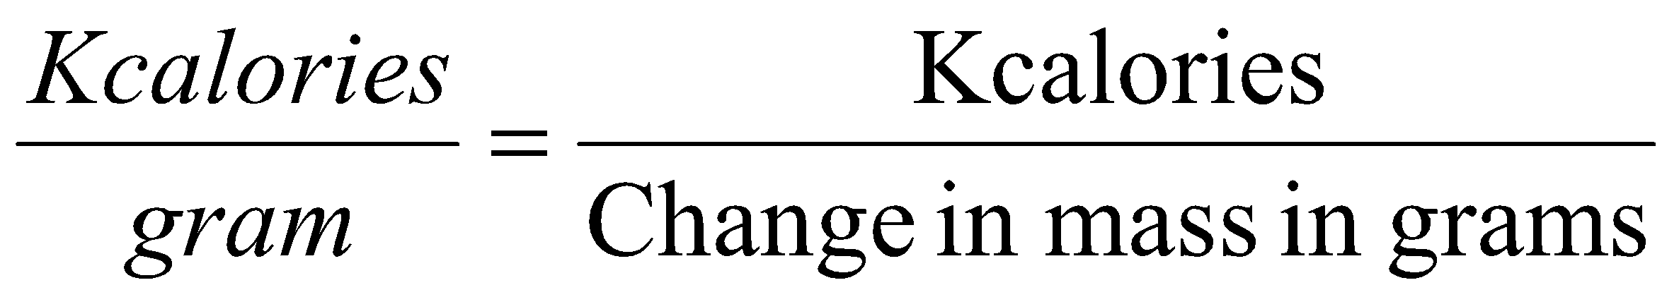

Example:
0.5 gram nut lost 0.35 grams in mass from burning
100 grams of water are heated
The temperature rises 15 degrees C

Energy (in Kcalories) = (100 grams of water) x (15 degree C) 1000

Energy = 1.5 Kcalories.

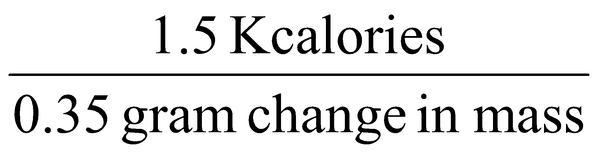
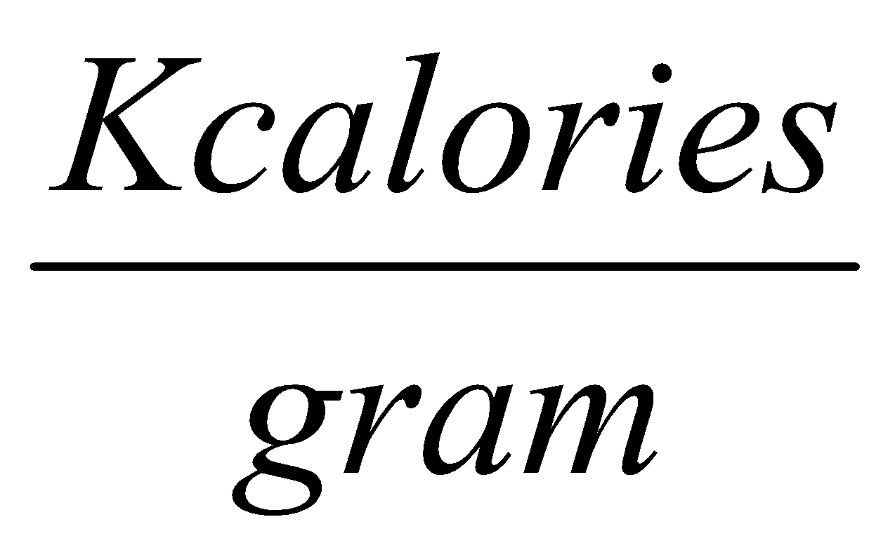
= = 4.29 Kcal/g

Calculation Guide:
Note: Blanks with identical letters below should contain the same value.
Complete for each nut burned.

Before Burning:
Amount of water used _________milliliters = _________grams
a a
Mass of nut: _________grams
b
Temperature of water: _________ degrees Celsius
c
After Burning:
Mass of nut: _________grams
d
Temperature of water: _________ degrees Celsius
e
Change in mass of nut: _________ – _________ = _________ grams
b d f

Change in temperature of water: _________–_________ = _________degrees Celsius
e c g
Kcalories = (mass of water in grams) x (temperature change) = (a) x (g) = ________
1000 1000 h
Kcalories = Kcalories = (h) = _________ Kcalories
gram Change in mass in grams (f) i gram

Final Calculations:
Used for averaging all results.

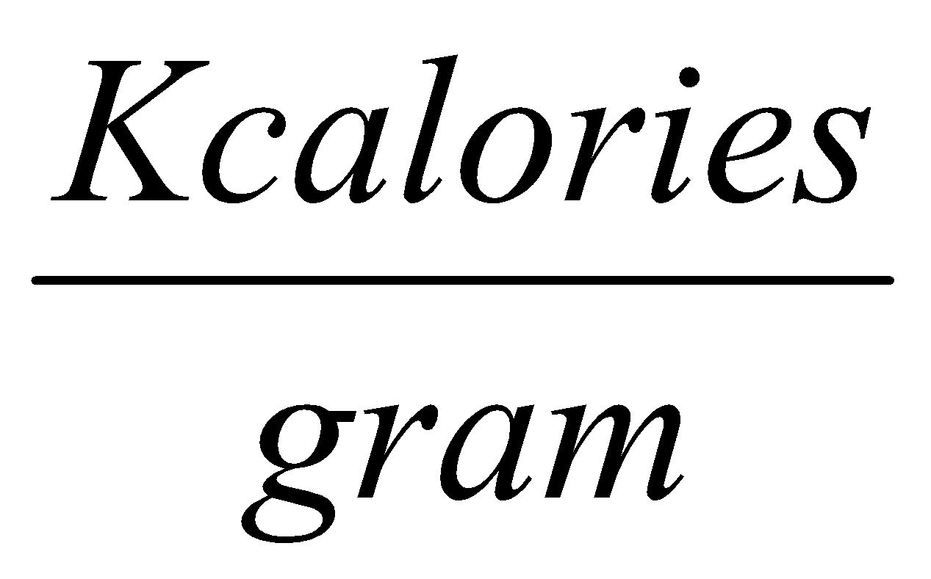
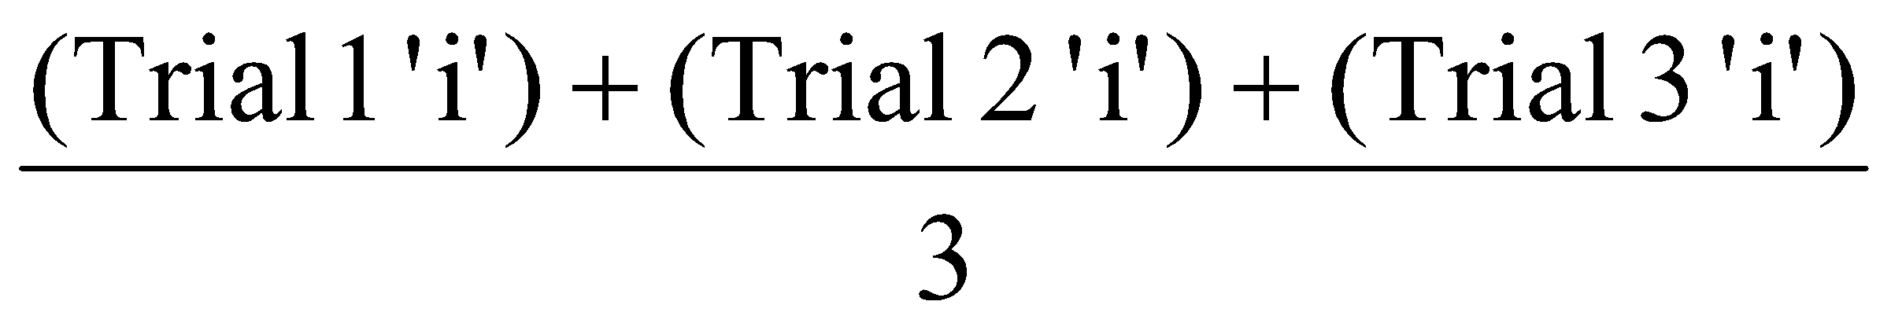
Average = = _________

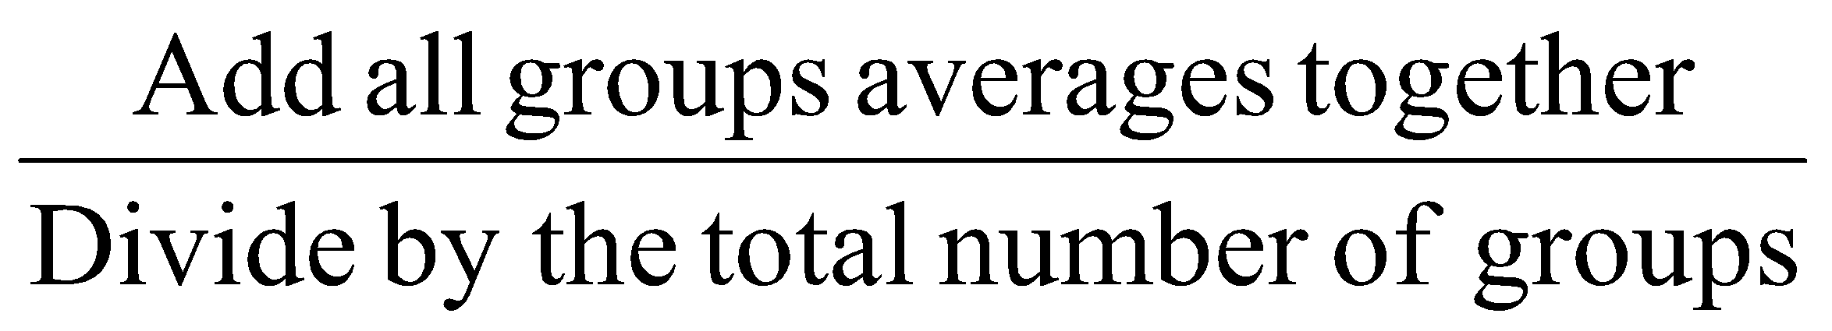
Class Average = = _________

Questions:

Describe the nuts before and after burning. How were they different? What happened to the energy in the nuts? What proof do you have that supports your answer?
________________________________________________________________________________________________________________________________________________________________________________________________________________________________________________________________________________________________________________________________________________________________________________________________________________________________________________________________________________________________________________________________________________________

How is burning the nuts similar to what happens to food in your body? How is it different?
________________________________________________________________________________________________________________________________________________________________________________________________________________________________________________________________________________________________________________________________________________________________________________________________________________________________________________________________________________________________________________________________________________________

Were there any sources of error in the experiment? If so, what were they and how would they affect the results of the experiment? _________________________________________________________________________________________________________________________________________________________________________________________________________
How could this experiment be changed to provide more accurate results? ________________________________________________________________________________________________________________________________________________________________________________________________________________________________________________________________________________________________________________________________________________________________________________________________________________________________________________________________________________________________________________________________________________________

