Student or Group Name: Date:
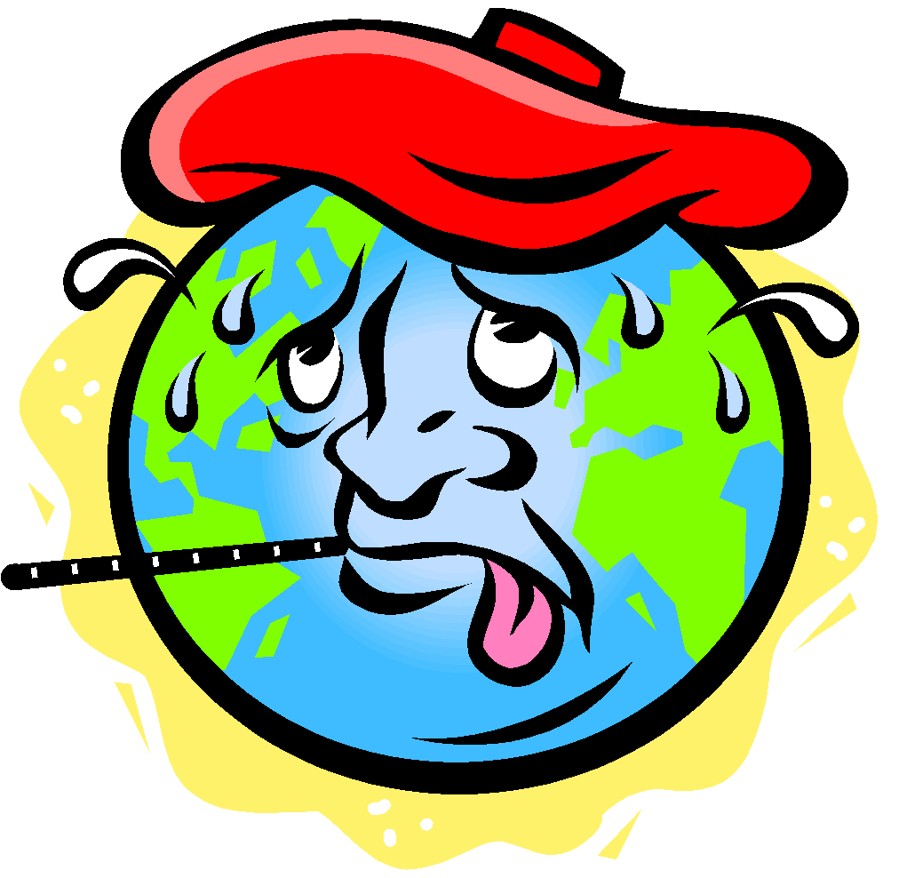 | Activity 1  A Global Warming Experiment

Question: Will melting of the polar ice sheets raise the level of sea water along beaches and coastal cities?

Procedure:
1. Fill a tall glass with ice.

2. Set the glass on a dry paper towel.

3. Fill the glass completely to the top without spilling any water and without letting any water overflow. The paper towel should be completely dry.

4. Make a hypothesis (prediction) on what will happen when the ice melts. Record that hypothesis. Will the glass overflow?

Questions:

1. Record your hypothesis (prediction) about whether the water would overflow the glass when the ice melted?

2. Did the water overflow? Why or why not?

3. On the basis of this experiment, what would you predict would happen to sea level if the polar ice sheets were to melt?

4. Would the impact on sea level be different if the ice in glaciers or icebergs melted? Why or why not?

