Student or Group Name : Date:
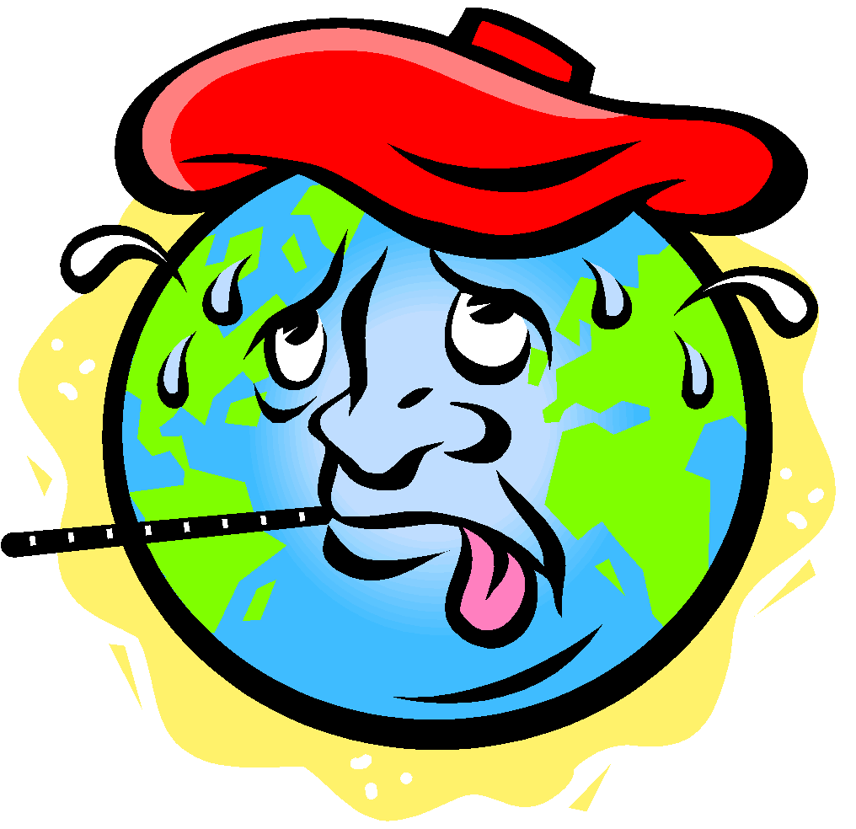 | Activity #3  Local Environmental Health Hazards

Procedure:
Using the websites listed below, identify any environmental problems in your area. Do you have any ideas on what could be done to prevent or solve the problems? Record the problems and possible preventions/solutions below.

Texas Environmental Concerns:
Texas Parks and Wildlife: https://tpwd.texas.gov/landwater/water/environconcerns/
Texas Air Quality: https://www.airnow.gov/index.cfm?action=airnow.local_state&stateid=45, https://www.tceq.texas.gov/airquality/monops/forecast_today.html
Texas Commission on Environmental Quality Superfund Sites: https://www.tceq.texas.gov/remediation/superfund/sites/county
Cleanups in My Community Map (national map): https://www.epa.gov/cleanups/cleanups-my-community

1. Identify any environmental health hazards in your area.

2. What ideas do you have for preventing or solving the problems?

