Name:__________________________________________________ Date:_______
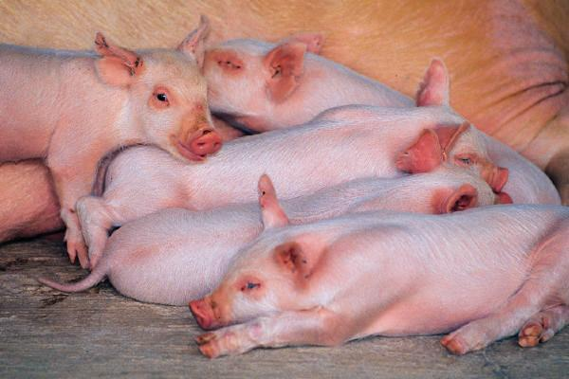 | Activity 3 – Natural Selection  Selective Breeding | 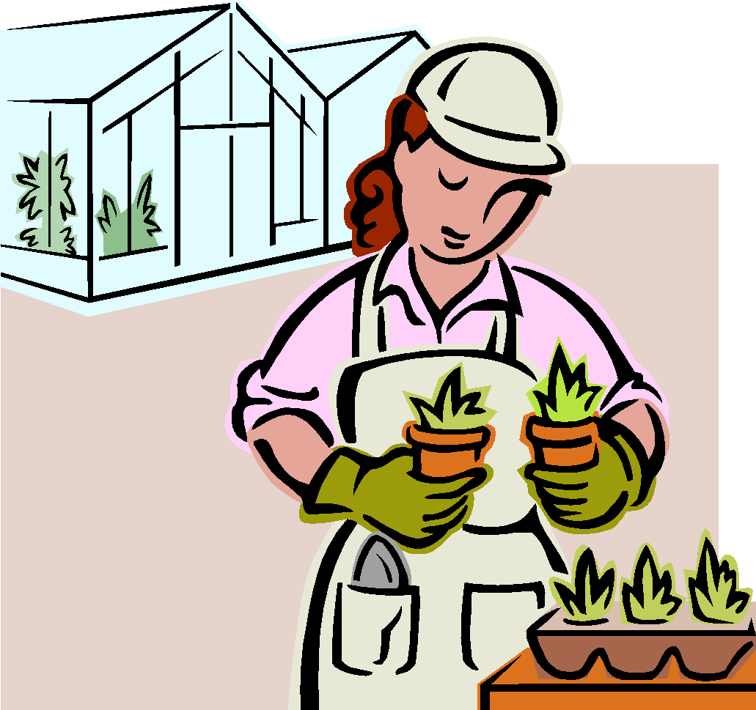

Interview task Assigned (example: farmer breeding better milk cows) _________________________________________________________________

- List the traits the selective breeder desires to pass on in his animals or plants.

- Does the breeder select males or females (or both) for these traits?

- For question two, give the reason for this decision.

- How long does it take for the traits to start showing up in the following generations?

- Do some traits show up in the first generation? Do some take longer? Which traits are immediate, which delayed?

- For plants that are propagated by cuttings or bud transplants, how is gene frequency for the desired traits affected by whether or not the plants are allowed to go to seed?

- For plants that are hybrids, how is gene frequency for desired traits affected? Why?

