Activity 1 – Population Growth

Teacher Instructions

This activity will demonstrate how a population of bacteria grows. Students will manipulate data and use their knowledge of populations to answer questions based on an imaginary bacterial colony, or group of bacteria. Then they will graph the growth of this colony.

Objective
After this activity, students should be able to:
-Graph bacterial growth
-Make inferences about population growth

Materials:
Writing paper, writing utensil

Name: ______________________________________________ Date: ____________

Activity 1 – Population Growth

Use your knowledge of bacterial growth and the information provided in this module to fill in the blanks in the chart.
Given Information:
- Each cell of this type of bacteria divides every 8 minutes
- No cell death occurs

Time (minutes) | Number of Cells
0 | 1
8 | 2
16
24
 | 16
 | 32
48
64
 | 512
80
 | 4,096
104
 | 16,384
120

Now that you’ve finished filling in the chart, plot the data on the grid provided below.
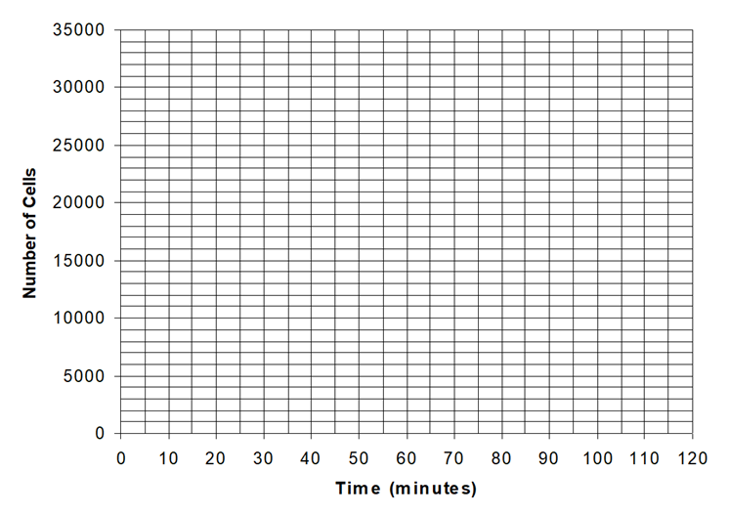
After you have plotted all the points on the graph, avoid simply drawing straight lines between points. Instead, draw a curved line including the plotted points that you think most accurately represents the trend of growth in the bacterial colony.

Answer the questions below based on the above graph.
- A straight line cannot be used to describe the bacterial growth in this colony. Why?

- The rate of growth, or the number of cells added with each division, depends on what?
- If growth continues at this rate, over 1,000,000,000 bacterial cells would be present after another two-hour period. In real ecosystems, however, this would never occur because the resources of any environment are limited. Therefore, the number of bacterial cells would also be limited. Use this knowledge to sketch a graph representative of real-world growth.
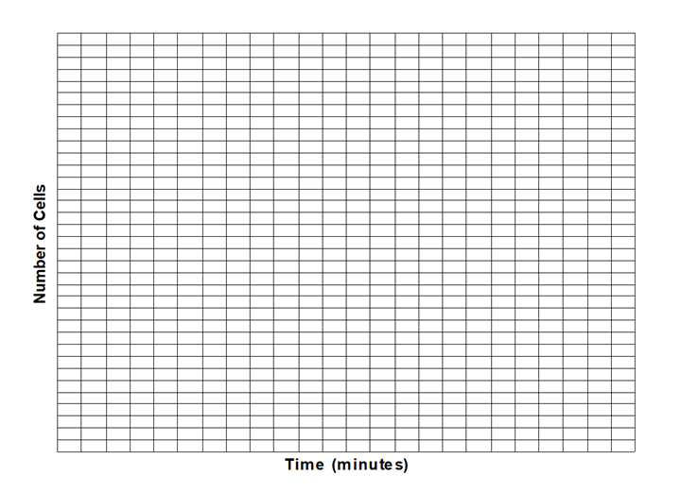
- Recent estimates place the population of humans somewhere just over 7,500,000,000. Knowing that humans are subject to a set of environmental limits, as are all living things, at what point in the future do you think the world population will level off? Support your answer.

Activity 2 – A Thought Exercise on Origin of Species

Teacher Instructions
Students will answer questions on the worksheet. Teacher have students work in groups or have a class discussion of answers.

Objective
This activity is designed to stimulate student thinking about how species might evolve.

Name: ________________________________________Date: _______________

Activity 2 – A Thought Exercise on the
Origin of Species

Please write the answers to the following questions:

1. A mutation occurs in the reproductive cell (sperm or egg) of a single individual. This mutation has the potential to create a new species. But how can this happen, since a species must begin with at least two individuals, male and female, who produce enough offspring to create a sustainable new species?

2. Bacteria were around for a billion years or more before "higher" organisms appeared. Why did it take so long for higher forms to appear?

3. Why is sexual reproduction important to populations arising that create a new species?

4. If a population beings to develop new characteristics, can these characteristics be passed on genetically to future generations? Give an example where this cannot happen and another where it can.

5. If a population stopped reproducing sexually, but still reproduced asexually, how would its genetic variation be affected over time? Could speciation occur in this situation?

Activity 3 – A Bird Watching Activity

Teacher Instructions
Students will make a bird feeder and observe the number and types of birds that visit the feeder.

Objective
This activity is designed to allow students to observe how creation of a niche (bird feeder) affects the number and kinds of birds in an area.

Materials:
Use the directions at this site to make a milk jug bird feeder: https://www.wikihow.com/Build-a-Milk-Jug-Bird-Feeder

Name: ____________________________________________ Date: __________

Activity 3 – Watching the Birds

1. Make a milk jug bird feeder by following the directions at: https://www.wikihow.com/Build-a-Milk-Jug-Bird-Feeder

2. Set up the feeder, fill it with bird seed, and keep it filled for the 7 days that you will observe the birds. Depending on your schedule, try to observe birds once in the morning and once after school for at least 15 minutes during each of the seven days.

Date started:
Location of feeder:
Times of day when observations made:
Length of observation time:

Fill in the table and make notes on your observations of the behavior of the birds that visit your feeder.

Day 1 (supply information requested) | Morning Session | Afternoon Session
 | # Birds seen: | # Birds seen:
 | # Kinds (species): | # Kinds (species):
 | Notes on behavior of birds: | Notes on behavior of birds:
Day 2 (supply information requested) | Morning Session | Afternoon Session
 | # Birds seen: | # Birds seen:
 | # Kinds (species): | # Kinds (species):
 | Notes on behavior of birds: | Notes on behavior of birds:

Day 3 (supply information requested) | Morning Session | Afternoon Session
 | # Birds seen: | # Birds seen:
 | # Kinds (species): | # Kinds (species):
 | Notes on behavior of birds: | Notes on behavior of birds:
Day 4 (supply information requested) | Morning Session | Afternoon Session
 | # Birds seen: | # Birds seen:
 | # Kinds (species): | # Kinds (species):
 | Notes on behavior of birds: | Notes on behavior of birds:

Day 5 (supply information requested) | Morning Session | Afternoon Session
 | # Birds seen: | # Birds seen:
 | # Kinds (species): | # Kinds (species):
 | Notes on behavior of birds: | Notes on behavior of birds:
Day 6 (supply information requested) | Morning Session | Afternoon Session
 | # Birds seen: | # Birds seen:
 | # Kinds (species): | # Kinds (species):
 | Notes on behavior of birds: | Notes on behavior of birds:

Day 7 (supply information requested) | Morning Session | Afternoon Session
 | # Birds seen: | # Birds seen:
 | # Kinds (species): | # Kinds (species):
 | Notes on behavior of birds: | Notes on behavior of birds:

Write a summary of your observations and be ready to discuss with your group or class:

Activity 4 – Changes in a Niche Essay

Teacher Instructions
Students will write an essay. Teacher will determine length and format. In this essay, they will describe a niche and the animals and plants within it with which they are familiar. For example, the niche may be in their backyard, a farm, a park, or a place that they go to often.
After describing the niche, they will explain what kinds of things could change or damage this niche. These can be caused by nature or by humans. Then they will summarize what can be done to protect this niche and the populations of animals that live in it.

Objective
This activity is designed to allow students to make careful observations and analyze and integrate them into a coherent essay.

Materials:
Writing paper and writing instrument

Name: _________________________________________ Date:______________

Activity 4 – Changes in a Niche

Writing Prompt:

Fritjof Capra, an Austrian-born American ecologist said, “A diverse ecosystem will also be resilient, because it contains many species with overlapping ecological functions that can partially replace one another. When a particular species is destroyed by a severe disturbance so that a link in the network is broken, a diverse community will be able to survive and reorganize itself... In other words, the more complex the network is, the more complex its pattern of interconnections, the more resilient it will be.”

Write an expository essay describing a niche and the animals and plants within it with which you are familiar. For example, the niche may be in your backyard, a farm, a park, or a place that you and your family go to often. After describing the niche, explain what kinds of things could change or damage this niche. These can be caused by nature or by humans. Then summarize what can be done to protect this niche and the populations of animals that live in it.

Be sure to —
• clearly state your controlling idea
• organize and develop your explanation effectively
• choose your words carefully
• use correct spelling, capitalization, punctuation, grammar, and sentences

Activity 5 – Root Beer Energy

Teacher Instructions
Students will model the transfer of energy in an ecosystem/energy pyramid from the sun to the tertiary consumers.

Objective
The purpose of this activity is to give students a visual representation of how much energy is taken and lost from the sun and how that energy is transferred between organisms.

Materials:
1 liter of Root beer (or any other cola)
4 graduated cylinders
Eyedropper

Name: ____________________________________________Date: ________

Activity 5 – Root Beer Energy
From the Utah State Office of Education website
Photosynthesis explains how energy from the sun is captured by green plants and used to make food. Most of this energy is used to carry on the plant's life activities. The rest of the energy is passed on as food to the next level of the food chain.
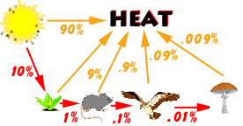
The figure above shows energy flow in a simple food chain. At each level of the food chain, about 90% of the energy is lost in the form of heat. The total energy passed from one level to the next is only about one-tenth of the energy received from the previous organism. Therefore, as you move up the food chain, there is less energy available. Animals located at the top of the food chain need a lot more food to meet their energy needs.
NOTE!! Each organism in the food chain is only transferring one-tenth of its energy to the next organism.
Try this fun activity with your class to help make this clearer. Think of energy as root beer. The teacher will represent the sun and four students will represent the organisms in a food chain: a plant, an insect, a sparrow and a hawk. You will need a liter of root beer, graduated cylinders, and an eyedropper.
Reviewing the above diagram, we find that:
- The sun has one liter of root beer (energy) to give.
- Of that, the plant gets one-tenth or 100 milliliters.
- The mouse gets 10 milliliters from the plant.
- The hawk gets 1 milliliter from the mouse.
- When the hawk dies and is decomposed by the mushroom, the mushroom gets only one-tenth of a milliliter!
When the root beer has been distributed in the correct amount to each participating student, they can drink their share.
The extra root beer that the sun does not give to the plant, is likened unto the 90% energy lost to the environment. You as the teacher to simulate this energy loss, pour the remaining root beer down the drain and listen to the moans of your students!

After doing the activity, answer these questions.
1. Which organism was most satisfied by the amount of "energy" he or she received? Which organism was least satisfied?

2. What happened to the 900 milliliters from the sun that the plant didn't absorb?

3. How much "energy" was USED by the insect?

4. What consumer in the food chain is going to have to eat the most food to meet their energy needs?

5. Why can't a food chain have an infinite number of links?

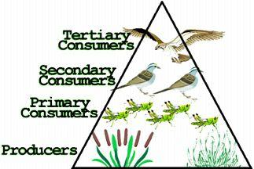
You can see that because energy is lost at each step of a food chain, it takes a lot of producers to support a few top consumers. The food pyramid below shows an example of this.

Notice that if there were 1000 units of energy at the producers level the primary consumers would receive 100 units of energy, the secondary consumers would receive 10 units of energy, and the tertiary consumer would receive 1 unit of energy. This pyramid helps to demonstrate the loss of energy from one level of the food chain to the next. Printed from the website http://www.usoe.k12.ut.us/curr/science/sciber00/8th/energy/sciber/ecosys.htm

Activity 6 – Arctic Food Web

Teacher Instructions
Instructions for this activity along with the resources and materials are found at:
https://www.teachercreated.com/lessons/270

Objective
The purpose of this activity is for students to create food webs for animals in the arctic.

Materials:
Pencils or pens
Resource materials
Computer with Internet access (optional)
Arctic Food Web Activity Sheet (find it at the “download” button at the top right of the page on the website listed above)

