Name: ______________________________________________ Date: ____________

Activity 1 – Population Growth

Use your knowledge of bacterial growth and the information provided in this module to fill in the blanks in the chart.
Given Information:
- Each cell of this type of bacteria divides every 8 minutes
- No cell death occurs

Time (minutes) | Number of Cells
0 | 1
8 | 2
16
24
 | 16
 | 32
48
64
 | 512
80
 | 4,096
104
 | 16,384
120

Now that you’ve finished filling in the chart, plot the data on the grid provided below.
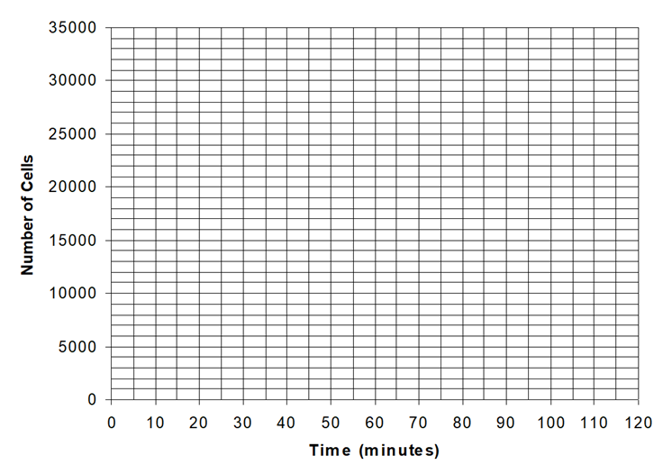
After you have plotted all the points on the graph, avoid simply drawing straight lines between points. Instead, draw a curved line including the plotted points that you think most accurately represents the trend of growth in the bacterial colony.

Answer the questions below based on the above graph.
- A straight line cannot be used to describe the bacterial growth in this colony. Why?

- The rate of growth, or the number of cells added with each division, depends on what?

- If growth continues at this rate, over 1,000,000,000 bacterial cells would be present after another two-hour period. In real ecosystems, however, this would never occur because the resources of any environment are limited. Therefore, the number of bacterial cells would also be limited. Use this knowledge to sketch a graph representative of real-world growth.
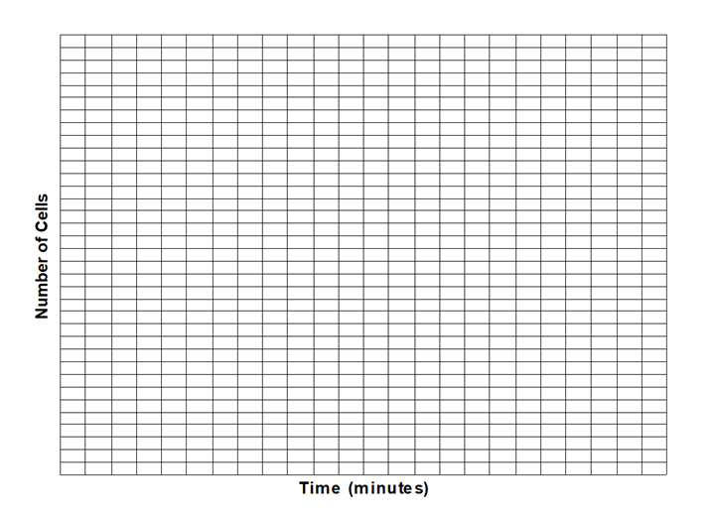
- Recent estimates place the population of humans somewhere just over 7,500,000,000. Knowing that humans are subject to a set of environmental limits, as are all living things, at what point in the future do you think the world population will level off? Support your answer.

