Ready, set, infect!
Emily Kang
Recreate the epic fight between pathogens and the immune system in your classroom.
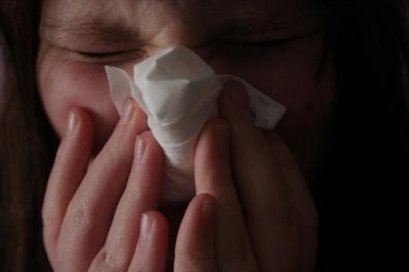
Image courtesy of Anna
gutermuth; image source:
Flickr
Anyone who has seen live footage of a human white blood cell chasing and capturing a bacterium in the body would think he or she was witnessing a game of cops and robbers. The white blood cell indefatigably chases the invader until the cell reaches its goal of ingesting and then ‘spitting out’ the villain. Unfortunately, the excitement of the chase does not easily translate onto the written page of a science textbook.
‘Ready, set, infect!’ is a role-playing game for middle-school science classrooms (ages 11–14). It allows students to experience how dynamic the human immune system must be to protect the body against infection via three lines of defence: skin; white blood cells (through inflammation); and antibodies (via the immune response).
The game can be taught in one 45-minute class and can be played as an introduction to the immune system or as a follow-up lesson. Rather than learning through textbook diagrams and direct instruction, students actively engage in and develop a model of how each component interacts with the other to protect the body from invasion and illness. Students can also use their model to argue whether or not a hypothetical patient’s blood test shows evidence of an immune response. Teaching through role-playing games allows students to engage in the messy nature of science.
Antibody versus antigen competition
The immune system relies on three main lines of defence, two of which are non-specific to the pathogen, and one of which is specific to fighting one particular type of germ.
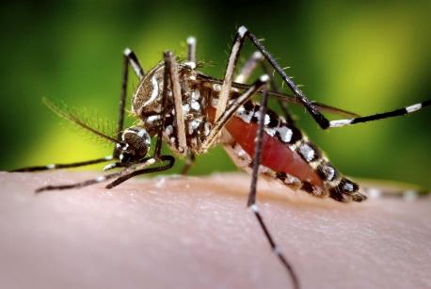
Our skin is the first line of
defence against infection.
Image courtesy of Sanofi
Pasteur; image source: Flickr
Non-specific defense
- Skin (or mucus or cilia): skin is an effective barrier to the entry of microorganisms, while cilia, tears, sweat, saliva, mucus and earwax trap or wash micro-organisms away.
- Inflammatory response (white blood cells): various types of white blood cells either surround and engulf microorganisms (e.g. neutrophils and macrophages) or kill their targets by releasing damaging chemicals (e.g. natural killer cells or basophils) . For example, histamines (released by basophils) promote the dilation of local blood vessels and the release of further white blood cells from the vessels to enter the infected tissue.
Specific defense
- The game is a competition between two teams, in which students on one team represent an invading source of infection (antigens), and students from the other team are members of the human immune system (skin, white blood cells and antibodies).
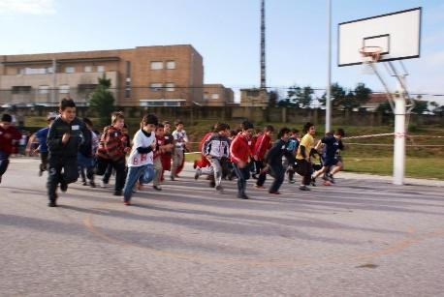
The game is a competition between two teams, in which students on one team represent an invading source of infection (antigens), and students from the other team are members of the human immune system (skin, white blood cells and antibodies).
Image courtesy of Pedro
Dias; image source: Flickr
Materials
- Role cards
These can be downloaded from the additional materials section.
Procedure
- Before the lesson starts, you should cut the antigen–antibody cards along the dotted lines to separate the two roles. There are enough role cards for a class of 28 students, but extra cards can be copied for larger classes. The role cards can be enlarged or laminated for ease of use.
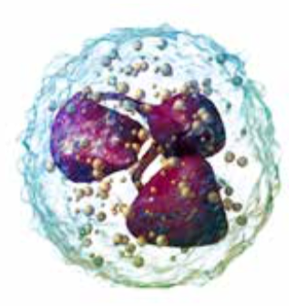
Neutrophil, a type of white
blood cell that engulfs
invading cells.
Image courtesy of BruceBlaus;
image source: Wikimedia
Commons
- As part of a whole-class discussion, begin by asking students to share the last time they were ill and how long the illness lasted. You can ask follow-up questions such as “Have you ever wondered why your doctor checks the glands on the side of your neck?” and “How do you think you were eventually able to recover?”. Students may mention the role of their immune system in the recovery process.
- Store tables and chairs at the side of the classroom and clear enough space for students to walk quickly around the room. To ensure safety, no running is permitted during the activity. Tagging by touch must be gentle – no pushing.
- Ask each student to pick a card with their eyes closed; it is important that students do not know who their matching antigen or antibody is before the start of the game. The cards will determine the roles of the participants as follows:
- Skin – this role is taken by the teacher, so that the rest of the class may participate in the game. The teacher is in charge of keeping the door of the classroom closed (the door remains unlocked but the teacher must keep the door from being opened by members of the opposite team, who are standing outside the classroom) until a cut or a breach in the body’s mucus membrane is simulated. Then the teacher (or skin) opens the door and lets the antigens into the classroom.
- White blood cells (macrophages, neutrophils and natural killer cells) – these students are in charge of standing inside the classroom, by the door, to prevent invading antigens from proceeding further into the room. The macrophages and neutrophils must ‘engulf’ antigens by placing two hands on an antigen’s shoulders. If only one hand is touching the antigen, then it can escape and roam free. The natural killer cells should be provided with a plastic pipette filled with a small amount of water to simulate the release of damaging chemicals. Natural killer cells can only wet the right hand of an antigen to ‘destroy’ it.
If the antigens successfully make it past the white blood cells, then the white blood cells summon the third line of defence: the antibodies, who have been waiting until that stage.
- Antibodies – these students are antigen-specific and should wait further inside the classroom. Their cards are uniquely shaped so that the students are allowed to capture only the student who carries the card with the complementary shape. This is why it is important that students do not know who their matching antigen or antibody is before the start of the game.
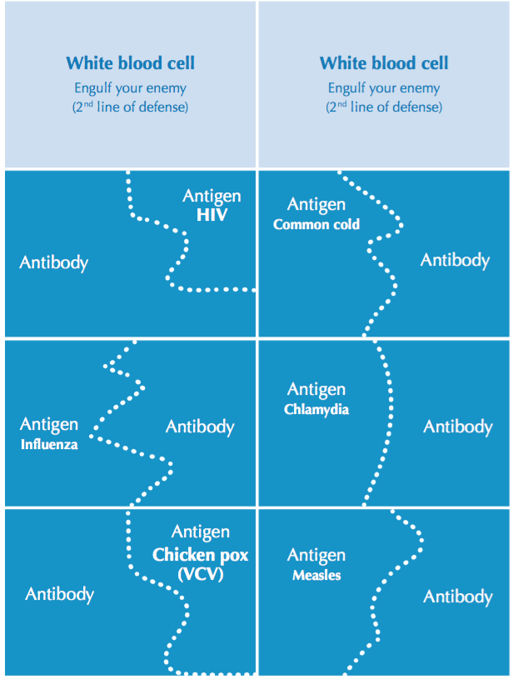
- Antigens – these students remain outside the classroom door at the start of the game. When the teacher gives the signal, the antigens must try to enter the classroom (even though the skin prevents the antigens from entering). If the antigens are successful in passing through the first line of defence, then they must battle the second line (white blood cells), who will try to tag the antigens by touching the antigens’ shoulders. If the antigens are successful in escaping the white blood cells, then it is up to the antibodies (the third line of defence) to tag the antigens. Once an antigen is tagged, it must present its card to the antibody. If the cards are a match, then the antibody and antigen sit down next to each other. If the cards do not match, the antibody must release the antigen and attempt to capture the next antigen until it finds and captures its match.
Examples of ‘Ready, set, infect!’ role cards.
Image courtesy of Emily Kang
The teacher should act as the narrator, timekeeper and referee of the game. As the narrator, the teacher should commentate on the action (e.g. when the antigens pass each line of defence or how many antigens are still at large).
Note: although B cells have an important role in making antibodies and proliferating, their role in this game is eliminated to provide as many students as possible with an active part in the chase as antibodies or antigens. Should the teacher wish to include B cells in the game, he or she can assign a student to play a B cell that is responsible for making additional role cards for B cells as quickly as possible.
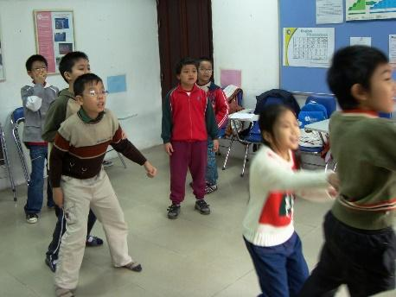
Image courtesy of Gavin White;
image source: Flickr
- Play the game as described above for about 4–5 minutes. If there is a single surviving antigen at the end of the game, then the class is infected with the disease named on the antigen’s card and the body will become ill (e.g. catch a cold) as the antigen multiplies. If all the antigens are vanquished, then the immune system has successfully kept the body healthy.
- Repeat the game at least twice, with the teams switching roles so that each student is allowed to play a role on both sides. Note that once the body has been infected, the immune system begins synthesising antibodies and additional white blood cells to defeat the invader. Then the system keeps a memory of the antigen as well as copies of the corresponding antibody should future infections occur. So if the class is ‘infected’ during the first game, then the corresponding antibodies should be present during the second game.
- Once the game has finished, have a brief discussion with students to ascertain what they learned or observed as a result of playing the game. Encourage them to summarise the process by which the immune system defends the body against pathogens.
- Ask the students to draw a model of the immune system (it can be a concept map, a comic strip, an animation or any other form of expression that is appropriate) to evaluate their ability to analyse data and construct an explanation based on their analysis. They should include terms from each of the three lines of defence in their diagrams.
- As an extension to the game, students can research the viruses labelled on the antigen cards to discover more about their pathogenesis, diagnosis, treatment and epidemiology.
‘Ready, set, infect!’ allows teachers to present a challenging concept in an understandable way to many types of middle-school learners, particularly those who learn best through movement and social interaction. It also allows students to develop a more complex conceptual model of how cells, chemicals and infecting agents interact simultaneously in the immune system. On a grander scale, the game gives them a deeper appreciation of their bodies.

Resources
- Watch a white blood cell chase bacteria: www.youtube.com/watch?v=JnlULOjUhSQ
Author
Emily Kang is an assistant professor of science education at Adelphi University in New York, USA. She is a former middle-school science teacher and currently focuses on teaching future teachers and providing professional development for elementary and secondary-school science teachers.

