PEER Life Science Organ Systems Coordination and Control Notes Outline

Why It Matters
- Brain scans indicate that the frontal cerebral cortex does not mature until about age 25.
- Some major nervous system diseases include:
  - Traumatic brain injury - concussion ruptures microtubules inside of neurons and neuronal contacts due to mechanical forces
  - Epilepsy - random episodes of convulsions due to overactive neurons
  - Stroke - interruption of blood supply to brain
  - Parkinson’s disease - disease of old age causing continuous trembling, depression, and poor motor skills
  - Alzheimer’s disease - disease of old age that kills nerve cells
- Name 4 mental disorders:
  - Depression
  - Anxiety
  - Schizophrenia
  - Bipolar affective disorder
  - Dementia
  - Post-traumatic stress disorder
  - Obsessive-compulsive disorder
  - Insomnia
What We Know
- The central nervous system is made up of the brain and spinal cord and is responsible for coordination and processing of nervous activity
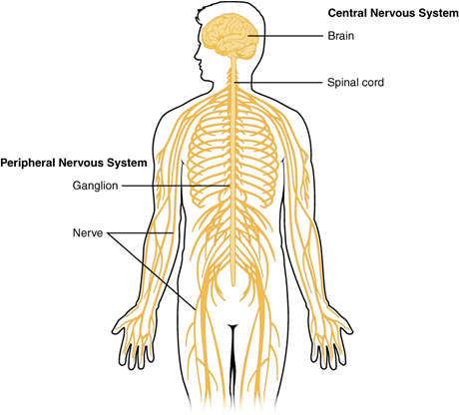
- The peripheral nervous system is the messenger to and from the CNS and includes sensory and motor neurons.
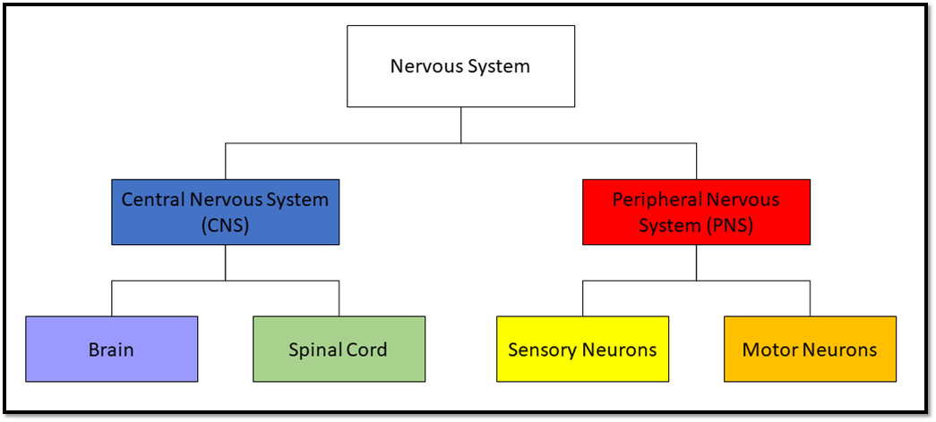
- Draw out a diagram or flowchart showing the organization of the nervous system
- Nerve cells are called neurons. The small branches that receive information from other neurons are called dendrites, and the long extensions that send information to other neurons are called axons.
- Sensory neurons take in information and send it to the brain or spinal cord. Motor neurons conduct impulses from the CNS to muscles or glands throughout the body.
- Some neurons have an insulating material called myelin around their axons to help electrical impulses move quickly down the cell.
- Two actions of neurons include generating electricity and secreting chemicals.
  - When a neuron has been excited it can carry an electrical impulse down the axon and release chemicals called neurotransmitters into a small gap between neurons called a synapse.
- Nerve impulses are also called action potentials.
- The three parts of the brain are:
  - The cerebrum - where higher functions like thinking, reasoning, learning, and emotions take place, where sensory impulses are interpreted, where memory is stored, and where fine control of bodily movements are directed.
  - The cerebellum - coordinates muscle movements, maintains posture, and maintains balance.
  - The brainstem - connects the cerebrum and cerebellum to spinal cord and controls involuntary actions like breathing, heart rate, and body temperature regulation.
- The spinal cord is made up of neurons that carry information between the brain and body.
- The peripheral nervous system is divided into two branches: the somatic system controls voluntary actions and the autonomic system controls involuntary actions.
- Sometimes, with urgent information like pain, impulses are carried from sensory neurons to the spinal cord and then straight back out to motor neurons without input from the brain. This kind of action is called a reflex.
- We know the mind is made up of nerve impulse patterns through EEGs showing us that:
  - Changing electrical activity changes the associated thought.
  - Changing the thought changes the electrical activity.
- Name five stimuli that humans can detect:
  - Light waves
  - Sound waves
  - Chemicals we smell
  - Chemicals we taste
  - Physical forces
  - Muscle tone and limb position
- Sensations are mapped in our brains, meaning that certain areas of the brain interpret and initiate only certain types of information from certain places in the body.
- Consciousness comes from the interaction between the cerebral cortex and the reticular formation
- Strong or meaningful stimuli trigger consciousness.
- There are two stages of sleep: slow wave sleep (SWS), which occurs in stages, and rapid eye movement or REM sleep in which brain activity resembles wakefulness.
- Learning involves
  - Attending new information
  - Registering or encoding that information
  - Associating it with prior knowledge
  - Forming a temporary or working memory
  - Consolidating temporary memory into a more lasting form
- Emotions arise as reactions to stimuli perceived from the outside world or our own thoughts.
- The area of the brain that processes emotions is called the limbic system.
- Classical conditioning uses a natural biological response to one stimulus to associate that behavior with a stimulus that normally would/would not trigger that response.
  - In Pavlov’s experiment:
    - Food was the unconditioned stimulus.
    - Salivating was the unconditioned response.
    - The noise started out as a neutral stimulus when it did not elicit a response and became the conditioned stimulus when it caused the conditioned response of salivating.
- Operant conditioning uses reinforcement and punishment to teach new behavior.
  - Reinforcement increases/decreases the likelihood of a behavior being repeated.
  - Punishment increases/decreases the likelihood of a behavior being repeated.
- The two neurotransmitters involved in the brain’s reward system are dopamine and norepinephrine.
- Stroke occurs when a blood vessel supplying the brain is blocked or ruptured, cutting off the blood supply to that part of the brain and killing the neurons in that area.
- Parkinson’s Disease causes a person’s limbs to tremble uncontrollably.

How We Know
- Chemicals that neurons secrete onto each other are called neurotransmitters, and they can excite (increase impulse firing), inhibit (decrease impulse firing), or modulate the response (make more or less sensitive to other chemicals) of the following neuron.

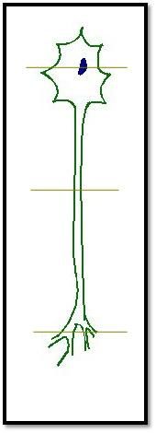
- Draw what it would look like if you cut through the neuron at the following points:
- How can we tell where neurons go and connect?
  - Kill the neurons and see where else in the brain degeneration appears.
  - Electrically stimulate an area and record responses in various other places to see what other areas respond quickly enough to be considered directly connected.
  - Inject radioactive precursors into a known area to see where they are transported to.
- An electroencephalogram or EEG puts electrodes on specific areas of the scalp to monitor the electrical currents/activity of the brain.
Common Hazards
- Acetylcholinesterase or cholinesterase inhibitors have been used as pesticides, medicines, and biochemical weapons of war. They inhibit or stop the activity of the enzyme cholinesterase.
- Acetylcholine is a neurotransmitter released at junctions between neurons and skeletal muscle, neurons and cardiac muscle, and neurons and smooth muscle, as well as between neurons and other neurons.
  - Acetylcholinesterase is present next to acetylcholine receptors on these targets to prevent buildup of acetylcholine in the junction between the neuron and the target cell. If it wasn’t there in a neuromuscular junction, your muscles would be constantly contracting or convulsing.
- Name 3 symptoms of cholinesterase inhibitor poisoning:
  - Muscle weakness
  - Difficulty walking
  - wheezing/coughing
  - Difficulty breathing
  - Blurry vision
  - Vomiting
  - Sweating
  - seizures/coma
- Cholinesterase inhibitors used as pesticides contaminate the environment and affect more than just insects.
- Cholinesterase inhibitors enhance acetylcholine activity and can be used to treat diseases like Alzheimer’s Disease, carbon monoxide coma, and glaucoma.
- Cholinesterase inhibitor poisoning can be treated by blocking acetylcholine receptors. The most common drug used for this is called atropine.

