Student or Group Name: Date:

Activity 1-

What’s the Right Dose?

From: https://www.pbs.org/wgbh/nova/teachers/activities/2805_cancer.html

When developing new medicines and cancer treatments, researchers must first determine important properties of the drugs at certain doses, including efficacy, toxicity level, the biological effects in cells, and the drugs' side effects. Only in this way can scientists determine which dose will maximize the desired effect while causing the fewest side effects. In this activity, you will determine a dose response curve for the effect of salt on a vital intracellular process in liver cells.

Procedure
- Copy down this data table.
Trial # | Drops of Liver  Cell Homogenate | Dosage of Salt  (# of drops) | Response Time  (# of seconds)
1 | 15 drops
2 | 15 drops
3 | 15 drops
- Add 15 drops of liver cell homogenate to three different wells in the spot plate. You will be conducting three dosage trials and determining their average.
- Add the prescribed dose (# of drops) of salt solution that has been assigned by your teacher to each well.
- Wait four minutes for the salt to "act" on the liver cells. While waiting, prepare a test tube with .34 fluid ounces (10 ml) of 3 percent hydrogen peroxide. Prepare your balloon, and decide who will be the time-keeper.
- Begin Trial #1: Use a pipette to add 3 drops of the liver cell/salt mixture directly to the hydrogen peroxide. Immediately place the balloon on the test tube and start tracking time. Avoid shaking or tapping the test tube because this will release too many oxygen gas bubbles too quickly and bias the readings.
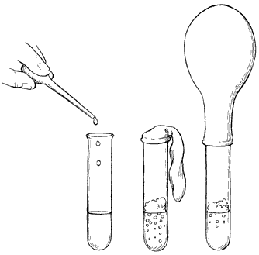
- When the balloon is filled with enough oxygen gas, it will stand up straight. Stop the watch and record the time.
- Repeat the above procedure for Trials #2 and #3. Make sure you use .34 fluid ounces (10 ml) of fresh hydrogen peroxide each time and that you squeeze any gas out of the balloon.
- Average your results for the three trials and provide this figure for the class data table.
Questions
Write your answers on a separate sheet of paper.
- According to the graph, what does salt do to intracellular processes in liver cells? Explain your reasoning.

- What might happen to cells and tissues of the body if the liver is unable to deactivate and eliminate hydrogen peroxide?

- Based on the class data table, what do you think are acceptable doses of salt? What doses do you think might be too toxic? Why?

