Activity 1 – Build Your Own Spirometer!

Teacher Instructions
This activity is designed to allow students to make a simple device that measure their own lung capacity. For a video of a similar set up, click here.

Objective
After this activity, students should be able to:
- Investigate the structure and function of the lungs by building a spirometer
- Record and analyze data

Materials per each set up:
1 3-liter soda bottle (empty) with cap
1 2-foot piece of plastic tubing for each student (can be cleaned at the end of the experiment)
1- 250 ml graduated cylinder
1 bucket or pan that can hold more than 3 liters of water
1 permanent marker
Length of masking tape

Student or Group Name: Date:

Activity 1-

Build Your Own Spirometer!

Spirometers are used to measure the amount of air that fits in your lungs and how much air you normally inhale and exhale. This is very useful in learning about our bodies and can help doctors determine if we are sick.

Materials:
3-liter clear soda bottle (empty) with cap, or for larger students, a milk jug or bottle that holds over 3 liters
2-foot long piece of plastic tubing for each student (can be cleaned at the end of the experiment)
250 ml graduated cylinder
A bucket or pan that can hold more than 3 liters of water
A permanent marker
A length of masking tape

Procedure for Making the Spirometer:
1. Place a piece of masking tape from the top of the 3-liter soda bottle (or larger bottle) to the bottom. It will be marked in 250 ml increments so the bottle can be used to measure the air you blow into it. To mark the bottle, measure 250 ml of water in a graduated cylinder and add it to the 3-liter bottle. Mark the tape, using the permanent marker, where the water level is on the bottle. Repeat this until the bottle is full making marks on the tape every 250 ml. If the last mark is less than 250 ml from the top, just fill the bottle to the top and do not put a last measuring mark. When the bottle is full, put the cap on the bottle. The bottle should look like the picture below.

2. Add sufficient water to the bucket or pan to submerge the soda bottle.

3. Invert the soda bottle and submerge it in the bucket, and remove the cap under the water. You could also carefully place your hand over the open end of the full bottle and submerge that end in the water and then remove your hand.

4. Place one end of the tubing into the soda bottle in the water, and leave the other end outside of the water.

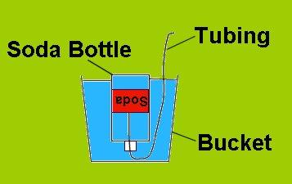

A simple spirometer

Tips:
-Remember to place the bottle in the water upside down before removing the cap or your hand.
-Don't forget to insert one end of the hose in the bottle after you open the cap underwater
-Before you exhale into the tubing, your spirometer should resemble the above picture.
For a video demonstration of how to make a spirometer, click here.

Procedure for Using the Spirometer:

1. While a partner holds the bottle to keep it from flipping over, inhale as much air as possible, then exhale all of the air into the tubing connected to the spirometer. Be sure to blow out all the "extra" air in your lungs. The bottle will now have a large amount of air in it. Count the number of marks above the water level.

Number of marks: ______________

How much air can my lungs hold?

To get a good estimate of your vital capacity, or the greatest volume of air that can be expelled from the lungs after taking the deepest possible breath, multiply the number of marks times 250 milliliters. That will give you total milliliters of air expelled.

Number of marks x 250 ml = vital capacity ml

________________ x ________________ = __________________ml

To convert that number to liters, divide your total by 1000 ml.

Vital capacity ml ÷ 1000 ml = vital capacity in l

_______________________ ÷ 1000 ml = _______________l

This is a good estimate of your vital capacity.
Questions:

Estimated Vital Capacities
Males by Height
Height | 150–155 cm (5'–5'2") | 155–160 cm (5'2"–5'4") | 160–165 cm (5'4"–5'6") | 165–170 cm (5'6"–5'8") | 170–175 cm (5'8"–5'10") | 175–180 cm (5'10"–6')
Vital Capacity (cm³) | 2900 | 3150 | 3400 | 3720 | 3950 | 4300

Males by age
Age | 15–25 | 25–35 | 35–45 | 45–55 | 55–65
Vital Capacity (cm³) | 3425 | 3500 | 3225 | 3050 | 2850

- Look at the tables above. In the first table, what trend do you see in the data comparing the height of a male to his vital capacity? Why do you think this occurs?

- In the second table, what trend do you see in the data comparing the vital capacity of males with their age? Why do you think this happens?

- The vital capacity of women is slightly lower than that for men of the same height and age. Can you give a reason why that might occur? (hint: it has nothing to do with fitness levels)

- Compare your estimated vital capacity with the tables. Do you think your vital capacity is in the normal range? Remember, you may be younger than the youngest age on this table, and if you are a female, your numbers should be less than reported on these tables.

- What are two things that could change your vital capacity for the worse (the number would go down) and why would they cause a change?

Activity 2 –

Just Breathe

Teacher Instructions
This activity can be found on: https://www.teachengineering.org/activities/view/cub_human_lesson09_activity1

Students explore the inhalation/exhalation process that occurs in the lungs during respiration. Using everyday materials, each student team creates a model pair of lungs. This activity includes a detailed description of the activity, step-by-step instructions, a video that shows the completed project, and questions for the students with a teacher key included.

Objective
In this activity, students will:
- Describe the function of the respiratory system.
- Create a model of the lungs and explain what happens to them when you inhale and exhale.
- Give examples of engineering advancements that have helped with respiratory systems.

Materials for each group:
- 2-liter empty plastic bottle with cap
- 2 plastic drinking straws; available inexpensively at restaurant supply stores or donated by fast-food chains; do not use the flexible drinking straws
- 2 9-inch balloons
- 1 larger balloon; for example, for a punch ball
- 2 rubber bands
- Lung Worksheet, one per student

Activity 3 – Blow it Up!

Teacher Instructions
This activity focuses on measuring respiratory values. The students will first predict, then test a hypothesis regarding respiratory rates. Students will draw conclusions based on their own collected data. An Excel sheet is included to compare data using graphs.

Objective
After this activity, students should be able to:
- Investigate the function of the lungs
- Record and analyze data

Materials per each set up:
1 balloon for each student
Flexible measuring tape
Meter stick/Ruler

Student or Group Name: Date:

Activity 3-

Blow it Up!

Measuring respiratory values not only helps us understand how the lungs work, but it also can help doctors determine if a patient might have lung disease. In this activity, we will measure vital capacity using balloons and then compare these values to our fellow classmates. Vital capacity is the volume of air that can be expelled after a full inhalation. The total air holding capacity of the lung is the sum of the vital capacity and the residual volume. Even when you try extremely hard to expel all of the air in your lungs, there is still some air left in the alveoli and airways. If there wasn't, then your alveoli and airways would collapse!!

Materials:
1 balloon for each student
Flexible measuring tape
Meter stick/Ruler

Pre-Lab:
1. Make Predictions/Hypothesis
Using what you know about lung health, make predictions on how the following variables will affect the vital capacity. Circle your choice.

Gender:
-Males’ vital capacity is greater than Females’
-Females’ vital capacity is greater than Males’
-Male’s vital capacity is equal to Females’
Why do you predict this?
_____________________________________________________________

Height:
-Taller people will have a greater vital capacity than Shorter
-Shorter people will have a greater vital capacity than Taller
Why do you predict this?
_____________________________________________________________

Sports Participation:
-People who play sports will have a greater capacity than those who don’t play sports
-Don’t who don’t play sports will have a greater capacity than those who do play sports
Why do you predict this?
_____________________________________________________________

Procedure:
1. Sit down and take deep breaths in and out five times.
2. Breath in, as deeply as possible.
3. Hold a balloon to your mouth, tightly sealing the opening, and blow all the air out of your lungs.
4. Take the balloon out of your mouth, taking care to keep the opening sealed tightly.
5. Continue holding the balloon while your partner measures the girth of the balloon (in centimeters). The girth is the circumference of the widest part of the balloon.
6. Record this value down on TABLE A as the Vital Capacity Girth.
7. Breathe in and out normally. Have your partner count the number of breaths you take in 30 seconds.
(1 breath = breathing in and then out).
8. Double this number to obtain the breaths taken in 1 minute and record this number on TABLE A as the Resting Respiratory Rate.
9. With your partner timing you, run in place for 1 minute.
10. At the end of one minute, sit down to have your elevated respiratory rate measured. (Partner: As soon as the student sits down, measure the number of breaths the student takes in 30 seconds.)
11. Double this number to obtain the breaths taken in 1 minute and record this number on TABLE A as the elevated respiratory rate.
12. Measure your partner's height in inches and record his/her height and gender on TABLE A.
13. Record your values, and report your values from TABLE A to your teacher in order for him/her to fill out TABLE B.

Table A
Student Name | Gender (M/F) | Height  (in) | Vital Capacity Girth (cm) | Resting Respiratory Rate (breaths/min) | Elevated Respiratory Rate (breaths/min) | Plays Sports  (Y or N)

Discussion Questions:

1. Look back at your hypothesis. Using the data collected during the activity, report on the results for each variable.
Gender: ___________ had greater vital capacity than ___________.

Height: _____________ had greater vital capacity than _______________.

Play Sports: _____________ had greater vital capacity than ____________.

2. Were your hypotheses (predictions) supported or not supported?

3. Which variable (Gender, Height, Sports Player) seemed to have the greatest effect on the vital capacity? Why?

4. What does vital capacity measure? Why would it change from person to person?

Activity 4 – Breathing Easy?

Teacher Instructions
In this activity, students will learn what it can feel like to have asthma. This activity is best done in pairs, with one person doing the activity while the other is timing. Or it can be done as a class with the teacher timing the activity.
Safety Note: Students with asthma or respiratory illness should not participate in this activity. This activity could trigger an asthmatic attack. If any student
asthmatics are in your class, they can skip this activity or designate them to be the timers so that nobody is
excluded.

Objective
After this activity, students should be able to:
- Simulate the feeling of asthmatic breathing
- Compare and contrast normal breathing to asthmatic breathing

Materials per each set up:
Regular drinking straws (one per student)
Timer or watch

Student or Group Name: Date:

Activity 4-

Breathing Easy?

Background Information:
Asthma is a disease that affects the lungs. In asthma, the airways and lungs become inflamed and narrower. With less space in the airways, it is harder to breathe. Asthma is one of the most common long-term diseases of children, but adults can have asthma, too. Asthma causes wheezing, breathlessness, chest tightness, and coughing at night or early in the morning. If you have asthma, you have it all the time, but you will have asthma attacks only when something bothers your lungs.

We don’t know all the things that can cause asthma, but we do know that genetic, environmental, and workplace factors have been linked to developing asthma.

Objective:
In this activity, you will:
- Simulate the feeling of asthmatic breathing
- Compare and contrast normal breathing to asthmatic breathing

Safety Note: If you have asthma or a respiratory infection, do not do this activity. You can observe or be the timer for this activity. This activity could trigger an asthma attack.

Materials:
Regular drinking straws (one straw per participant)
Timer/watch
Procedure:
1. For the first trial, decide who will do the activity and who will time.

2. Breathe normally for 1 minute and think about what your breathing feels like.

3. Next, clamp both nostrils shut with thumb and forefinger, and breathe through the straw for 30 seconds. Do not open your mouth, but make all air move through the straw. Think about what it feels like. At the end of the 30 seconds, remove the straw and breathe normally. Safety First! If at any time you are feeling light-headed or dizzy, stop breathing through the straw, and sit down until your breathing returns to normal.

4. Now, clamp both nostrils shut again, and breathe through the straw. Run in place for thirty seconds while breathing through the straw. At the end of the thirty seconds, remove the straw and breathe normally. Safety First!
If at any time you are feeling light-headed or dizzy, stop breathing through the straw, and sit down until your breathing returns to normal. Think about how it felt to breathe through the straw while running.

5. Now, change roles and repeat the activity with the other person.

Discussion:
1. This activity simulates how it feels to breathe if you have asthma. Breathing through the straw is like breathing with asthma because you have to breathe through a very narrow tube. Remember, with asthma, the airways become inflamed and become narrower. Using the Venn Diagram below, compare normal breathing to breathing through the straw. In the left side, write about breathing normally. On the left side, write about breathing through the straw. In the middle write things that both have in common.

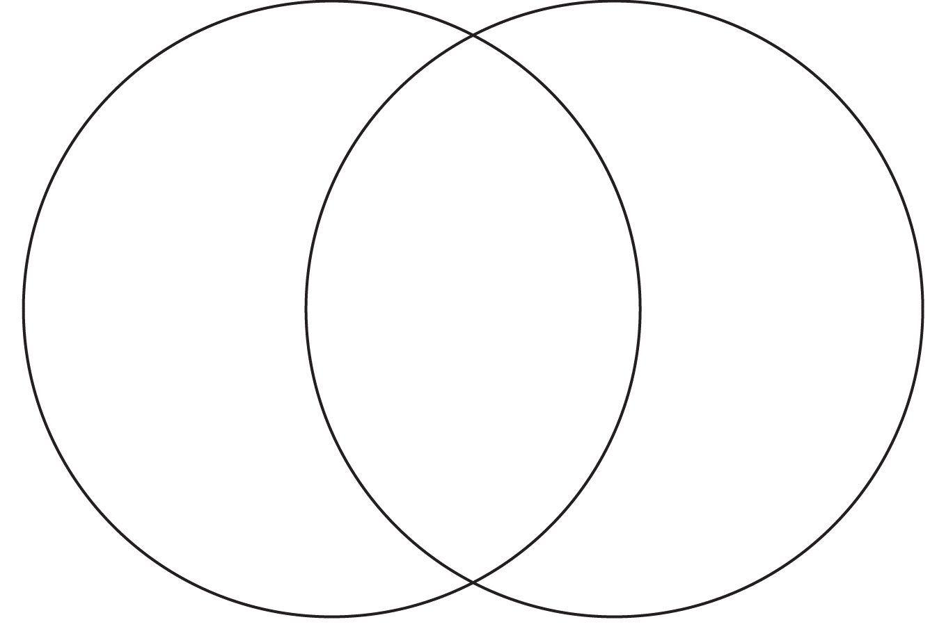
2. This activity also is used to simulate how it feels to breathe if you have the disease called Cystic fibrosis. In cystic fibrosis, the body cells that produce mucous are affected. They produce thick mucous that plugs up tubes and passageways, especially in the lungs and pancreas. Explain why this activity is a good simulation of how it would feel to breath with cystic fibrosis.

