PEER Life Science Organ Systems Digestion Notes Outline
Why It Matters
- The main purpose of the digestive system is to provide the body with nutrients, including
  - water
  - proteins
  - carbohydrates
  - lipids
  - vitamins
  - minerals
- The two main ways that the stomach breaks down proteins into amino acids are acidic stomach juice and enzymes
- Bile is secreted by the liver and helps separate fats so they can be broken down by enzymes and absorbed.
- Insulin is secreted by the pancreas and is involved in a disease called diabetes.

What We Know
- Food first enters the body through the mouth where saliva begins to break down carbohydrates.
- The esophagus pushes food down into the stomach with muscular contractions.
- Bile is produced by the liver and is stored in the gall bladder.
- The pancreas helps digest carbohydrates, proteins, and fats as well as regulates blood sugar.
- The small intestine breaks down and absorbs proteins, carbohydrates, and fats. The large intestine absorbs moisture from what is left of the food.
- The final storage space before waste is removed is the rectum.
- Food stays in the stomach for 4-6 hours, the small intestine for 2-4 hours, and the large intestine for 24-48 hours
- The pharynx has openings that go into the lungs and to the esophagus/stomach.
- The epiglottis is the structure that covers the opening of the trachea and prevents food from entering the lungs.
- The body has a normal pH of 7.2. The stomach has a pH of 2.5 or 2.
- The stomach secretes mucous to protect the lining of the stomach and prevent ulcers.
- The pH of the small intestine is higher than the stomach.
- In addition to making bile, the liver:
  - Processes carbohydrates, fats, and proteins absorbed by the small intestine.
  - Breaks down hormones, drugs, and toxins
  - Makes the proteins in blood responsible for clotting
- The pancreas releases insulin when blood sugar is high and glucagon when blood sugar is low.
- The large intestine removes fluid and salt from solid waste and stores feces.
- The large intestine has many beneficial bacteria that aid in fermentation and produce vitamin K.

How We Know
- A cow’s stomach has four (4) compartments.
- Enzymes in your saliva break down carbohydrates.
- Dr. Beaumont noted that proteins were especially degraded by acids in the stomach.
- The liver is a nutrient storage organ that releases stores as needed.
- The gall bladder is not necessary for life
- The pancreas secretes two hormones into blood
  - Insulin - triggers cells to absorb sugar from blood
  - Glucagon - triggers cells to release sugar into blood
- There are two ducts that connect the pancreas and the small intestine.
- The portal vein collects all of the blood leaving the small intestine and has high amounts of carbohydrates and amino acids.
- Fats from the small intestine are absorbed through lymphatic vessels.
- Blood leaving the large intestine has more water and salt than the blood entering the large intestine.
- Bacteria can break down certain foods that humans cannot.
- Vitamin K is needed for normal blood clotting.

Common Hazards
- Ulcers
  - A lesion in the mucus lining of the stomach or duodenum is called a peptic ulcer.
  - Causes of ulcers include
    - a bacteria called Helicobacter pylori
    - long term use of NSAIDs
    - a disease called Zollinger-Ellison syndrome that causes tumors that release hormones that causes large amounts of acid to be produced.
- Food Poisoning
  - Symptoms of food poisoning are
    - nausea
    - vomiting
    - abdominal cramps
    - fever
    - diarrhea

  - Food poisoning can be avoided by
    - Washing your hands
    - Cleaning kitchen tools
    - Washing fruits and vegetables
    - Cooking food thoroughly
    - Refrigerating leftovers within 2 hours
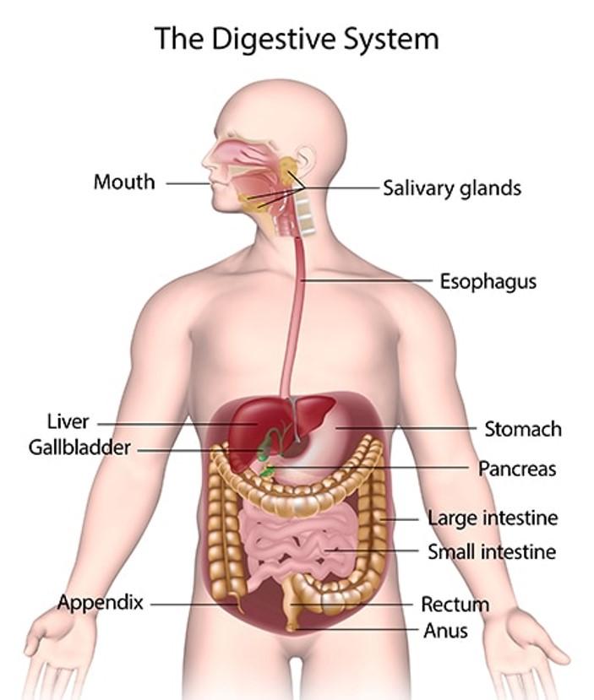
Fill in the blanks labeling the digestive system. (Source: NIH NIDDK)

