PEER Life Science Organ Systems Digestion Notes Outline
Why It Matters
- The main purpose of the digestive system is to provide the body with ____________ including
  - ______________
  - ______________
  - ______________
  - ______________
  - ______________
  - ______________
- The two main ways that the stomach breaks down proteins into amino acids are ____________ and ____________
- _______ is secreted by the liver and helps separate fats so they can be broken down by enzymes and absorbed.
- Insulin is secreted by the __________ and is involved in a disease called ________.

What We Know
- Food first enters the body through the _________ where ________ begins to break down carbohydrates.
- The _________ pushes food down into the stomach with muscular contractions.
- Bile is produced by the _____ and is stored in the _____________.
- The ________ helps digest carbohydrates, proteins, and fats as well as regulates blood sugar.
- The _________ intestine breaks down and absorbs proteins, carbohydrates, and fats. The _______ intestine absorbs moisture from what is left of the food.
- The final storage space before waste is removed is the ______.
- Food stays in the _____________ for 4-6 hours, the __________________ for 2-4 hours, and the __________________ for 24-48 hours
- The ___________ has openings that go into the lungs and to the esophagus/stomach.
- The ___________ is the structure that covers the opening of the trachea and prevents food from entering the lungs.
- The body has a normal pH of ____. The stomach has a pH of ____.
- The stomach secretes _________ to protect the lining of the stomach and prevent ulcers.
- The pH of the small intestine is (lower/higher) than the stomach.
- In addition to making bile, the liver:
  - Processes _________, __________, and __________ absorbed by the small intestine.
  - Breaks down hormones, ________, and ___________
  - Makes the proteins in blood responsible for __________
- The pancreas releases _________ when blood sugar is high and _________ when blood sugar is low.
- The large intestine removes ___________ and __________ from solid waste and stores ___________
- The large intestine has many beneficial _________ that aid in fermentation and produce vitamin K.

How We Know
- A cow’s stomach has _________ compartments.
- ________s in your saliva break down carbohydrates.
- Dr. Beaumont noted that ___________ were especially degraded by proteins in the stomach.
- The liver is a nutrient _________ organ that releases stores as needed.
- The gallbladder (is/is not) necessary for life
- The pancreas secretes two hormones into blood
  - __________- triggers cells to absorb sugar into blood
  - __________- triggers cells to release sugar from blood
- There are two ducts that connect the pancreas and the ______________.
- The _______________ collects all of the blood leaving the small intestine and has high amounts of carbohydrates and amino acids.
- Fats from the small intestine are absorbed through ________ vessels.
- Blood leaving the large intestine has more ________ and _______ than the blood entering the large intestine.
- __________ can break down certain foods that humans cannot.
- Vitamin K is needed for normal blood __________

Common Hazards
- Ulcers
  - A lesion in the mucus lining of the stomach or duodenum is called a peptic __________.
  - Causes of ulcers include
    - a ___________ called Helicobacter pylori
    - long term use of __________
    - a disease called Zollinger-Ellison syndrome that causes tumors that release hormones that causes large amounts of _______ to be produced.
- Food Poisoning
  - Symptoms of food poisoning are
    - _______________________
    - _______________________
    - _______________________
    - _______________________
    - _______________________
  - Food poisoning can be avoided by
    - ____________ your hands
    - ____________ kitchen tools
    - ____________ fruits and vegetables
    - ____________ food thoroughly
    - Refrigerating leftovers within ___ hours
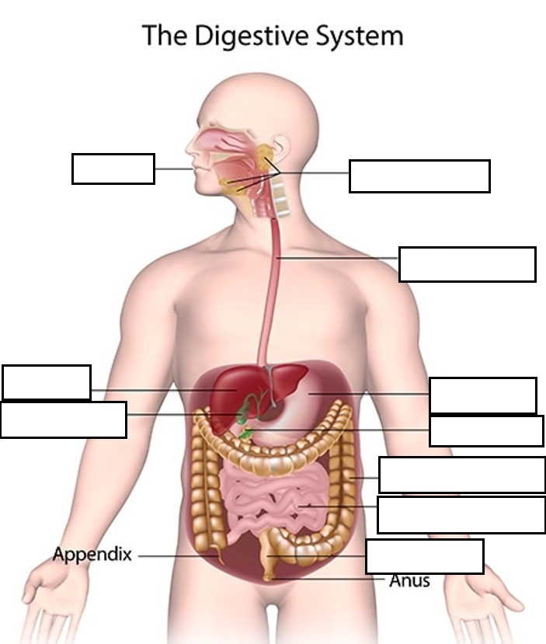
Fill in the blanks labeling the digestive system. (Modified from: NIH NIDDK)

