**C:\Users\karenk\AppData\Local\Microsoft\Windows\Temporary Internet Files\Content.IE5\2C4GRFK4\MCj04245940000[1].wmfSunscreen SPF Experiment Worksheet**

**Instructions**

1. 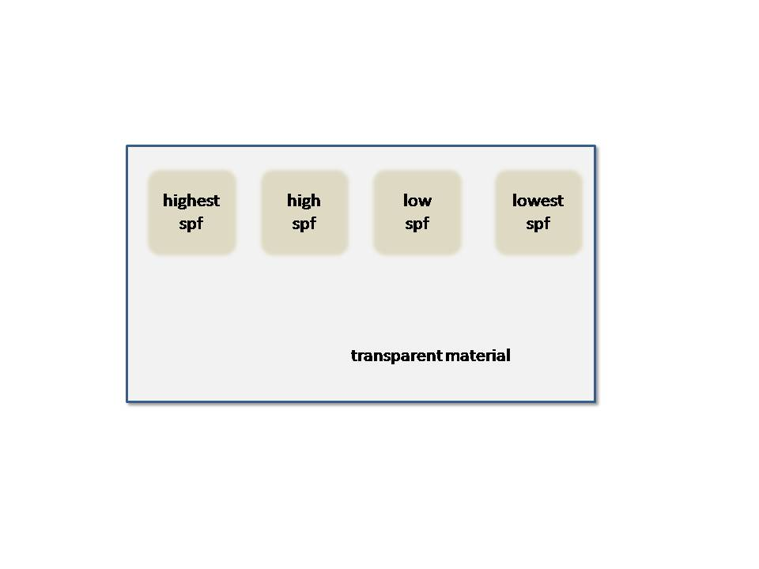Smear sunscreen on your transparency in the   
   order shown in the diagram to the right.   
   A small circle (1-2” diameter) works well. Use the small piece of index card to spread the sunscreen into an even layer.

Why do you think that we organize the sunscreen types like this?

1. 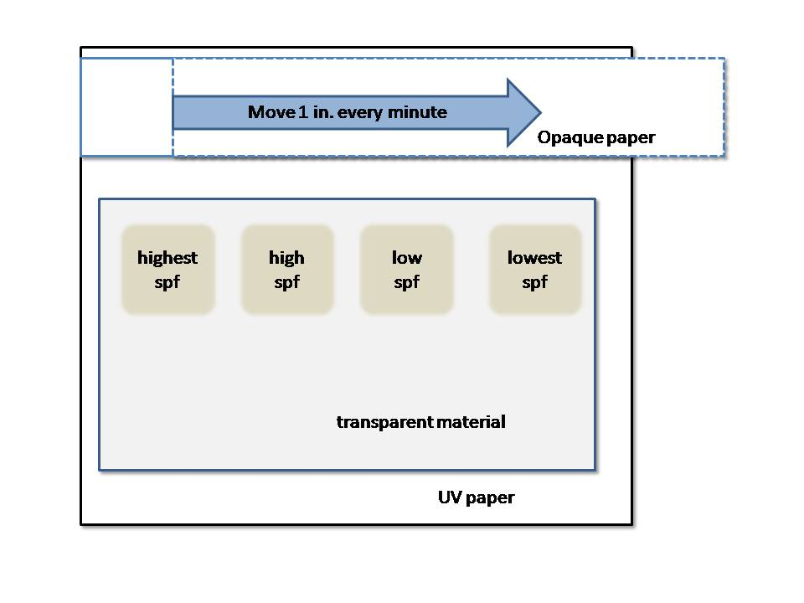When you expose your UV paper, you will put the transparent plastic on top of it and cover the top portion of the UV paper with your opaque index paper to provide a control strip.

Then, after 1 minute, you will move the opaque strip 1 inch to the right. This creates a control area for the experiment.

Practice these steps with regular paper before using UV paper.

1. Record general observations about the experiment. *Does the SPF value seem to affect how much exposure you would have to UV rays as you spend time out in the sun?*

1. Create a bar graph of your results using the axes below. First, write the appropriate SPF values on the horizontal axis. Next, measure how exposed the paper was for each SPF value by comparing that section of UV paper to the control area. Draw the bars accordingly. For example, if an SPF value of 8 looks similar to the control area that you exposed for 3 minutes, then draw a bar with a height of 3 for SPF 8.

**Analysis and Conclusion**

Evaluate your experiment by answering the following questions.

1. How reliable do you think your results are?

1. What are some limitations in your technique and/or errors in your data?

1. What might you do differently if you were to do it again?