Fighting the Invaders: Simple Immunology
Student Handout

Summary:
Students will discover the function of the immune system and how vaccines support immune response.
Before Watching the Video
List five ways our bodies fight off bacteria and viruses.

After Watching the Video
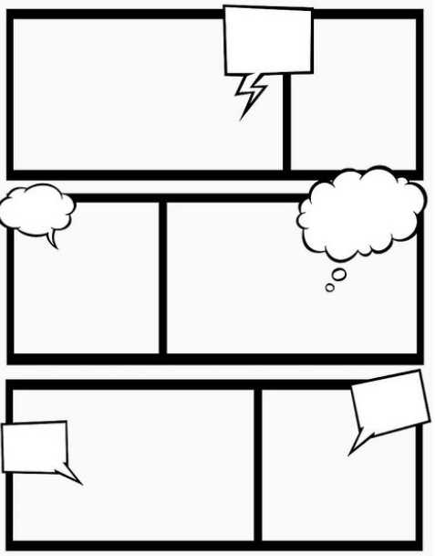
Correct and/or add to your list above.
Create a two to three panel comic illustrating how vaccines aid the immune system in fighting pathogens.

