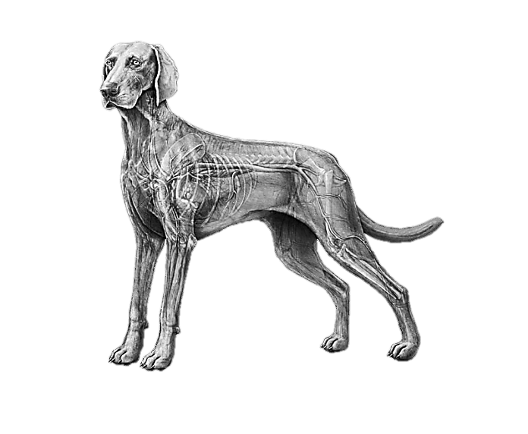  
Name: ___________________________________ Date: ________________ Period: _________________

The Circulatory Systems of Animals

*TEKS: 130.3 Livestock Production 4A, 130.6 Veterinary Medical, Applications 6A-B*

⬥ **What is the Circulatory System?**

⬥ **Three Primary Types of Circulatory Systems:**

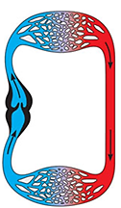 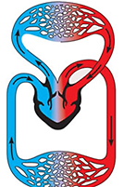 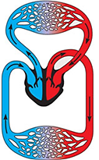 *What animals have these types of circulatory systems?*

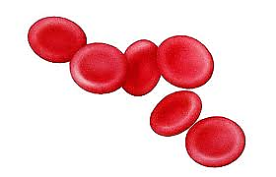⬥ **The Parts of the Circulatory System- Blood**

- The liquid that _______________ in the blood vessels,

_________________ oxygen, carbon dioxide, waste, etc. around the body.

What is blood made of?

⬥ **The Parts of the Circulatory System- Blood Vessels:  
 Veins Arteries Capillaries**

⬥ **The Parts of the Circulatory System- The Heart:**

- This is the that is involved in the blood throughout the body.

- What are the parts of the heart?

**VENTRICLE CHAMBER(s): ATRIUM CHAMBER(s): VALVES:**

*- Draw and describe the differences in the parts of 2, 3 and 4 chamber hearts.*

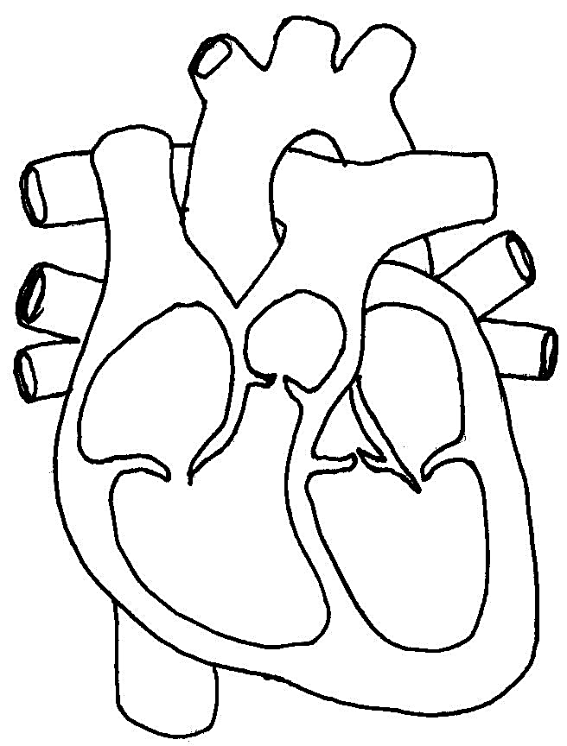*-Label each part of the below 4 chamber heart.*

*Determine how many chambers each of the following animals’ hearts have:*

**Horse:**

**Catfish:**

**Turkey:**

**Pig:**

**Trout:**

**Bull:**