Download all Associated Files for this lesson from our Website

Summary:
This lesson and associated activates will teach students about the different circulatory systems in animals. Students will understand different animals have different systems. The integration of biological science will assist students in understanding how their own bodies are circulated in comparison to animals.
Keywords: circulatory system, loop circulation, chamber, blood, heart, blood vessel, red blood cells, white blood cells, platelets, plasma, vein, artery, capillary, ventricle, atrium, valve

Subject TEKS:
130.3 Livestock Production 4A, 130.6 Veterinary Medical Applications 6A-B

Grade Level: 10th-12th

Learning Objectives: The learner will:
- Distinguish what type of circulatory system each class of animal has.
- Compare human circulatory systems to other types of animal systems.
- Be able to explain how and why blood moves and travels through the body.
- Create and label the components of blood.
- Draw and label the parts of the heart and blood vessels.

Time Required: 2- 50 min. class periods

Materials:
- Animal Circulatory Systems PowerPoint
- Animal Circulatory Systems Handout (1 per student) KEY provided
- Animal Circulatory Systems Activities (for teacher)
- Edible Blood Activity sheet (1 per student) explanation and KEY provided below
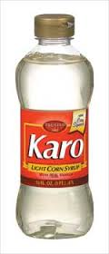
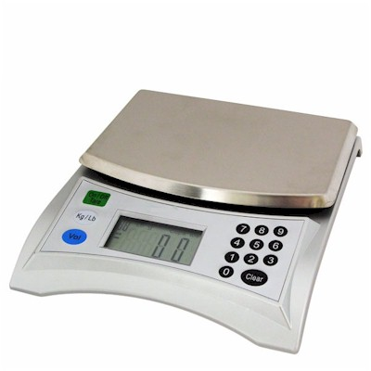
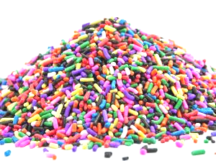
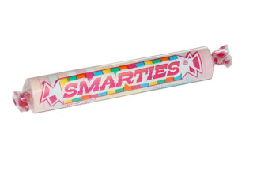
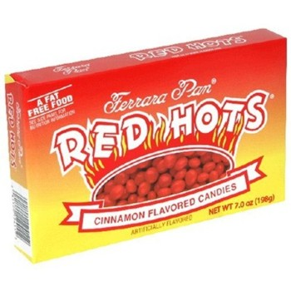
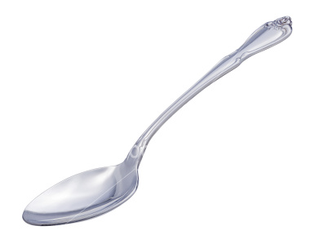
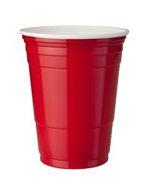
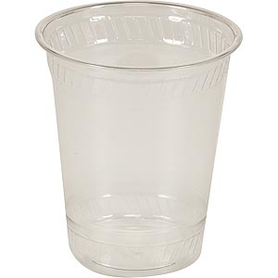
  - Scale (that reads in grams)
  - Small, plastic clear cup
  - Small, plastic colored cup (e.g. Dixie cup)
  - Spoon
  - Red Hots candy
  - Karo Syrup (or any other syrup that is clear)
  - Smarties candy
  - Granola oats
  - Sprinkles

Reusable Activity Cost:
Scales that measure grams can be found online for $10-$20+ (depending on the brand)
Expendable Activity Cost Per Class:~$10 on candy, sprinkles, and Karo syrup
Presentation explanation and application of handout:
The provided Animal Circulatory Systems PowerPoint presentation should be used as a helpful guide for the students to understand and fill out their handouts. You will find that the handout goes along with the presentations, in order. Take the time to let your students fill out the handout.
Slide 14 Has a minute long video clip, if the video does not begin to play when clicked you can watch the video here: http://youtu.be/R-sKZWqsUpw. Be sure to turn up the speakers! Other videos in the PowerPoint are linked below in the Resources section.

Activity and Application of material:
Each student will need an Activity sheet, a clear plastic cup and a spoon. Break the class into groups small enough for the students to share the scale, Dixie cup, spoon and ingredients provided. (You can find the full list of needed materials on the activity sheet.)
Ask your students to read the notes side of the worksheet and underline important details about each part of blood.
Next, explain the lab procedures and allow the class to follow along on their sheet and create their blood models. Your students will need to answer the questions at the bottom of the sheet. The answers are the following:
1-any drawing that is appropriate in your opinion
2-PLASMA=Syrup and sprinkles “Plasma is 90 percent water (Karo Syrup) The other 10 percent consists of glucose, hormones, wastes, minerals, vitamins, proteins, and other substances(Sprinkles).” RED BLOOD CELLS= Red Hots, WHITE BLOOD CELLS= Smarties, PLATELETS= Granola Oats.
3- Blood appears red because of the oxygen in the hemoglobin in red blood cells.
4- This drawing should show low numbers of RBC.

Lesson Extensions: (Optional- if time allows)
Another great way for students to learn about the circulatory system is to have them draw and label a life size model. You will need large sheets of butcher paper and markers. Have the students draw the silhouette a large animal, such as a horse or a pig and ask them to draw and label the parts of the heart. They should also draw and label veins, arteries and capillaries in the animal’s body. Have each student or group present their animal to the class.

Resources:
BILL NYE videos:
http://www.youtube.com/watch?v=GbttJ-5do9M http://www.youtube.com/watch?v=RiYOuI7iyp8
http://www.youtube.com/watch?feature=endscreen&v=WqiPBgVbFDU&NR=1
References:
- http://communities.naae.org/docs/DOC-4874
- http://library.thinkquest.org/28807/data/circ1.htm
- http://www.mcffa.com/uploads/4/4/8/0/4480777/00-respiration__circulation_pp.pdf
- http://www.youtube.com/watch?feature=player_embedded&v=R-sKZWqsUpw
- http://www.youtube.com/watch?v=CjNKbL_-cwA
- http://www.youtube.com/watch?v=5XqEQr-KsW8

Authors:
Undergraduate Fellow: Lindsey E. Nyquist
Graduate Fellow: Jennifer Graham

