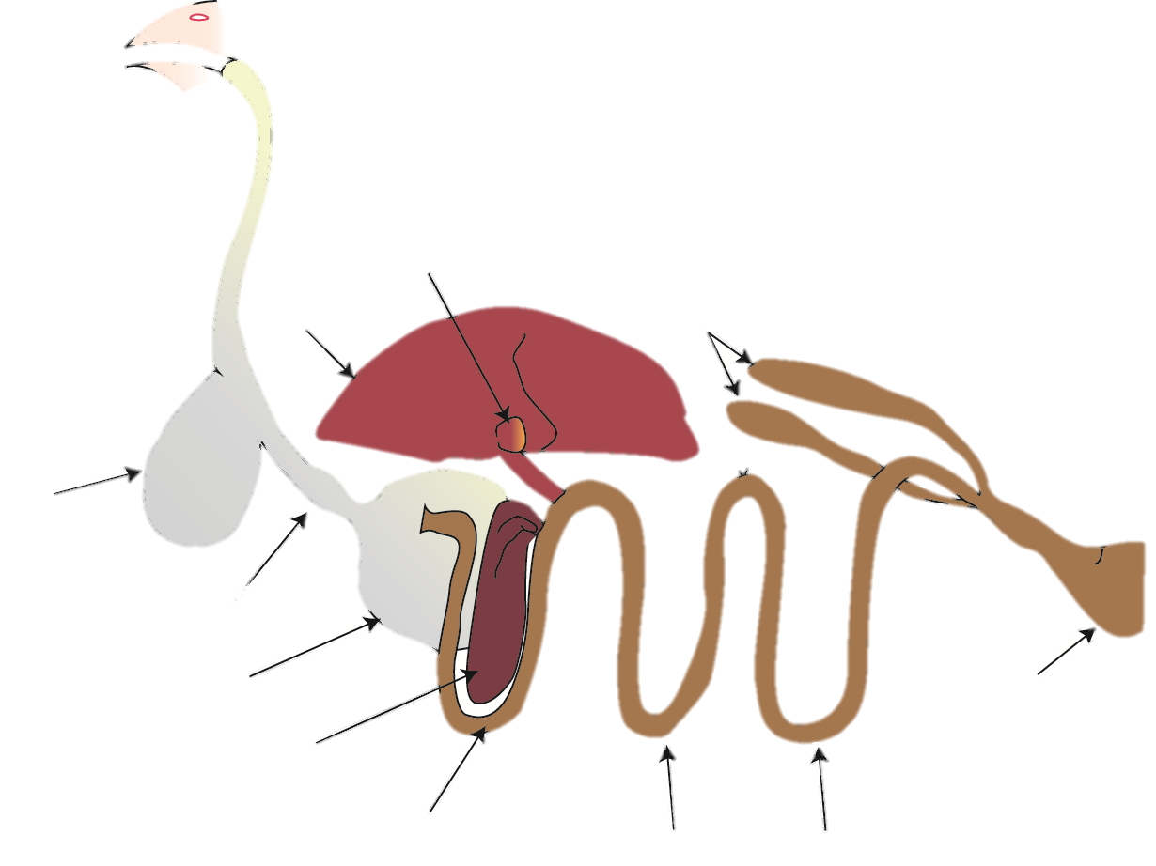

2.___________

**Digestive System Labeling Quiz**

9. ____________

7. _________

8. __________

11.__________

10._______

1. ___________

3.__________

4._____________

5. _____________

6. ______________

13._________

14._________

12._______­­­____