- Mark with an “X” the locations that IM penicillin can be injected.
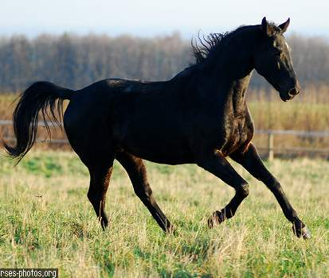
- Where on this animal should you NOT given IM injections? Mark that area with an “X.”

Why shouldn’t we inject at that location?

____________________________________________________________________________________________________________________________________________________________________________________________________________________________________________________________________________________________________________________

- If you don’t want to be kicked by a horse, where should you probably give an IM injection? Put an “X” on that site.
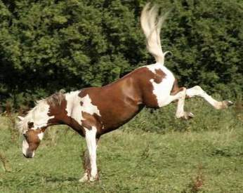
- If we want a vaccine or medicine to be absorbed slowly we use a ___________________injection.
Mark with an “X” on this animal where we can give this type of injection.
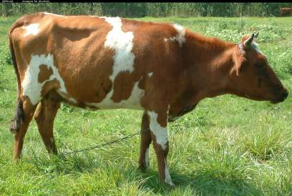
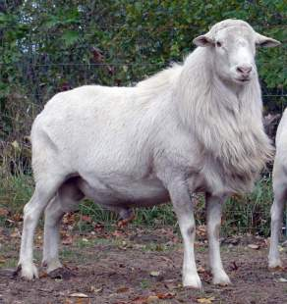
- Mark with an “X” on this animal the injection site that should only be done by a veterinarian or with a veterinarian’s supervision.

What type of injection is given at this site? ____________________________________________

