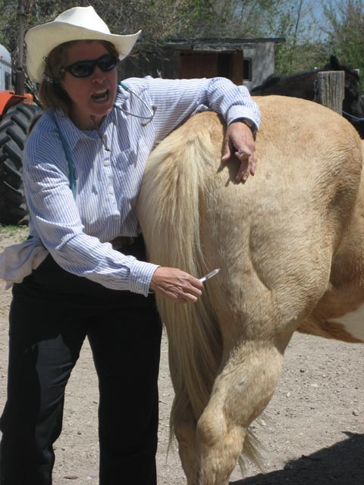
Just Give it a Shot

Summary:
Injections are given to animals to prevent and treat illness. Knowing where and how to give injections and learning safe habits when giving injections are important skills. In this lesson, students will learn the common procedures for giving injections to cattle, sheep, horses, and goats.

Curriculum Objectives:
Livestock Production TEKS | Equine Science TEKS | Veterinary Medical Applications TEKS | Advanced Animal Science TEKS
3 B Describe common veterinary procedures and skills | 2 C Explain methods of maintaining horse health and soundness | 13 D Demonstrate animal care skills such as administering medications | 10 C Explain the methods of prevention, control, and treatment for diseases

Time Required: 1-2 class periods
Materials needed:
- PowerPoint presentation
- Quiz
- Quiz Key
- Activity PowerPoint
- Activity Sheet
Learning Objectives:
- Learn and understand the different types of injections
- Learn where to give the different injections on different animals
- Learn some safety measures to protect both the animal and the person giving the injection

Lesson Procedures:
Preparation:
Have students brainstorm what they know about giving injections and about some ways to stay safe when giving animals injections. Share this as a discussion with the class. Write their answers on a large piece of poster board or on an interactive white board. You may want to categorize their answers as “procedures for injections,” “sites for giving injections,” and “injection safety issues.” Keep this poster during the lesson and put a check by the ideas that are correct. Identify common misconceptions that are written and address these as a closure to the lesson.
Presentation:
PowerPoint presentation on “Injections 101.” This PowerPoint presentation is long due to the amount of material presented. You may want to break this into several days. It is conveniently separated into sections based on category of livestock. Students should take notes as they view the presentation.
Application:
1. Assign students a type of drug for a given animal. This may be done individually or in groups. For example: Liquamycin LA-200 for cattle. Try to pick at least one common drug for each of the classes of livestock mentioned in the PowerPoint; horses, cattle, sheep, and goats.

2. Instruct the students to look up the drug and write its common usage and common administration method. Inform them to include the reference from which they obtain their information.

In this example: Liquamycin LA-200 is to be administered by subcutaneous (SC, under the skin), or intravenous injection according to Beef Quality Assurance Guidelines.
A single dosage of 9 mg of Liquamycin LA-200 per lb of body weight administered subcutaneously is recommended in the treatment of the following conditions:
1) Bacterial pneumonia caused by Pasteurella spp. (shipping fever) in calves and yearlings, where retreatment is impractical due to husbandry conditions, such as cattle on range, or where their repeated restraint is inadvisable;
2) Infectious bovine keratoconjunctivitis (pinkeye) caused by Moraxella bovis.
Liquamycin LA-200 can also be administered by subcutaneous or intravenous injection at a level of 3-5 mg of oxytetracycline per lb of body weight per day. In the treatment of severe foot rot and advanced cases of other indicated diseases, a dosage level of 5 mg/lb of body weight per day is recommended. Treatment should be continued 24-48 hours following remission of disease signs; however, not to exceed a total of 4 consecutive days. Consult your veterinarian if improvement is not noted within 24-48 hours of the beginning of treatment.
From: http://www.drugs.com/vet/liquamycin-la-200.html

3. Instruct the students to create a poster or PowerPoint slide with their information and a picture of the appropriate animal with the injection sites indicated.

4. Display the posters or have the students present their PowerPoint slides.

Assessment:
There is a quiz and key provided.
There is also a PowerPoint activity and activity sheet with a key that allows students to demonstrate their knowledge.

Vocabulary / Definitions:
- Subcutaneous- an injection given in the fatty layer of tissue just under the skin.
- Intramuscular- an injection given into a muscle.
- Intravenous- an injection made into the vein.
- Intradermal- The introduction of a hypodermic needle into the dermis for the purpose of instilling a substance, such as a serum or vaccine.
References and Resources:
- http://www.fotothing.com/photos/566/566d3256d4d982cbe4598f0c02ecf429_328.jpg
- http://doublequarterhorses.webs.com/DQH%20141.jpg
- http://crossfittribe.com/wp-content/uploads/2010/11/funny_goat_1400x1050.jpg
- http://lbeeeze.files.wordpress.com/2011/03/happy-sheep.jpg
- http://www.slideshare.net/jben501/subcutaneous-injection
- http://medical-dictionary.thefreedictionary.com/injection
- www.wisegeek.com/what-is-intravenous-therapy.htm
- http://www.enotes.com/nursing-encyclopedia/intradermal-injections
- http://www.horsesuppliesdirect.com.au/category85_1.htm
- http://www.horse-vetsupplies-andmore.com/Givinghorseinjections.html
- http://dailyoxford.files.wordpress.com/2010/12/img_2452.jpg
- http://www.ehow.com/how_2144102_give-injections-horses.html
- http://nwequinevet.com/files/Internal%20medicine%20photo.jpg
- http://sheehantraining.blogspot.com/2010/11/how-can-i-improve-my-health-instantly.html
- http://www.omafra.gov.on.ca/english/livestock/vet/facts/07-031.htm#injection
- http://www.cvm.umn.edu/Academics/course_web/current/Cvm6301/Notes/asept.htm
- http://www.stackyard.com/news/2009/04/veterinary/07_fort_dodge.html
- http://www.infovets.com/healthysmrm/C275.htm
- http://www.sheepandgoat.com/articles/generalhealthcare.html
- http://farm1.static.flickr.com/50/135566967_5b8e36efdd.jpg?v=0
- http://www.luresext.edu/photos/redsign3a.jpg
- http://www.popfi.com/wp-content/uploads/einstein-worlds-smallest-horse.jpg
- http://www.extension.org/pages/13012/how-to-administer-an-injection-in-horses
- http://www.happy-horse-riding.com/images/Horse-injection.jpg
- http://www.domonation.com/user_images/view/3619
- http://www.infovets.com/videoclips/B115-2.jpg
- http://nicebackgroundworld.com/sheep-10.html
- http://www.omafra.gov.on.ca/english/livestock/vet/facts/07-031.htm#injection
- http://www.mcsheepproducers.com/SheepDay.htm
- http://www.sheepandgoat.com/articles/generalhealthcare.html
- http://www.raftersb.com/PDInjectionSites.gif
- http://thehorsepedia.com/unwanted-horse-coalition/
- http://www.maiohmy.com/scaughtland-pt2
- http://familycow.proboards.com/index.cgi?board=diy&action=display&thread=19621
- http://tolweb.org/Ovis_aries/51091
- http://www.learn-about-horses.com/horse-markings.html
- http://www.darkhorsevet.com/images/mesotherapy_pulo.jpg
- http://juleskessler.com/?page_id=73
- http://www.healthysheepinfo.com/healthysmrm/Images/C275-6.jpg
- http://www.cvm.umn.edu/Academics/course_web/current/Cvm6301/Notes/asept.htm
Keywords:
- Injection
- Cattle
- Horse
- Sheep
- Goat
- Intradermal
- Intramuscular
- Intravenous
- Subcutaneous
Authors:
Undergraduate Fellow Name: Katie Clark
Please email us your comments on this lesson:
E-mail to ljohnson@cvm.tamu.edu
Please include the title of the lesson, whether you are a teacher, resident scientist or college faculty and what grade you used it for.

Teacher’s Comments:

