Large Animal Restraint

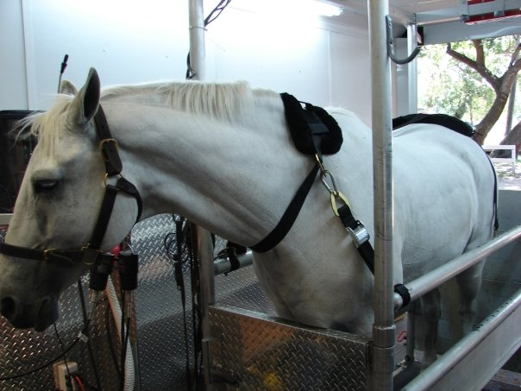

Download all Associated Files for this lesson from our Website

Summary: This lesson introduces large animal restraint to students in a practical setting. Students will be able to restrain large animals and understand how to approach and handle livestock.
Keywords: Restrain, Psychological, Physical, Chemical, Flight Zone

Subject TEKS:
Agriculture: 130.3 Livestock Production:
- (3) The student performs technical skills related to livestock production. The student is expected to:
  - (C) practice proper animal restraint techniques;

Grade Level: 9th-12th

Learning Objectives:
The learner will:
- Understand the three types of restraint.
- Know safe ways to approach cattle and horses.
- Understand different methods of restraining various large animal species.
- Practice proper animal restraint.
- Present to the class the differences in proper or improper restraint behaviors.
- Identify unsafe or improper restraint behaviors of classmates.

Time Required: 2-50 min. class periods:

Materials:
- Large Animal Restraint PowerPoint
- Large Animal Restraint Teacher’s Activity Sheet
- Restraint Tools: Cattle rope halter, equine rope halter, any other available tools…
- Large or Medium sized stuffed toy animal(s)

Vocabulary / Definitions:
- Restraint: To control movement and activity of an animal to keep both the human and the animal safe.
- Flight Zone: the area around an animal where it feels safe. If a predator or human enters, the animal will move away.

Background and Concepts for Teachers:
-Common tools used to restrain cattle:
Halters- used to maneuver the animal and secure when needed
Squeeze Chutes- used to secure beef cattle when receiving care; protects handler
Nose tongs-inserted into nostrils to keep animal’s head still
Flanking- used to restrain calves on sides by lifting calf and lying on side
-Common tools used to restrain horses:
Stocks- uses minimal restraint while preventing animal from swinging hips; protects handler
Hobble- restrains legs by preventing kicking
Nose twitch-loop tightened around upper lip, to distract from stressful environments
Foal Restraining- prior to halter broking, hold under neck and hind quarters prevents struggling
-Common tools used to restrain swine:
Snare- used to catch and hold heavier hogs
Boards- used to separate or block hogs in open spaces
Panels, Gates and Cages-use of confinement to reduce movement of animal(s)
Restraining young pigs- lifting animal by either forelegs or hind legs to prevent movement
-Common tools used to restrain sheep/goats:
Halters or Collars- used to maneuver the animal and secure when needed
Fitting Stand – a lifted stand with place to secure animal’s head when receiving care
Jaw Restraint- gently restraining the animal by the jaw to maneuver animal
Straddle- straddling over the animal’s back and holding the head to prevent movement
Lesson Introduction: To introduce this lesson, teach your class how to use a rope halter for a horse and cattle. (You will need a rope halter for a horse and a rope halter for cattle) Use the provided halter activity sheet for directions. You may use additional tools or types of halters if available.
- You will start this introduction by asking your students, “What am I holding?” (Hold up the halters and show them to the class.) Be sure to discuss what they are used for and why they are an important tool to be able to use with livestock.
- Describe each part of the halter: nose strap, lead rope, etc.
- Demonstrate how to halter an animal. (You may use a live or toy animal) You may also show the videos provided on the activity sheet.
- Allow students to practice haltering the animal with your supervision/assistance.
Presentation/Explanation:
- The PowerPoint presentation provided should be a great introduction to animal restraint. Be sure to discuss what ‘types of restraint’ are used in each picture and what is going on in the picture; discuss why the restraint is being used such as giving a vaccination or castration.
- The titles of every slide are at the bottom of the slide due to formatting.
- The Presentation has two embedded videos each at about 1 minute long. You can find the link for the full videos in the “notes” section below the slide and at the top of the slide should the embedded videos not work.
- Slides 9, 12-14 show pictures of common types of tools used to restrain. You can find the definitions and explanations for each tool in the “notes” section below each slide.
Activity/Application: This section of the lesson should be as hands on as possible. You will want to bring any large animal restraint tools that you have access to for the students to look at or use. You should not be limited to the tools discussed in the PowerPoint presentation, but should only use tools that you have knowledge of or any experience using.
- Briefly show each available tool to the class, explain how and why it may be used and which species the tool may be used on. You may want to demonstrate the tool on a live animal or stuffed toy animal.
- Separate the class into small groups and ask them to prepare a demonstration or skit to present to the class on “unsafe or improper behavior when restraining”. You may ask them to demonstrate the following topics:
  - Unsafe or improper use of (provided tool or technique)
  - Unsafe or improper approach to a large animal.
Be sure to assign each group a specific animal to “approach”, tool to demonstrate or technique to discuss.
- DO NOT let students demonstrate these incorrect behaviors on live animals or other students. Stuffed toy animals or imaginary animals are safest to allow students to practice on when not under strict supervision such as this small group project.
- For each presentation ask each group to demonstrate their skit of an improper or unsafe behavior. Next, ask the class to name what behaviors were unsafe during their skit. Last, ask the group to demonstrate the proper and safe behavior that should be used when restraining large animals.

Safety Issues:
If you have access to live animals, be sure that your safety, your students’ safety and the animals’ safety are of #1 priority!
Never let students handle animals without prior instruction, demonstration and your supervision.
Handling live animals is the best way for your students to gain experience, but will only be beneficial if they are safe.

Resources:
- http://wikivet.mediacore.tv/media/applying_cow_halterwmv
- http://www.youtube.com/watch?v=WvjRoNHa1QU
- http://www.youtube.com/watch?v=-q55fC649XM
- http://www.ehow.com/video_4439276_safety-tips-approaching-horse.html

References:
- Faries, F. C. (1995). Veterinary assistant handbook. (First ed., pp. VI.5.1-VI.8.3).
College Station, TX: Instructional Materials Service.
- Faries, F. C. (2011). Veterinary science: Preparatory training for the veterinary
assistant. (pp. 133-144). College Station, TX: National Center for Foreign Animal
and Zoonotic Disease Defense.

Authors:
Undergraduate Fellow: Lindsey E. Nyquist
Graduate Fellow: Jennifer Graham

