Materials Needed:
- Rope Halter
- Animal to halter (this may be a live animal, if available, or a stuffed toy)
The Parts of a Halter for Restraint

- Identify the parts of the rope halter used for cattle, sheep and goats
  - (Fixed) Nose Band
  - Head Loop
  - Chin Loop
  - Lead Rope

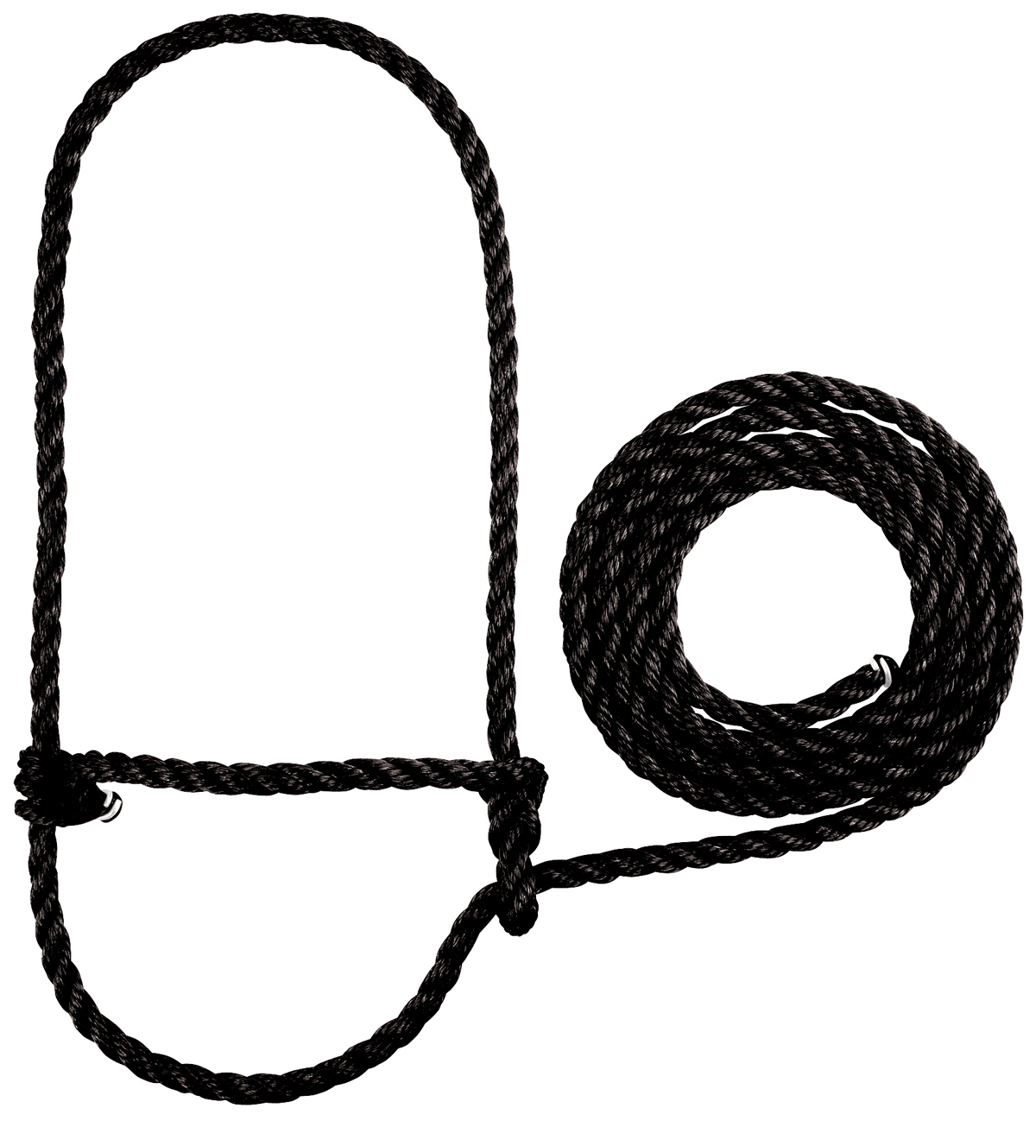
a
b
c
d
- Identify the parts of the rope halter used for horses
  - Poll Strap
  - Nose Band
  - Cheek Strap
  - Chin Piece
  - Gullet Strap
  - Throat Piece
  - Lead Rope

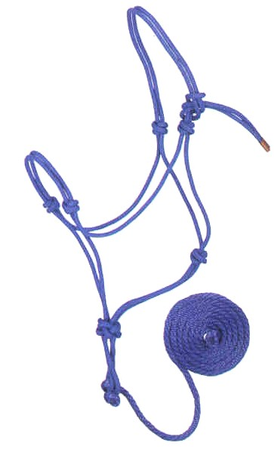
a
g
b
f
d
e
c

How to Put the Halter on Cattle for Restraint
- Safely approach the animal
- Place the “Head Loop” over the animal’s head, behind the ears and horns (if horned)
- Make sure the “Nose Band” lays across the nose correctly
- Place the “Chin Loop” under the chin of the animal
- Pull the “Lead Rope” and secure the halter
Helpful demonstration video: http://wikivet.mediacore.tv/media/applying_cow_halterwmv
How to Put the Halter on a Horse for Restraint
- Safely approach the animal
- Untie the “Poll Strap”
- Place the “Chin Piece” below the chin, making sure the “Nose Band” is laying across the nose
- Pull the halter up the animal’s face so that the “Cheek Straps”, “Gullet Piece” and “Throat Straps” are in place. (against the cheek, gullet or throat)
- Lay the “Poll Strap” across the animals poll, behind the ears
- Re-tie the “Poll Strap” and make sure the halter is secure
Helpful demonstration video: http://www.youtube.com/watch?v=WvjRoNHa1QU

