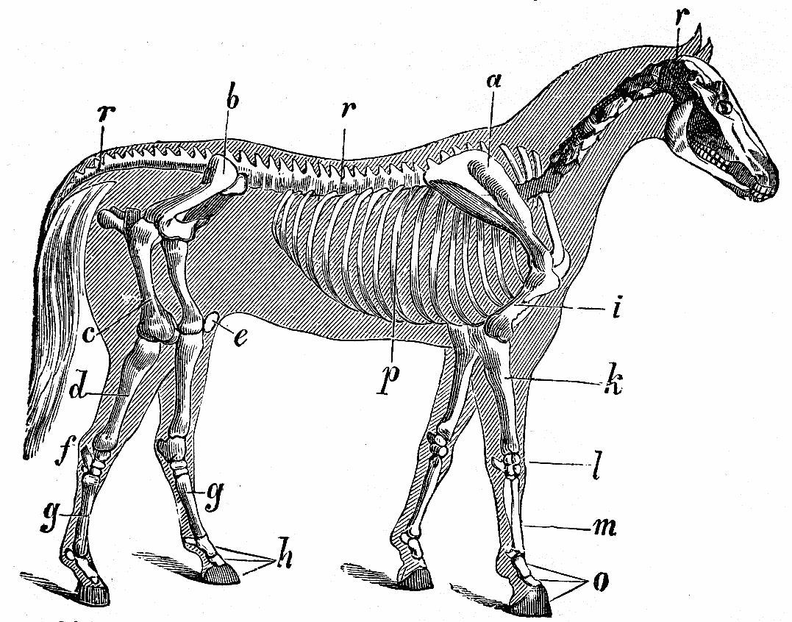
Large Animal Skeletal Systems

Download all Associated Files for this lesson from our Website

Summary:
This lesson will demonstrate the skeletal systems of large animals. It is important for students to be able to understand and identify the different skeletal structures when working with large animals. Activities will challenge and promote learning of the bones of large livestock species (cattle, horses, swine, sheep, and goats) and poultry with quizzes of each skeleton in the PowerPoint.

Agriculture TEKS
- 130.3 Livestock production
  - (4) The student explains anatomy and physiology related to nutrition, reproduction, health, and management of domesticated animals. The student is expected to:
    - (A) explain the skeletal, muscular, respiratory, reproductive, and circulatory systems of animals; and

Keywords: Axial, Pectoral, Pelvic, Bone, Cartilage, Ligaments, Joints, Cervical, Thoracic, Lumbar, Caudal

Grade Level: 9th- 12th

Learning Objectives:
The learner will:
- Understand the functions of the skeletal system
- Understand the different uses of bones cartilage, ligaments and joints
- Know the different parts of bones
- Be able to show the difference in types of joints
- Show knowledge of the three parts of a skeleton
- Be able to label the bones of large animal structures such as Cattle, Horses, Swine, Sheep, Goats, and Poultry
- Be able to tell the difference in species based on differing skeletal features
Time Required:
30 min. to complete the PowerPoint and skeleton labeling activity
15 min. to complete assessment quiz
Materials:
- PowerPoint Presentation on “Large Animal Skeletal Systems”
- Each student will need 3 different colors of choice (colored pencils, markers, highlighters, crayons...)
- Print out of “Bovine Skeleton” (1 per student)
- Print out of “Large Animal Skeletal Systems Quiz” (1 per student)

Activity Cost [in dollars]: $0.00
Background and Concepts for Teachers:
- Cartilage, ligaments and tendons
- Parts of the bone
- Types of joints and where animals have these joints
- The bones of mammalian species
- Tibia in most large animals are a singular fused tibia and fibula
- Swine commonly have present fibula and tibia
- Poultry have large keeled breast bone known as sternum or keel bone

Lesson Introduction / Motivation:
Ask your class “Think about how the physical structures of large livestock species differ from human bodies. Based on this, how do you think their skeletons differ? What bones may they have or not have that we do or don’t?” Discuss that most animals have tails and the bones in the tail are part of the vertebrae, classified as the caudal vertebrae. Also discuss how most livestock have hooves rather than fingers and toes. These are known as digits. Next, ask your class “Why is it important that large animals, like pigs, cattle, horses, goats and chickens to have bones? What would happen if they didn’t?” This will lead into the first slide of the PowerPoint, “Large Animal Skeletal Systems.”

Presentation/Explanation:
Before starting the presentation, make sure each student has 3 colors and a “Bovine Skeleton” sheet. Go through the PowerPoint presentation over “Large Animal Skeletal Systems” with the class. You may ask your students to take notes in their notebook or on the back of this bovine skeleton sheet to study later. On slides 9, 11 and 13, allow ample time for your students to label and color their bovine skeletons. Slides 15-20 will allow time to review the bones of differing species. Be sure to point out important features of each species. Slides 22 – 27 are quizzes of 5 bones from each species with answers located in the notes section of the slide.
Activity/Application:
During the presentation, each student will label and color their Bovine Skeleton. The skeleton should be colored with three different colors, one for each part of the skeleton: axial, pectoral and pelvic. Be sure to pause on slides 9, 11 and, 13 to allow the students to label and color their skeleton.
After completion of the labeling, continue the PowerPoint presentation. Review the bones as a class. Slides 22-27 will each have 5 bones to label. Make sure to point out differences between similar bones such as ulna and radius, mandible and maxilla, tibia and fibula, tarsus and metatarsus…
*Cattle (slide 22) 1.Caudal Vertebrae 2. Ribs 3.Tarsus 4.Scapula 5.Mandible
*Horse (slide 23) 1.Pelvis 2.Thoracic Vertebrae 3.Humerus 4.Metatarsus 5.Tibia
*Swine (slide 24) 1.Maxilla 2.Radius 3.Ulna 4.Fibula 5.Tibia
*Sheep (slide 25) 1.Cervical Vertebrae 2.Digits 3.Patella 4.Ischium 5.Ilium
*Goat (slide 26) 1.Thoracic Vertebrae 2.Lumbar Vertebrae 3.Radius 4.Ulna 5.Tibia
*Poultry (slide 27) 1.Ulna 2.Pelvis 3.Caudal Vertebrae 4.Metatarsus 5.Keel/ Sternum

Assessment/Evaluation:
Large Animal Skeletal Systems Quiz and Key provided.

Resources:
- http://en.wikibooks.org/wiki/Anatomy_and_Physiology_of_Animals/The_Skeleton
- http://www.google.com/url?sa=t&rct=j&q=cattle%20tibia%20fibula&source=web&cd=5&ved=0CEcQFjAE&url=http%3A%2F%2Ftoolboxes.flexiblelearning.net.au%2Fdemosites%2Fseries4%2F414%2Fmmp3072a%2Ftraining%2Fsection01%2Ftopic02%2Fdoc%2FMINTRAC2.rtf&ei=JJqqUIOWB4aA2wXIvYHwDg&usg=AFQjCNFXY5aJvPHTqngRQFdW6Wr0l3YzBQ&cad=rja

References:
- http://www.google.com/url?sa=t&rct=j&q=animal%20skeletal%20system%20powerpoint&source=web&cd=1&ved=0CC0QFjAA&url=http%3A%2F%2Flehiffa.org%2FBushman%2Fassets%2F1.%2520Agriculture%2520Biology%2FAnimal%2520Science%2FAnimal%2520Structure%2520and%2520Function.ppt&ei=qi-hUK3uFMKHqgGr44CYAg&usg=AFQjCNEbT5vaMYHaDm0SLksGeuYn_WWxlg
- http://cms.cnr.edu.bt/cms/files/docs/File/penjor/AAP/Skeletal%20system.pdf
- http://www.agriscience.msu.edu/3000/3020/3022/overheads/3022overheads.html
- http://www.statemuseum.arizona.edu/crservices/human_animal_bone.shtml
- http://www.google.com/url?sa=t&rct=j&q=cattle%20tibia%20fibula&source=web&cd=5&ved=0CEcQFjAE&url=http%3A%2F%2Ftoolboxes.flexiblelearning.net.au%2Fdemosites%2Fseries4%2F414%2Fmmp3072a%2Ftraining%2Fsection01%2Ftopic02%2Fdoc%2FMINTRAC2.rtf&ei=JJqqUIOWB4aA2wXIvYHwDg&usg=AFQjCNFXY5aJvPHTqngRQFdW6Wr0l3YzBQ&cad=rja

Authors:
Undergraduate Fellow: Lindsey Nyquist
Graduate Fellow: Jennifer Graham

