Carlos Davila

DVM Candidate - Class of 2026

Texas A&M College of Veterinary Medicine

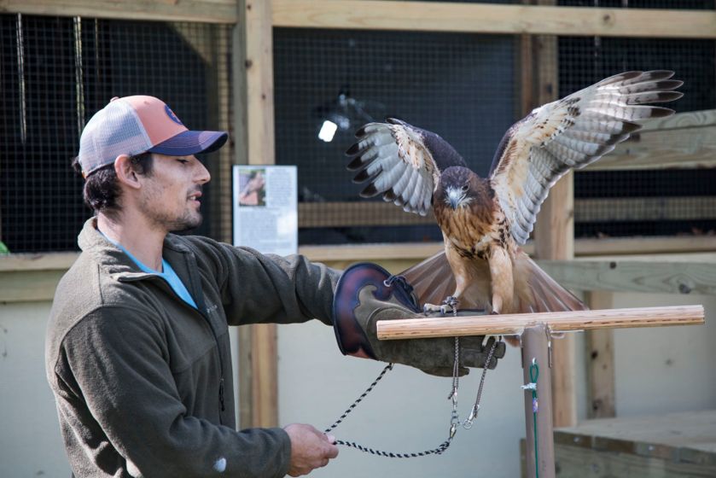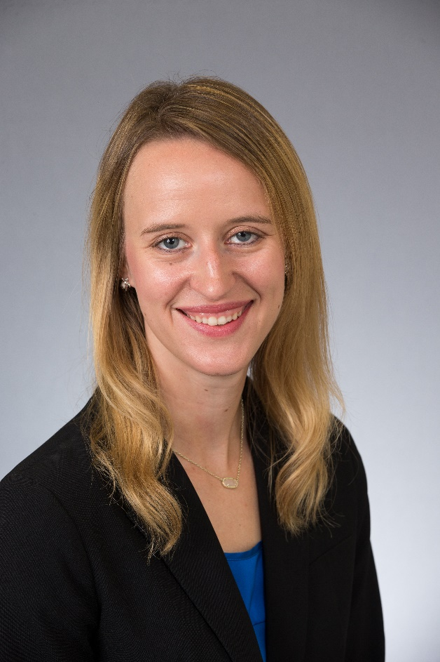

**Alyssa Hartmann** | DVM Candidate 2026 | VMBS Ambassador

Texas A&M University | School of Veterinary Medicine and Biomedical Sciences